
Gwangju Institute of Science and Technology
Official Press Release — https://www.gist.ac.kr

Section of Dongsun Cho Nayeong Lee
Public Relations Section Chief Senior Administrator
062-715-2061 062-715-2062

Contact Person Kyu-rang Lee, Administrator
for this Article GIST Academy
062-715-2623

Release Date 2021.06.28

GIST Academy hosts June Breakfast Forum on 'Current Status and Challenges of the Oil and Petrochemical Industries'

□ GIST (Gwangju Institute of Science and Technology) Academy held the June Breakfast Forum on the 'Current Status and Challenges of the Oil and Petrochemical Industries' at Oryong Hall on June 28, which was attended by some 40 corporate representatives from Gwangju and South Jeolla Province.



□ The forum was held with a special lecture by Hyung-soon Kim, CEO of Marine Energy Co., Ltd., and drew keen attention by introducing the history of oil refining in Korea, the current status of petrochemical industries, and marine energy projects.

∘ CEO Kim mentioned that there should be a transformation strategy for the oil refining and petrochemical industries in the 4th Industrial Revolution, and he emphasized the importance of carbon neutrality, waste treatment, and energy conversion.

∘ CEO Kim said, "In order to lead new and renewable energy worldwide, each country is investing enormous resources in energy development and is concentrating on research and development. Marine Energy is actively participating in the construction and operation of a hydrogen charging station by utilizing the company’s CNG charging station infrastructure in connection with Gwangju City’s hydrogen-leading city construction policy, and we are also actively promoting the construction of a hydrogen production base."

□ Marine Energy Co., Ltd. has been supplying city gas, an eco-friendly clean energy, to 8 cities/guns in Gwangju Metropolitan City and Jeollanam-do since its establishment in 1982. Currently, in addition to the city gas supply business, new and renewable energy, CNG charging stations, IoT sensors and communication technology development, maintenance, and energy-based personalized care services are also being conducted.

∘ CEO Kim Hyung-soon has been the CEO of marine energy since 2017 and has been in office until now. Currently, he is active in social contribution activities as the alumni president of Chonnam National University's engineering college, a member of the Carbon Neutral Council, a chairman of the Korea Chemical Engineering Association, and a vice chairman of the Gwangju Regional Association.

□ The GIST Academy Breakfast Forum provides opportunities for awareness innovation, technology transfer, and industry-university cooperation through lectures by experts from various fields on the last Monday of every month for alumni of the academy and executives of local companies.

∘ GIST Academy operates two courses: GIST Techno Management Business Academy (opened in 2010) and GIST Climate Change Academy (opened in 2016). It is contributing to revitalizing regional economic and industry-academic cooperation by fostering the business environment, global management strategy, and cultural sense.

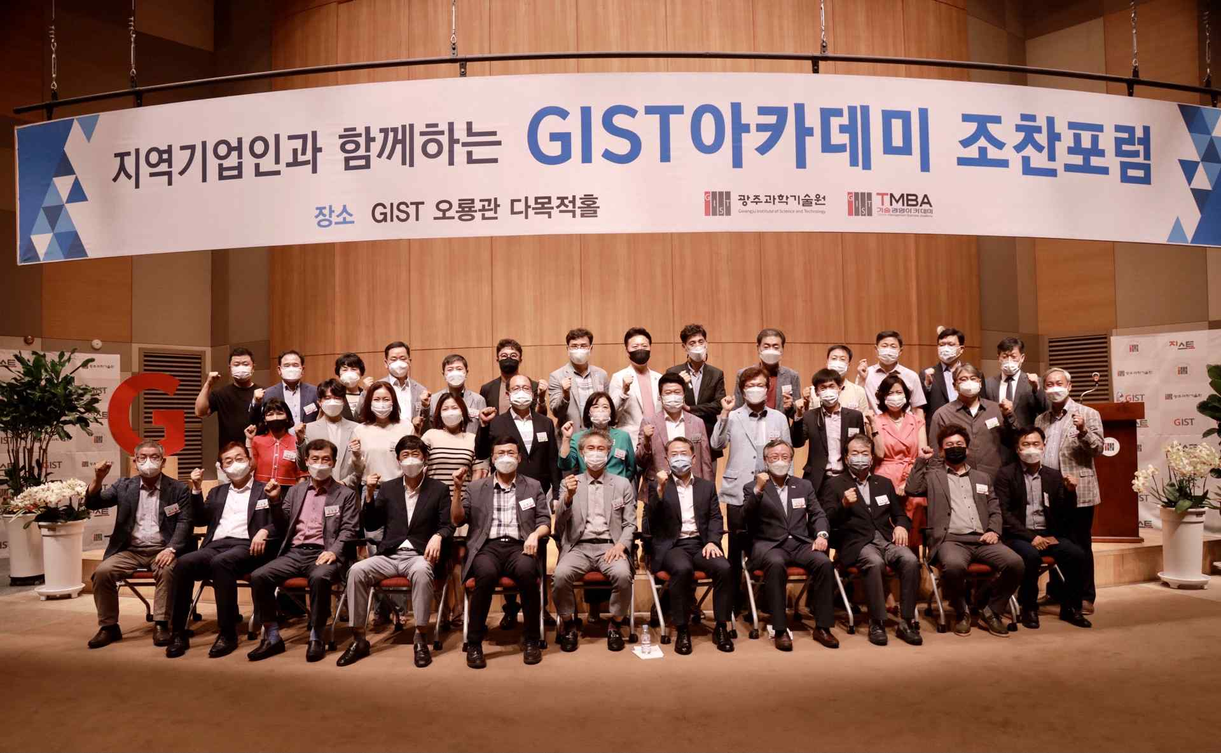
▲ GIST Academy hosts June Breakfast Forum



