
Gwangju Institute of Science and Technology
Official Press Release — https://www.gist.ac.kr

Section of Dongsun Cho Nayeong Lee
Public Relations Section Chief Senior Administrator
062-715-2061 062-715-2062

Contact Person Research Professor Byung-tae Lee
for this Article GIST Central Research Facilities
062-715-3315

Release Date 2021.06.24

GIST Central Research Facilities, 'acquired KOLAS accreditation for materials and environment'

□ GIST (Gwangju Institute of Science and Technology) Central Research Facilities (GCRF) was recognized on June 24, 2021, as an international accredited testing institution in the field of environment and materials by the Korea Laboratory Accreditation Scheme (KOLAS), which is a member of the International Laboratory Accreditation Cooperation (ILAC).



∘ GIST Central Research Facilities (Director Sang-Don Kim, School of Earth Sciences and Environmental Engineering professor), which opened in June 2019, aims to enhance the convenience of research and development in the southwestern region through the establishment and strengthening of state-of-the-art research equipment joint utilization services through an industry-academia-research support system.

□ The KOLAS certification is a national system that officially recognizes that GCRF has a quality system and technical capability that meets international standards in accordance with the Framework Act on National Standards and the ISO/IEC Guide for accreditation systems. Currently, 104 countries have joined the accreditation body of ILAC to mutually recognize the official certifications of other countries.

∘ The items recognized this time by the GIST Central Research Facilities are quantitative analysis of elements using an energy dispersive spectrometer, which is a field of other petroleum products (materials) in chemical testing, and it is now possible to issue environmental-related official reports for surface potential, glass transition temperature, four melting crystallization temperature enthalpies in 12 environmental water quality areas, materials in a total of 16 sizes, and chemistry.

□ Last year, this center proved its superiority in water quality analysis and materials tests, including the International Proficiency Test conducted by the American Association of Environmental Resources (ERA). ISO-17025, the international standard for laboratory operating systems, which is a requirement for KOLAS testing and calibration laboratories, was introduced.

□ Director Sang-Don Kim said, "The Central Research Equipment Center supports the best test and analysis services by continuously expanding world-class joint-use research equipment to systematically utilize, maintain, repair and manage equipment. In the future, we will actively utilize the KOLAS test analysis operation system, which is the international standard, to expand support for international test analysis to researchers in various fields such as materials and environment."

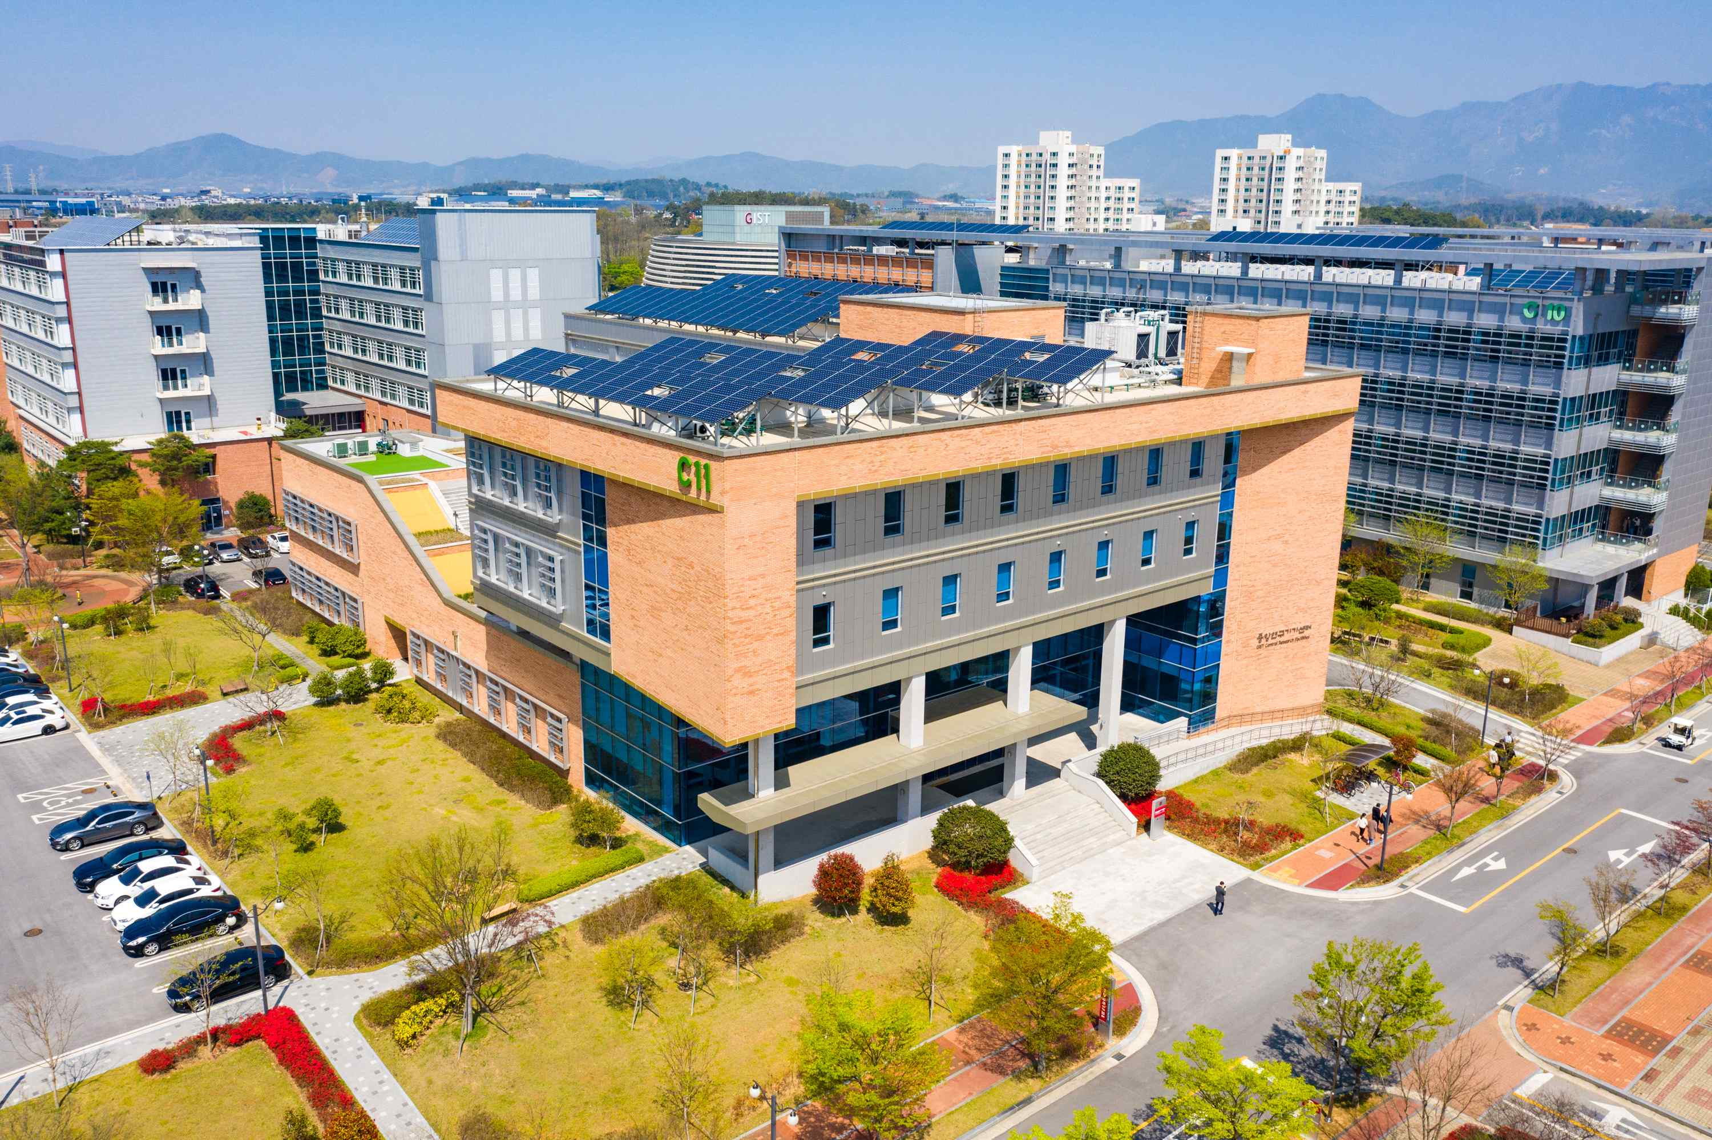
▲ View of the GIST Central Research Facilities



