
Gwangju Institute of Science and Technology
Official Press Release — https://www.gist.ac.kr

Section of Dongsun Cho Nayeong Lee
Public Relations Section Chief Senior Administrator
062-715-2061 062-715-2062

Contact Person Suin Choi, Administrator
for this Article GIST Institute for Artificial Intelligence
062-715-6913

Release Date 2021.06.24

GIST and KOLab signed an industry-academic
exchange agreement in the field of dementia

□ GIST (Gwangju Institute of Science and Technology) Institute for Artificial Intelligence (Director Heung-No Lee) signed an industry-academic cooperation business agreement with KOLab Co., Ltd.(Co-CEO Kyu-young Choi, Ha-sook Kim), a company specializing in dementia clinical trials, to develop medical diagnosis technology for dementia-causing bacteria.



∘ The signing ceremony was held on the 23rd (Wednesday) at the GIST Institute for Artificial Intelligence with Director Heung-No Lee, KOLab Co., Ltd. Co-CEO Kyu-young Choi and Ha-sook Kim, and project manager Han-gyeol Song.

□ The main contents of the agreement include: ▲ joint research on dementia using artificial intelligence ▲ development and demonstration of dementia prediction and prevention technology through biomedical big data ▲ promoting joint projects (tasks) with research results such as AI, blockchain, cloud, and data (ABCD) technologies ▲ cooperation in training professionals and programs for employment and start-ups ▲ other matters related to the promoting relations between the two organizations and the joint development.

∘ KOLab Co., Ltd., is a local company that develops health care products using artificial intelligence (AI) technology and manages clinical trials for dementia using big data in the field of dementia. Recently, it signed a business agreement with Gwangju City and Chosun University.

□ GIST Institute for Artificial Intelligence Director Heung-No Lee said, "Through industry-academic cooperation with KOLab, we will do our best to become a partner in unexplored fields through joint projects for technology development in various fields as well as development of medical diagnosis technology for dementia-causing bacteria using artificial intelligence."

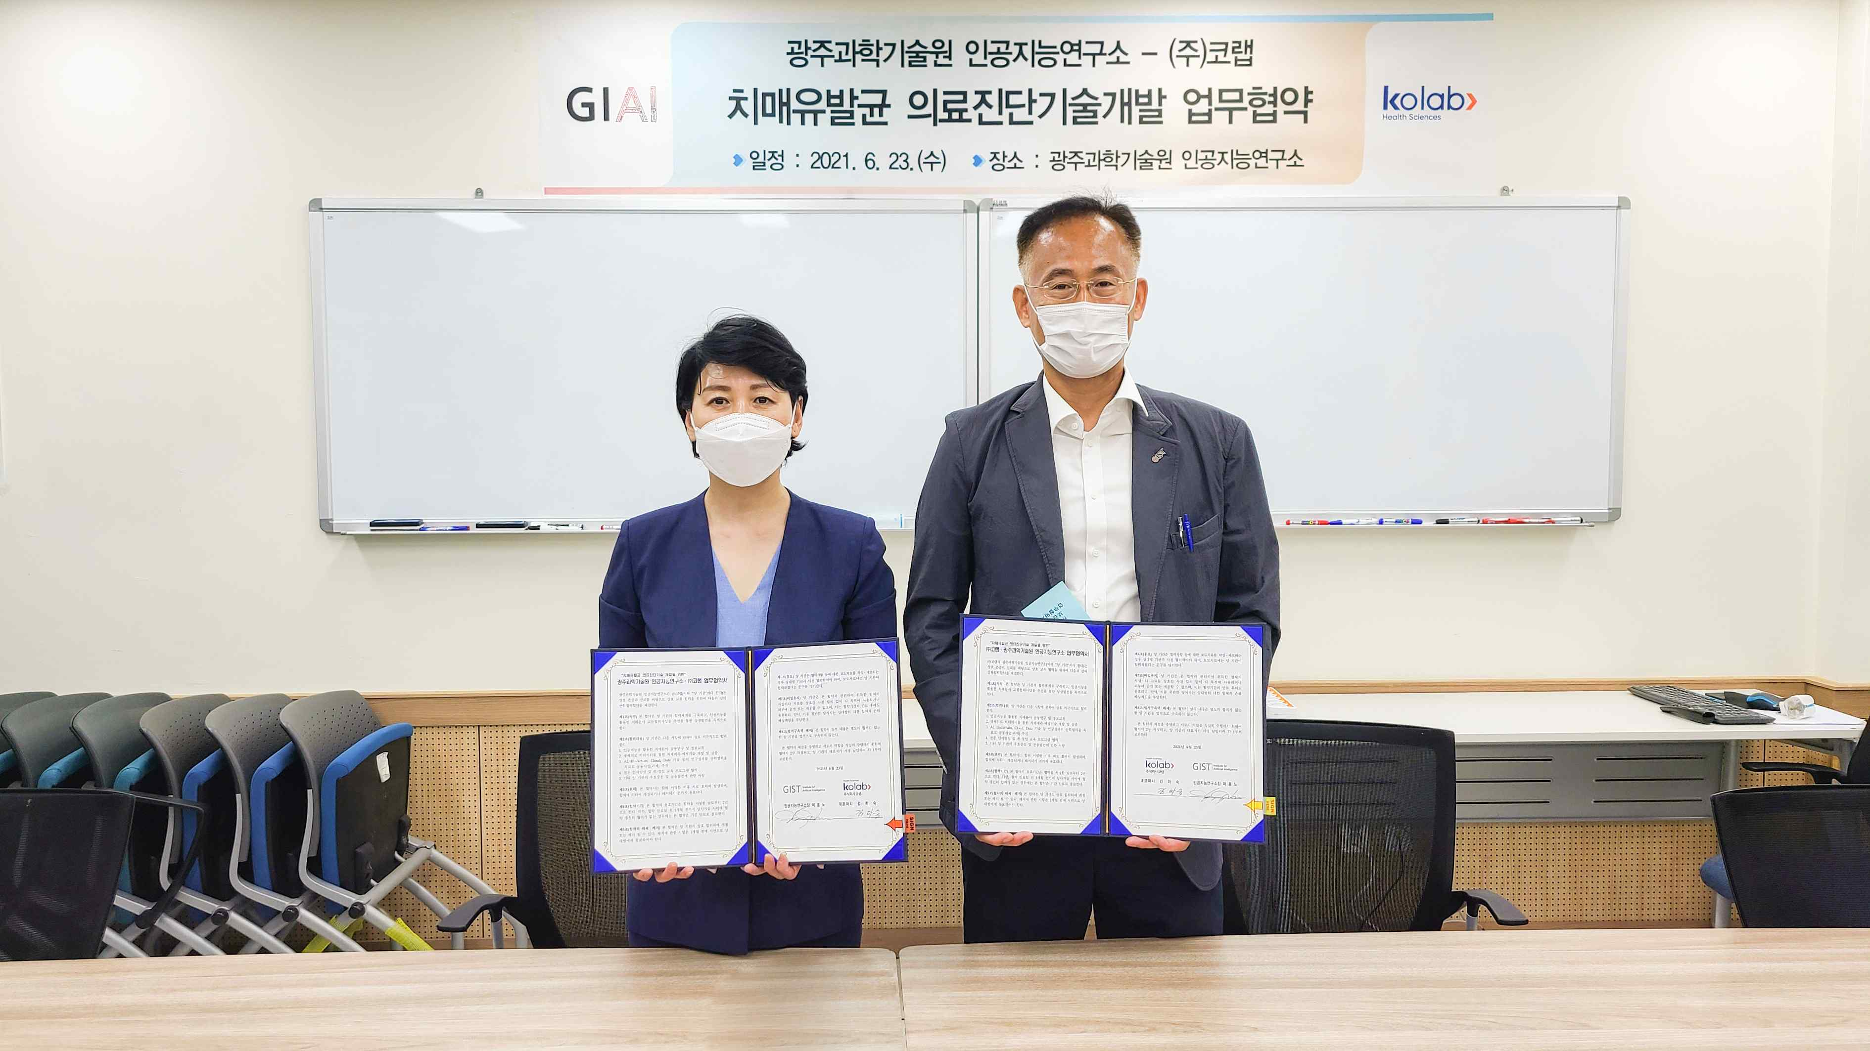
▲ GIST and KOLab signed an industry-academic exchange agreement in the field of dementia (from left): KOLab CEO Ha-sook Kim and GIST Institute for Artificial Intelligence Director Heung-No Lee



