
Gwangju Institute of Science and Technology
Official Press Release — https://www.gist.ac.kr

Section of Dongsun Cho Nayeong Lee
Public Relations Section Chief Senior Administrator
062-715-2061 062-715-2062

Contact Person Tae-wan Kim, Administrator
for this Article GIST Business Incubator
062-715-6302

Release Date 2021.06.21

GIST to host 7th Creative Space G A.I. & IoT Hackathon

□ GIST (Gwangju Institute of Science and Technology) will host the 7th Creative Space G A.I. & IoT Hackathon with the participation of the general public to lead the 4th Industrial Revolution and to inspire a healthy start-up culture in the region and on campus.



∘ Starting in 2018, his event is held twice a year (first half and second half). In the first half of the year, an idea hackathon contest is held to discover brilliant ideas from participants or a hackathon-type contest is held in which program developers participate. In the second half of the year, there will be a hackathon contest where to realize ideas.

□ On June 18, prior to the main event, an event was held for the participants to provide orientation, special lectures, and advance information. In particular, in consideration of the theme for the hackathon, a special lecture was held to explain how to prepare a 'business plan' and a 'business model' for new start-ups, which received a high response from the participants.

∘ The main event will be held for two days from July 3 (Sat) to 4 (Sun), and communication between team members and development meetings will be held online. Initially, the open recruitment target was a total of 45 participants in 10 teams. Because the teams had a strong will to participate in advance, it was finally confirmed that 53 people in 14 teams will participate.

∘ The participating teams include GIST's 'Advanced Guardian' team as well as teams from KAIST, Chonnam National University, Chosun University, Gwangju University, Ewha Womans University, Dankook University, Hanyang University, Korea Maritime University, etc.

□ GIST will discover excellent ideas through this event and, for items that are highly likely to be manufactured as prototypes, those will be linked with various startup programs operated by GIST by linking them with the hackathon held in the second half of the year.

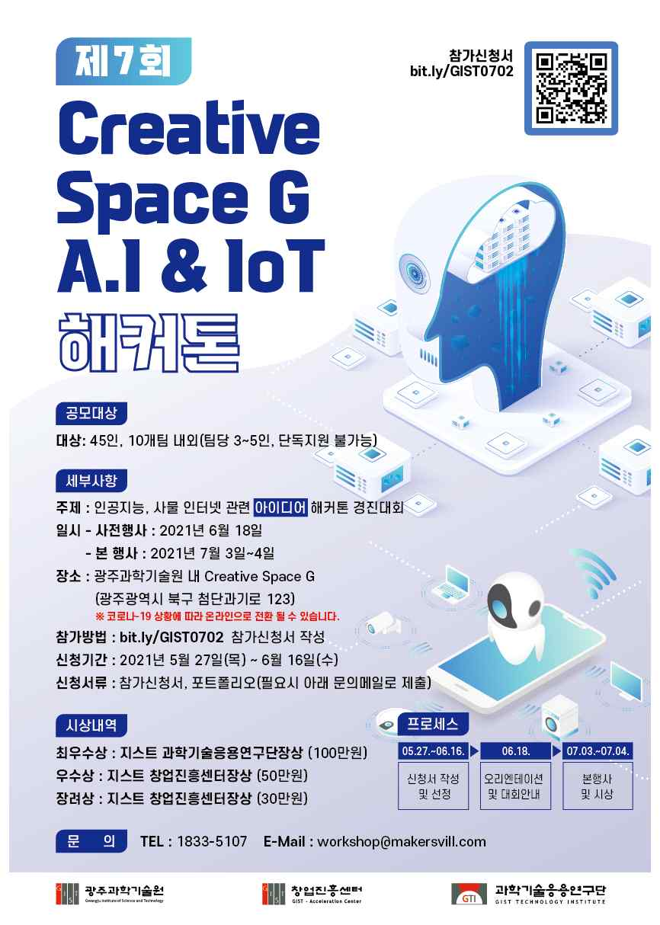
▲ 2021 GIST promotional poster

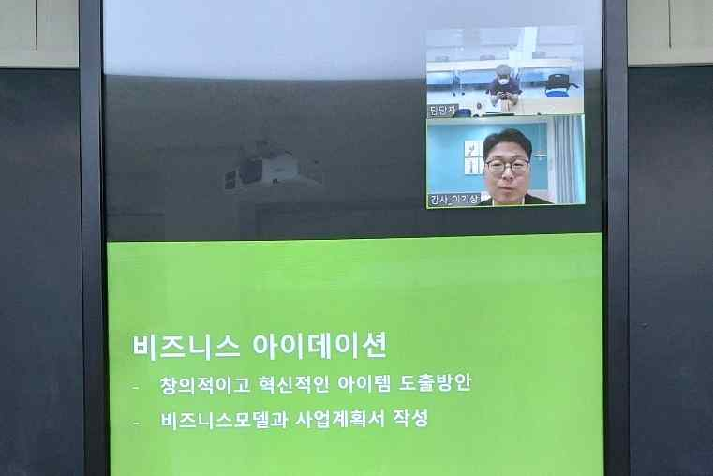
▲ Special lecture explaining 'business models' for new start-ups



