
Gwangju Institute of Science and Technology
Official Press Release — https://www.gist.ac.kr

Section of Dongsun Cho Nayeong Lee
Public Relations Section Chief Senior Administrator
062-715-2061 062-715-2062

Contact Person Deuk-jo Gong, Senior Researcher
for this Article GIST Institute for Artificial Intelligence
062-715-2934

Release Date 2021.06.18

GIST and Yeonggwang-gun discuss the revitalization
of the smart e-mobility industry

□ GIST (Gwangju Institute of Science and Technology, President Kiseon Kim) held business consultations with Yeonggwang-gun (Governor Jun-seong Kim) held a business consultation for long-term balanced development and revitalization of local industries, including promotion of the smart e-mobility industry, industry-university cooperation, and nurturing specialists.



∘ This consultation was held at the Yeonggwang-gun County Office in the presence of GIST President Kiseon Kim, Yeonggwang-gun Governor Jun-seong Kim, and key officials.

□ The discussions included ▲ construction of a second GIST campus and smart e-mobility specialized graduate school ▲ establishment of specialized service demonstration through the establishment of a smart e-mobility innovation center ▲ providing tourism contents through smart e-mobility R&D ▲ other matters necessary for promoting mutual exchange and cooperation between other institutions and local governments.

∘ For the promotion of the 2nd campus, GIST plans to carry out major projects such as the establishment of a smart e-mobility innovation center and activities to attract businesses in stages from 2021.

∘ Following this consultation, Yeonggwang-gun announced that it will provide all administrative and financial support to establish a smart e-mobility innovation center.

□ GIST President Kiseon Kim said, "Through the Smart e-Mobility Innovation Center, it is expected that related industries such as artificial intelligence, energy, and mobility will develop, and industrial competitiveness will be strengthened through human resource training and demonstration. By applying artificial intelligence to e-mobility, the main industry of Yeonggwang-gun, and striving to attract companies and establish a GIST specialized graduate school, we will do our best to lay the foundation for future growth engines for the region and country."

□ GIST is fulfilling its role and responsibility as a science and technology specialization university to foster human resources and conduct national artificial intelligence (AI) research suitable for the era of the 4th Industrial Revolution. It recently signed business agreements with CJ Olive Networks, Pyeongdong Industrial Complex Management Council, and Gwangju Metropolitan City Sustainable Development Council, and it is leading regional industrial innovation such as social problem-solving technology and promoting start-ups.

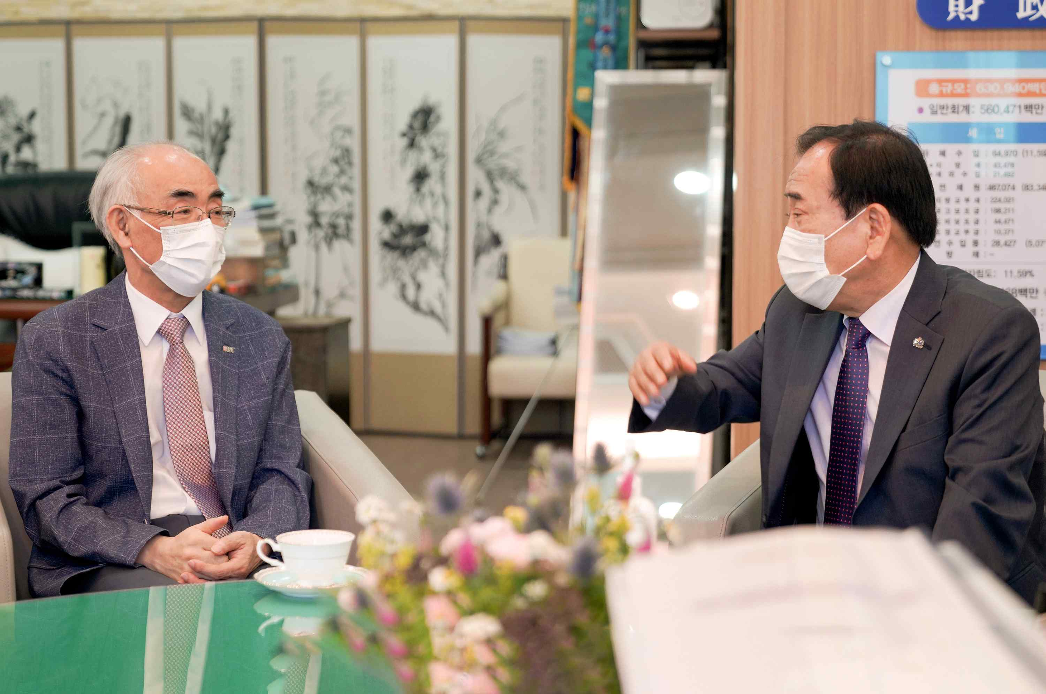
▲ Photo 1: GIST and Yeonggwang-gun discussion for revitalization of the smart e-mobility industry (from left) GIST President Kiseon Kim and Yeonggwang-gun Governor Jun-seong Kim

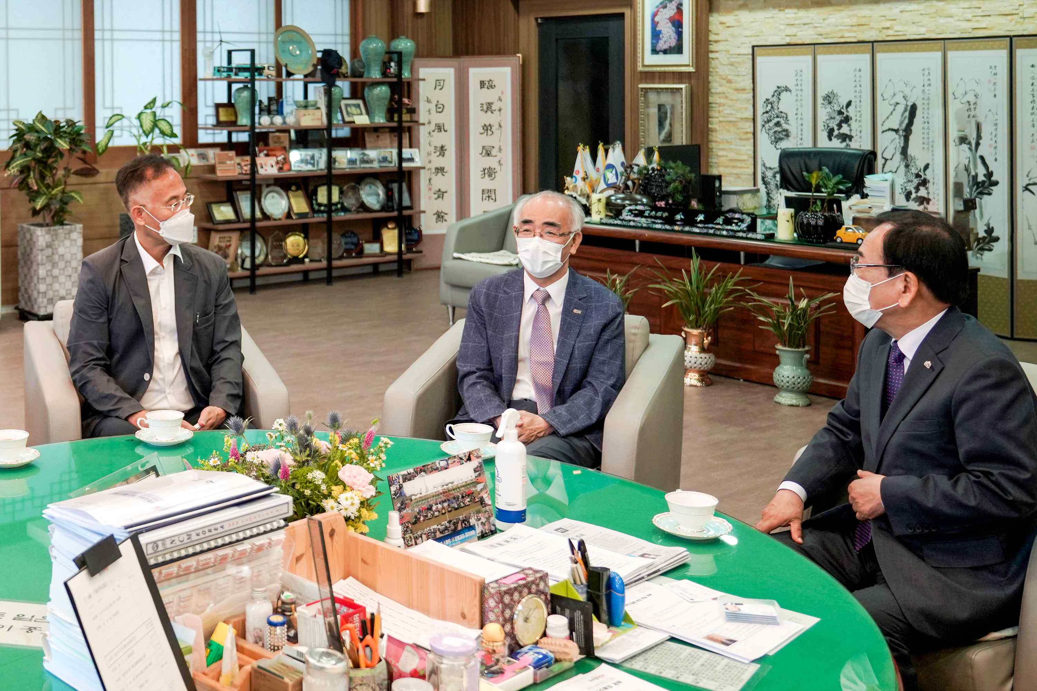
▲ Photo 2: GIST and Yeonggwang-gun discussion for the revitalization of the smart e-mobility industry (from left) GIST Institute for Artificial Intelligence Director Heung-No Lee, GIST President Kiseon Kim, and Yeonggwang-gun Governor Jun-seong Kim

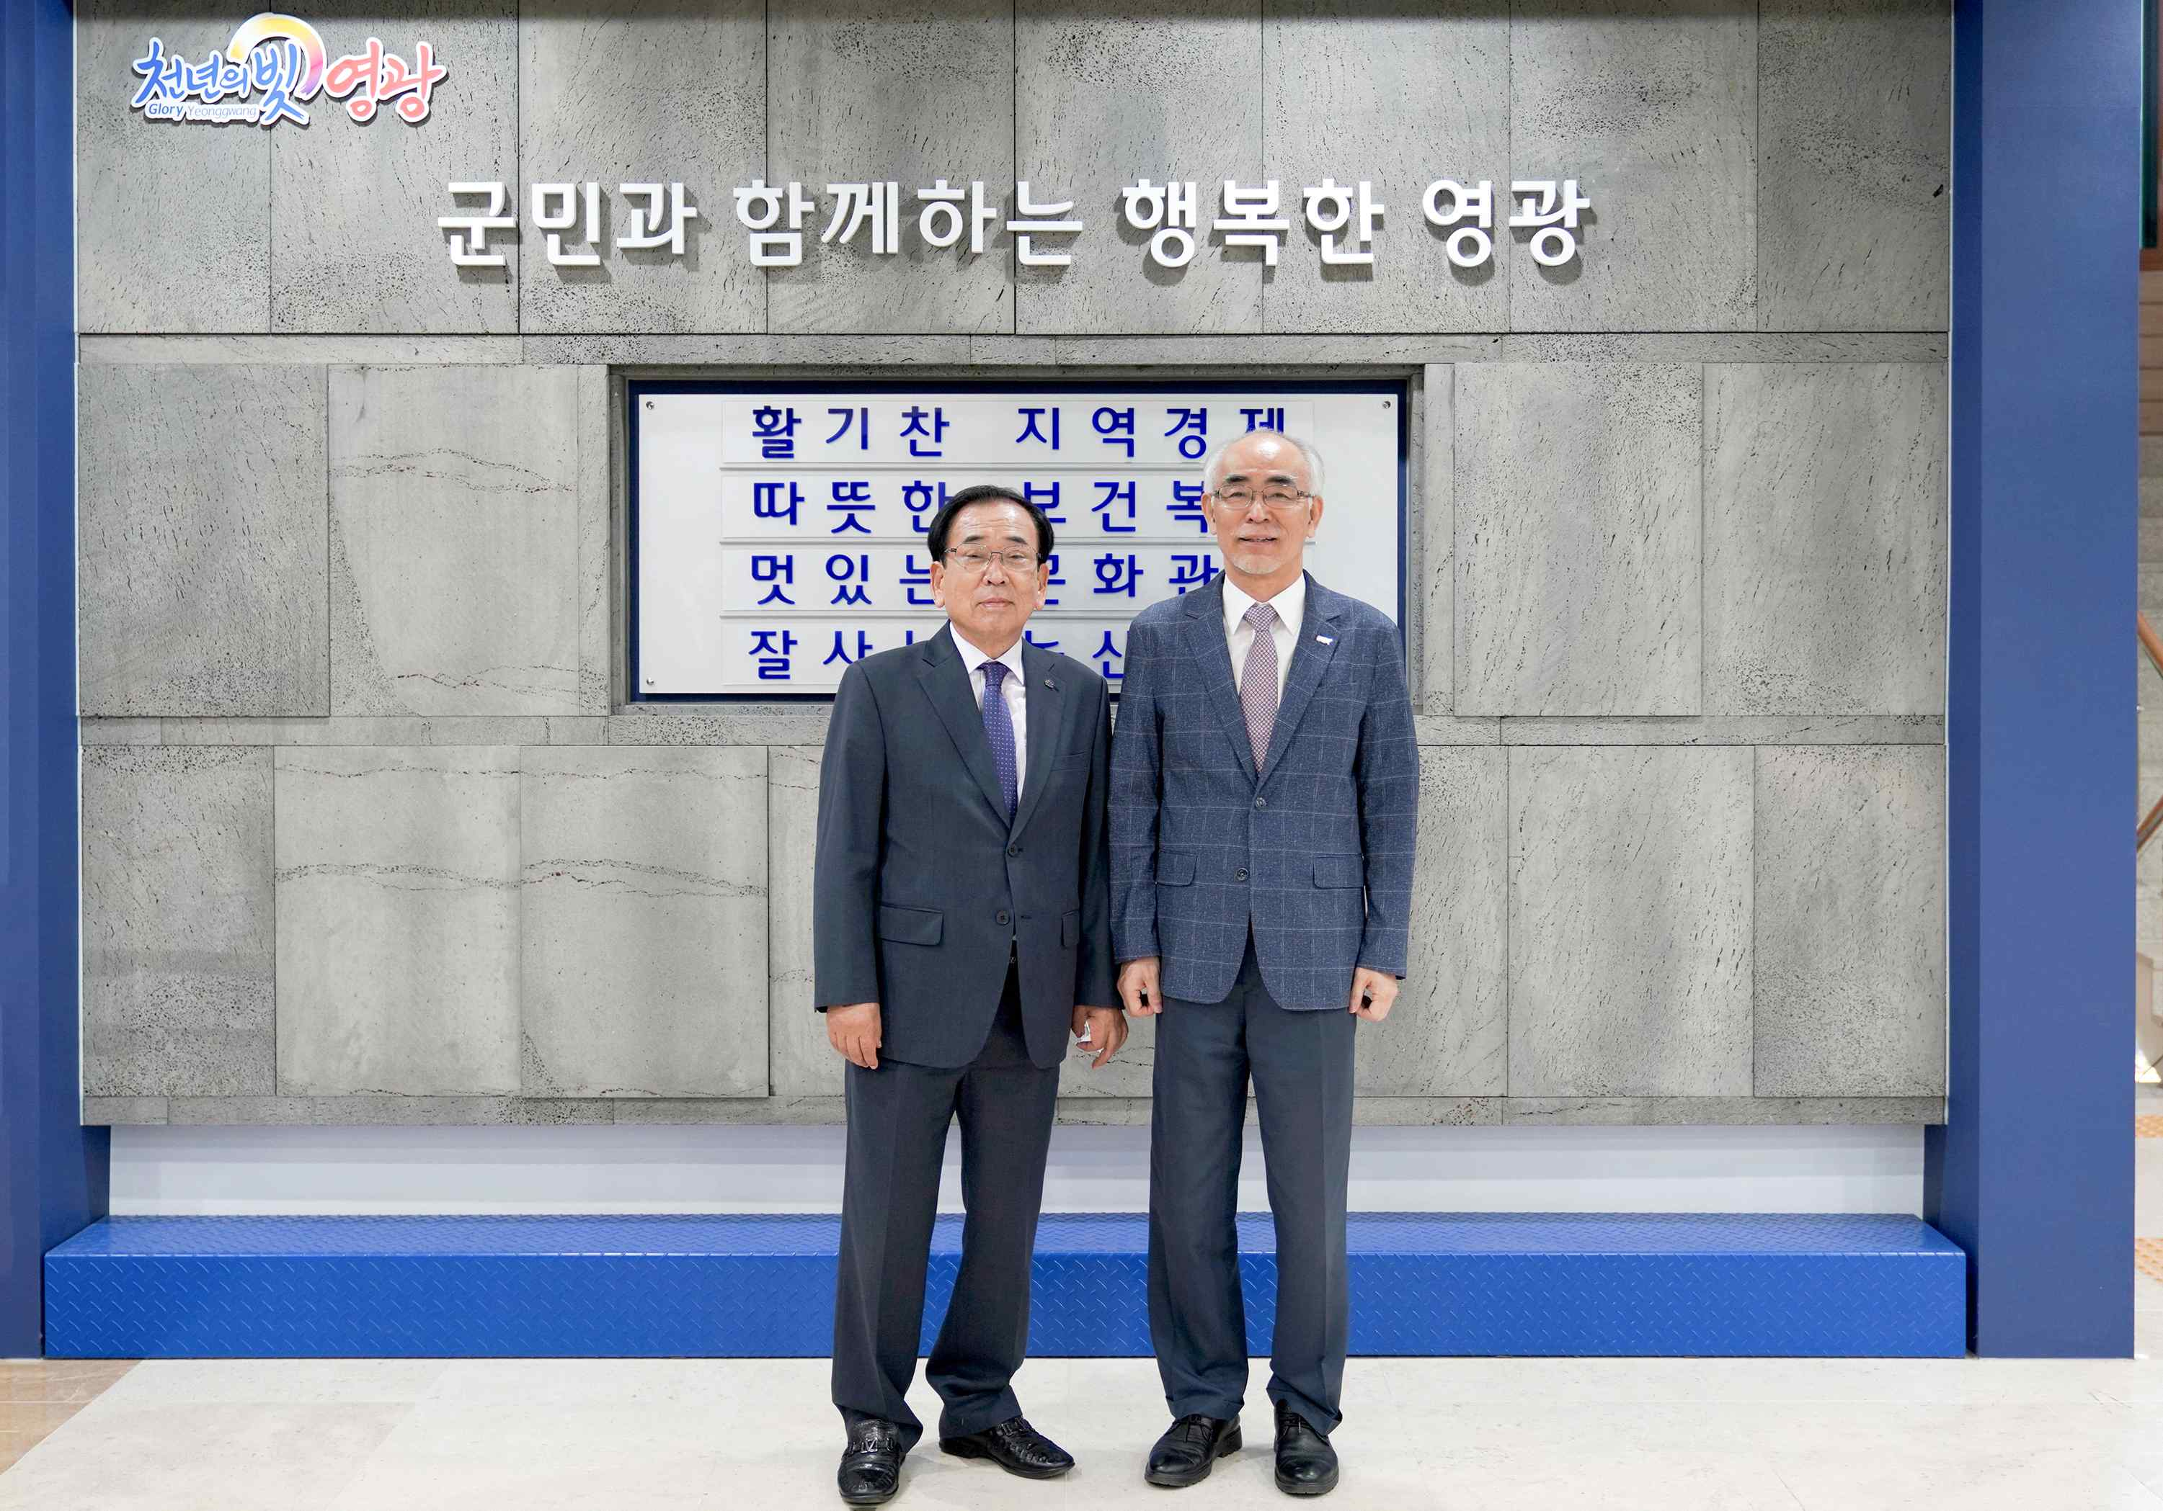
▲ Photo 3: A commemorative photo was taken at Yeonggwang-gun County Office after business consultation (from left) Yeonggwang-gun Governor Jun-seong Kim and GIST President Kiseon Kim



