
Gwangju Institute of Science and Technology
Official Press Release — https://www.gist.ac.kr

Section of Dongsun Cho Nayeong Lee
Public Relations Section Chief Senior Administrator
062-715-2061 062-715-2062

Contact Person Seon-ji Lee, Administrator
for this Article GIST Academy
062-715-2622

Release Date 2021.061.16

GIST Techno Management Business Academy hosts inaugural ceremony for the 11th Alumni Association

□ GIST Techno Management Business Academy (GTMBA) held a ceremony to launch the 11th Alumni Association (Chairman Young-hee Choi, CEO of KOS Co., Ltd.) on June 15 at Oryong Hall with about 50 GTMBA alumni in attendance.



∘ The event was attended by Goun City Eye Co., Ltd., Chairman Ki-sup Chung and GIST Vice President for Public Affairs Young-jip Kim and others to celebrate its launch.

□ Alumni Association Chairman Young-hee Choi delivered the inaugural address, saying, "I think the 11th GTMBA Association will also be the best association to harmonize and interact with alumni on the basis of the solid capabilities and potential that the GST Technology Management Academy has built up. I will do my duty as chairman to contribute to regional development and win-win development through industry-academic cooperation as well as exchange and communication between alumni."

□ GIST Vice President for Public Affairs Young-jip Kim said, "I think it is very meaningful to run the 11th course with wonderful leaders and opinion leaders who are leading Gwangju and Jeonnam. From now on, we will work harder for the development of GIST and GTMBA."

□ Alumni Association President Ki-sup Chung said, "On behalf of the alumni, I sincerely congratulate you on the launch of the 11th Alumni Association. Let's strive for harmony among each class to be reborn as the best academy in the community and let alumni companies be central to local economic development."

□ The GIST Techno Management Business Academy provides opportunities for awareness innovation, technology transfer, and industry-university cooperation through systematic training courses by experts from various fields every Tuesday at 7:00 pm for CEOs, executives, and employees of public institutions. Since the opening of this course in 2010, about 400 alumni have contributed greatly as the best global leaders in each field of society, including politics and relations, as well as the business world.

□ The 11th executives and executive departments are as follows: △ Chairman Young-hee Choi, CEO of Course Co., Ltd. △ Auditor Seong Heo, CEO of Hanyang Remicon Co., Ltd. Sa·Im-Jun Yuk, Ganesh Kim, CEO of Honam Chain Headquarters △ Senior Vice Chairman Lee Gap-jo, CEO of Hankook2M Co., Ltd., Koh Hee-joo, CEO of Bright Future Pharmacy △ Standing Vice Chairman Ham Jong-soon, CEO of Gaya Industry Co., Ltd. Jung-min Park, CEO of Illusion Gwangju Branch, Lee Ho-jun, CEO of Headline △ Secretary General Kim Kang, CEO of Seyeon E&S Co., Ltd. △ Golf Club Competition Chairman Kim Min-soo, CEO of Joyyard Co., Ltd. △ Chairman of Cultural Exploration Committee Jaehwan Wi, CEO of Leejin Sculpture Research Institute △ Chairperson of Education Industry-Academic Cooperation Chairman Jae-Hoon Jeong, Executive Vice President, KEPCO △ Treasurer Hyo-seok Park, CEO of Yangji Accounting Firm, Certified Public Accountant △ Public Relations Director Pyeon Ran Lee Director of Gugak Nara

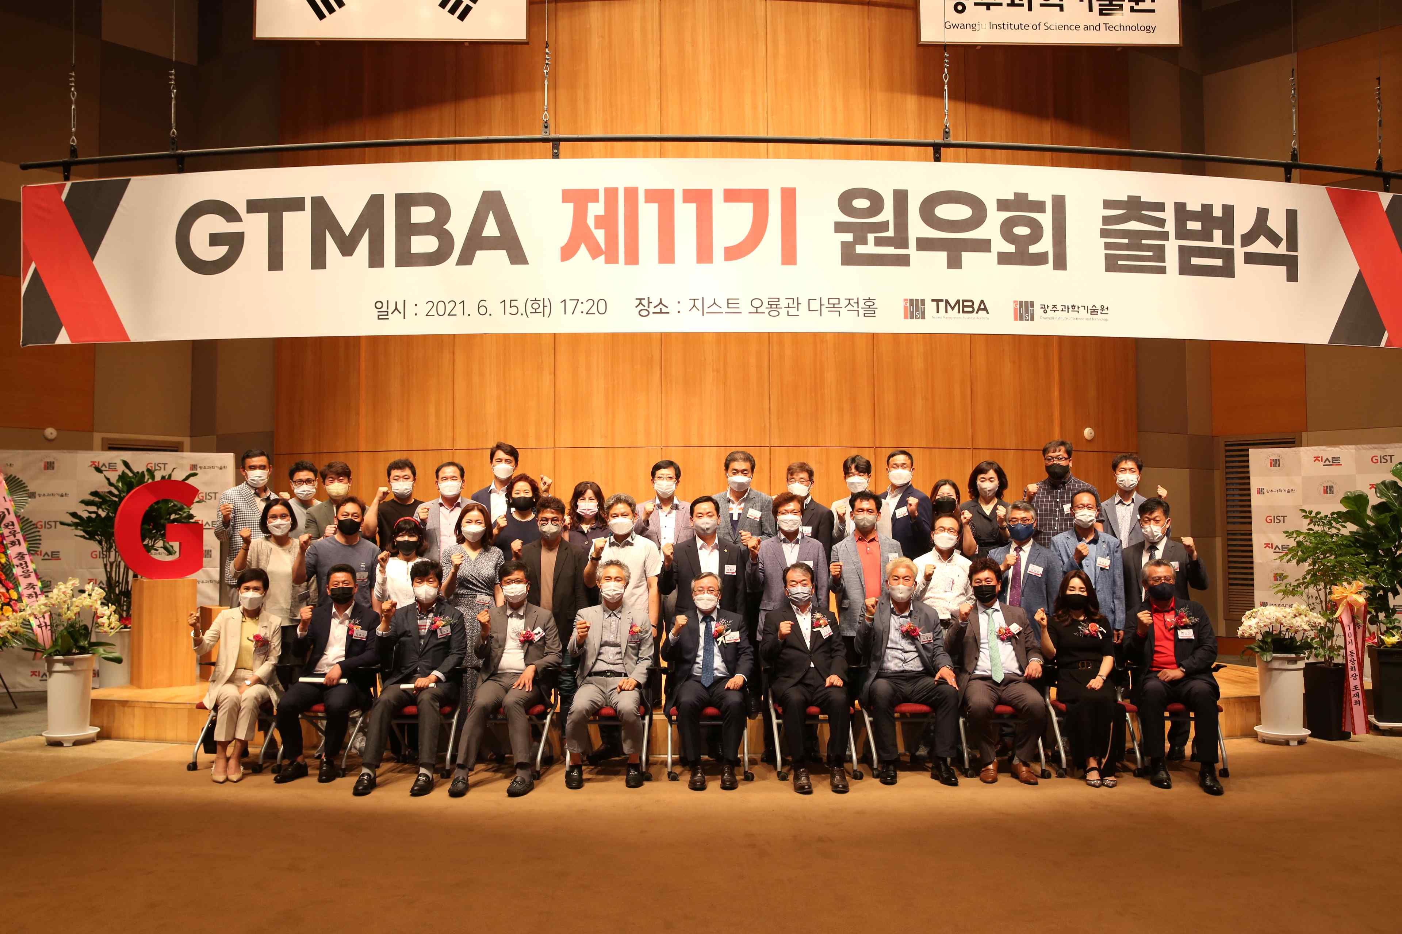
▲ GIST Techno Management Business Academy 11th Alumni Association inaugural ceremony



