
Gwangju Institute of Science and Technology
Official Press Release — https://www.gist.ac.kr

Section of Dongsun Cho Nayeong Lee
Public Relations Section Chief Senior Administrator
062-715-2061 062-715-2062

Contact Person Tae-won Kim, Administrator
for this Article GIST Business Incubator
062-715-6302

Release Date 2021.06.14

GIST nurtures students' dreams of
entrepreneurship with bright ideas

□ GIST (Gwangju Institute of Science and Technology, President Kiseon Kim) held the '2021 Start-up Idea Contest' was held to lead the 4th Industrial Revolution and inspire a healthy start-up culture in the region and on campus.



∘ Starting in 2013, this competition is a student start-up revitalization program that recruits student startup teams through an announcement at the beginning of each year. As a festival-like program to foster a university start-up culture, it was designed with the purpose of allowing freshmen who entered GIST to propose and verify ideas without burdens.

□ Start-up ideas were openly received from GIST undergraduate and graduate students in March, and a total of 23 startup ideas were received by mid-May. After that, the start-up ideas to participate in a presentation review were selected through a document review, and the presentation review was conducted on June 10 to select the final four winners. This year, due to the impact of COVID-19, the screening was conducted through non-face-to-face online presentations.

∘ ▲ The Grand Prize was given for the 'DengDengFit' idea from the student team of Joo-young Hong and Yoon-hwan Kim from the School of Electrical Engineering and Computer Science ▲ the Excellence Award was given to the 'Secondary Traffic Accident Prevention IoT Signage System' from the student team of Hyun Park from the Division of Liberal Arts and Sciences and E-sak Han from the Institute of Integrated Technology ▲ the first Encouragement Award was given for the 'Creative Sharing SNS Platform' from the student team of Kun-ho Lee from the School of Electrical Engineering and Computer Science ▲ the second Encouragement Award was given to 'Shared Artificial Intelligence Learning Dataset Platform' from the student team of Jun-seok Lee from the Institute of Integrated Technology.

□ ▲ ‘DengDengFit’ is an artificial intelligence (AI) dog clothing platform application. It automatically models the dog size with AI and recommends customized products and sizes. ▲ 'Secondary Traffic Accident Prevention IoT Signage System' transmits text messages such as ‘accident’ or ‘access prohibited’ to vehicle signage when a traffic accident occurs and informs the surrounding area using GPS. It is an APP that connects to the National Traffic Information Center and transmits the location and situation. ▲ 'Creative Sharing SNS Platform' is a picture sharing SNS platform that provides users with a new topic every day. It relieves the worries about choosing a subject and provides an opportunity to grow your senses while appreciating other people's pictures. ▲ 'Shared Artificial Intelligence Learning Dataset Platform' is an artificial intelligence dataset integration platform that shares the datasets of each user and induces users to activate their research.

□ Student Joo-young Hong the Grand Prize said, "I probably received a high score for having my skill and technology and for actually starting a business. I am very excited to see how 'DengDengFit' will be realized, and I hope that many people will pay attention and watch the process."

□ By linking various programs that can advance start-up ideas, GIST Sprint for Startup and Innopolis Campus business plan to produce start-up ideas in the form of initial prototypes and provide opportunities to be verified.

∘ In addition, fields related to artificial intelligence (AI) will be linked with start-up programs implemented by Gwangju Metropolitan City and the Artificial Intelligence Industry Convergence Project Group.

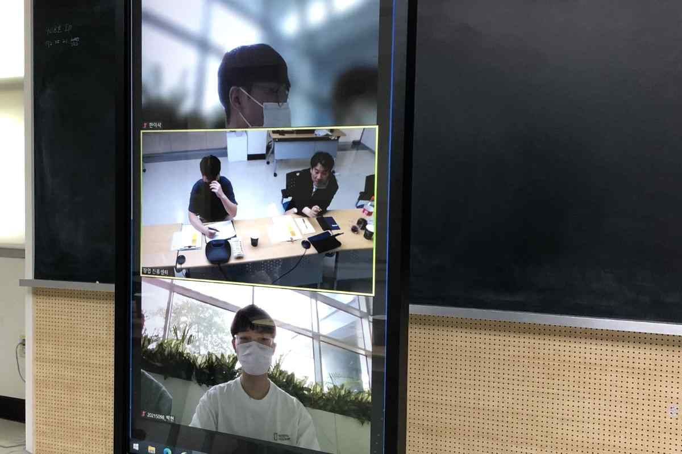
▲ 2021 GIST Start-up Idea Contest



