
Gwangju Institute of Science and Technology
Official Press Release — https://www.gist.ac.kr

Section of Dongsun Cho Nayeong Lee
Public Relations Section Chief Senior Administrator
062-715-2061 062-715-2062

Contact Person Tae-wan Kim, Administrator
for this Article GIST Business Incubator
062-715-6302

Release Date 2021.06.044

GIST College students participate in
Europe's largest global hackathon event

□ GIST (Gwangju Institute of Science and Technology) College students with Shift, a non-profit organization made up of college students with various majors and interests, including college students, has successfully completed the 'Junction X Seoul 2021' hackathon.



∘ The 'Junction X Seoul 2021' hackathon, which marks its third anniversary this year, was the largest ever with a total of 400 people from 25 global countries participating. The event was held for two nights and three days from May 21st (Friday) to 23rd (Sunday) in a non-face-to-face online manner using YouTube live broadcasting, Zoom, and Slack programs in consideration of the global pandemic situation.

□ This event is a successful licensing of Junction, Europe's largest hackathon, and unlike the existing hackathon method, it is characterized by a track-challenge method in which global participants from all over the world freely choose and solve some of the various topics. Each topic was also presented in areas where companies wanted to get fresh ideas.

∘ This year's presentations are ▲ AutoCrypt, 'Barrier-free Mobility', ▲ Microsoft, 'Application for Fusion Teams', ▲ AWS (GameTech), 'Game Changing Games', ▲ SIA (SI Analytics), 'AI and The theme was 'Satelite Imagery' and it consisted of a total of 4 tracks. The final winner went to the Dino team who performed the task AWS GameTech. The Dino team presented a prototype in which game characters on the screen are linked and moved according to the movement of the user during the actual game.

∘ Meanwhile, as a pre-event for the hackathon, global planners, developers, and designers performed team building missions, and as side events, yoga classes, participant interviews, track workshops, and entrepreneurship webinars were held in a 1:1 meeting format. The new event was held and received a high response from the participants.

□ GIST College student Dae-wook Song was in charge of the event and said, "The Junction X Seoul Hackathon event has firmly established itself as Asia's best online hackathon competition as recognized by Finnish staff. Next year, we are planning jointly with the Finnish team, and we look forward to hosting the best hackathon in the world."

□ Shift, a non-profit organization, is an organization created by university (graduate) students with various majors and fields of interest to build a student-centered startup ecosystem. Most of its members have actual startup and startup experience. It was established under the initiative of students Dae-wook Song from the School of Mechanical Engineering, So-yeon Kim from the Department of Chemistry, Jin-woo Kim from the School of Electrical Engineering and Computer Science, Min-seok Kim from the Division of Liberal Arts and Sciences, and students from other universities such as Seoul National University, POSTECH, Ewha Womans University, Konkuk University, and Yonsei University.

∘ Shift aims to become Korea's Aalto Entrepreneurship Society, which benchmarks Finland's AaltoES (a student-led entrepreneurship group at Aalto University), and plans to lead a student-centered startup ecosystem and culture.

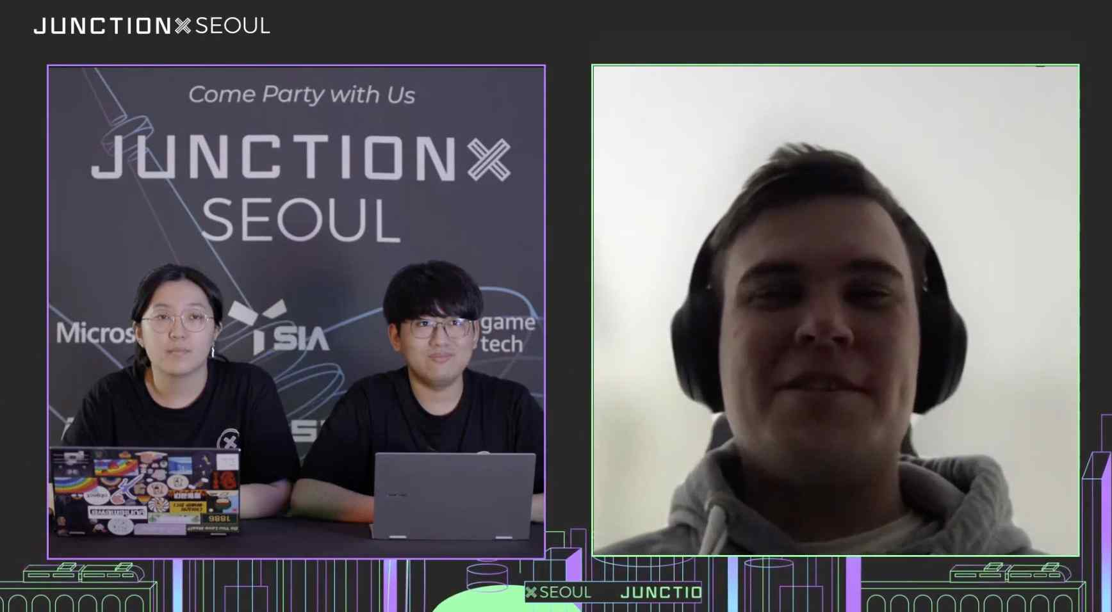
▲ Photo 1: Interview with the winner Dino team

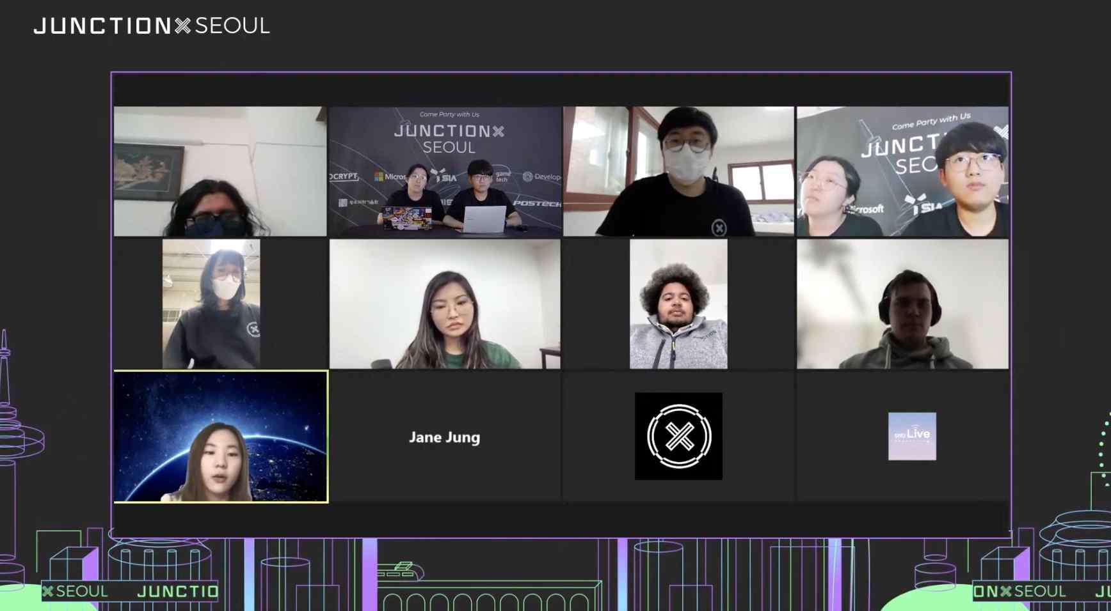
▲ Photo 2: Online Closing Ceremony



