
Gwangju Institute of Science and Technology
Official Press Release — https://www.gist.ac.kr

Section of Dongsun Cho Nayeong Lee
Public Relations Section Chief Senior Administrator
062-715-2061 062-715-2062

Contact Person Myung-eun Lee, Administrator
for this Article GIST Blockchain Internet Economic Research Center
02-523-2997

Release Date 2021.06.03

GIST signs international MoU for
exchange of blockchain experts

□ GIST (Gwangju Institute of Science and Technology) Blockchain Internet Economic Research Center (Director Heung-No Lee) signed a memorandum of understanding with the Swiss Asia Crypto Alliance (SACA), a non-profit organization based in Switzerland for mutual exchange of blockchain experts.



∘ Through the signing of this MOU, the Blockchain Internet Economic Research Center and SACA are expected to benefit each other by collaborating within the Korea-Swiss blockchain ecosystem, including academia, fintech, and banking industries.

□ Based in Switzerland, which has a favorable environment for virtual assets, SACA develops and supports fintech and blockchain companies and ventures in Switzerland and Asia, and strives to bridge the gap.

□ The GIST Blockchain Internet Economic Research Center is constructing a blockchain distributed computer network and conducts technological innovation-type research such as block formation, proof-of-work technology, and transaction speed enhancement technology while discovering new application fields and nurturing talented people.

∘ This research center has developed a new consensus algorithm 'Desecure Blockchain' to solve the problem of re-centralization of virtual asset (Bitcoin, Ethereum, etc.) consensus algorithms since its opening in August 2018. program was calculated. Several related technical papers were published and a total of four domestic applications were filed.

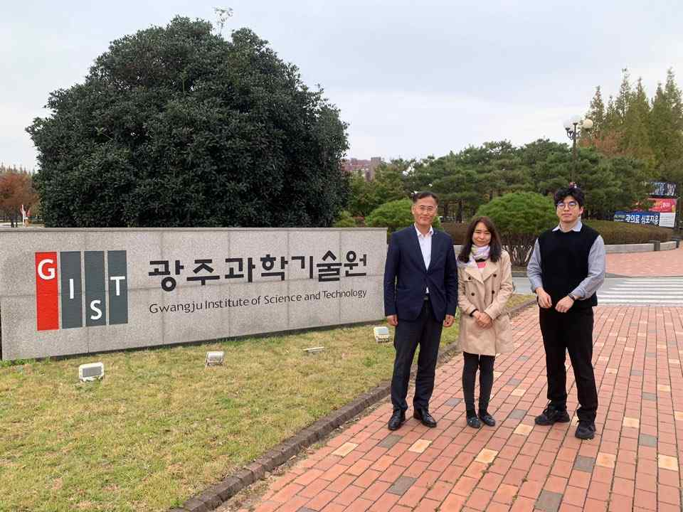
▲ From left, Blockchain Internet Economic Research Center
Director Heung-No Lee and SACA CEO Joo-hee Lee



