
Gwangju Institute of Science and Technology
Official Press Release — https://www.gist.ac.kr

Section of Dongsun Cho Nayeong Lee
Public Relations Section Chief Senior Administrator
062-715-2061 062-715-2062

Contact Person Anna Kim, Administrator
for this Article Korea Culture Technology Institute
062-715-4922

Release Date 2021.06.02

Korea Culture Technology Institute will exhibit 'Water Has Memory' at the Busan Museum of Modern Art

□ GIST (Gwangju Institute of Science and Technology) Korea Culture Technology Institute (Director Moongu Jeon) research team (Research Director Anna Kim) will exhibit 'Water Has Memory,' which deals with microplastics, in the special exhibition 'Sustainable Art Museum: Art and the Environment' at the Busan Museum of Modern Art.



∘ The research team developed a participatory interactive storytelling work that uses natural language-generated artificial intelligence to make the audience a solution to future marine environmental problems to raise public awareness of microplastic pollution. About 60 domestic and foreign artists and related organizations will participate in the exhibition, and about 90 works will be exhibited, which is expected to serve as a venue for various opinions on the ecological environment.

□ Starting from the Anthropocene worldview that active human interest and participation is required to resolve these changes, the eco-environment exhibition at the Busan Museum of Modern Art shows that humans have a clear influence on the change of the ecological environment.

∘ For this purpose, all activities including production, packaging, transportation, installation, and demolition of works are carried out in accordance with eco-friendly practices. In addition, in order to minimize exhibition waste, the use of paint and sheet paper is restricted without the use of plaster walls, and various efforts will be made to practice “Zero Waste” by using recycled paper for promotional prints.

∘ This exhibition will be held free of charge until September 22, and due to COVID-19 precautions, visitors must make a reservation one day in advance through the Busan City Integrated Reservation System to attend.

□ Korea Culture Technology Institute Director Moongu Jeon said, "This work is meaningful to relate the dangers of microplastic pollution to mankind by applying artificial intelligence technology to media art by our research institute. In the future, we plan to focus on research and various artistic activities with interest in the environmental and social issues facing modern humans."

□ GIST Korea Research Institute of Culture and Technology carried out not only cultural technology research and development policy-designated tasks, but also science and culture exhibition service reinforcement support projects and convergence art creation support cooperative planning projects. Recently, through the development of artificial intelligence real-time media façade mapping technology, it is conducting research and development of cultural technology to utilize it in a number of performances and exhibition contents and to lead the development of the national cultural industry.

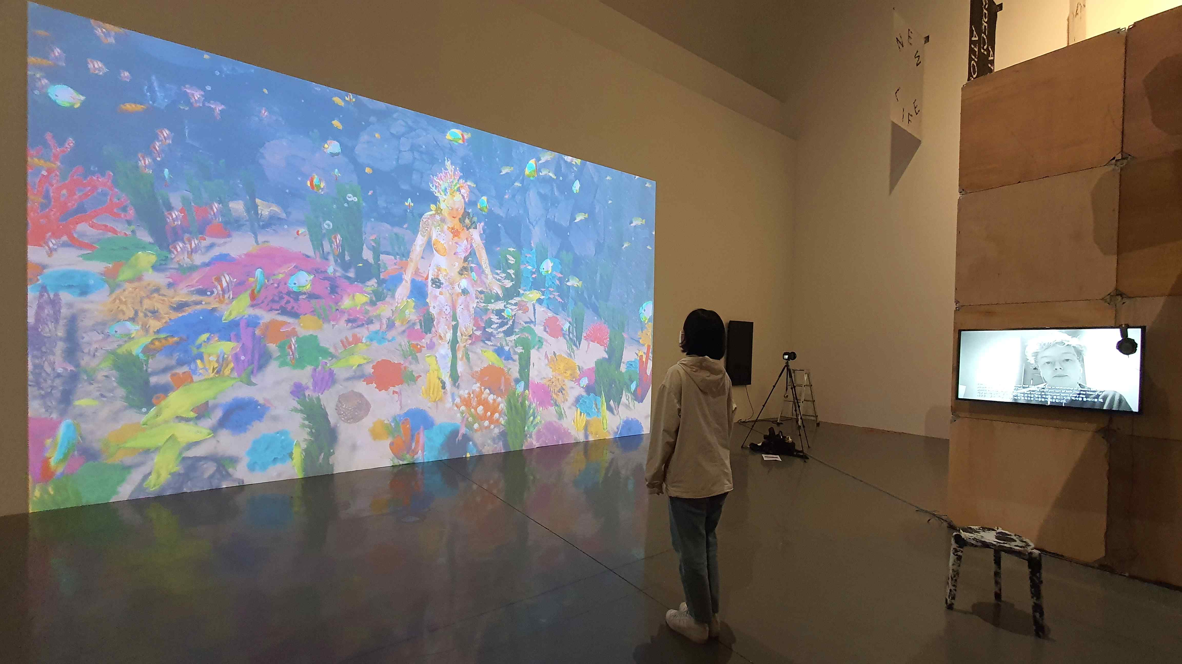
▲ 2021 'Water Has Memory' exhibition



