
Gwangju Institute of Science and Technology
Official Press Release — https://www.gist.ac.kr

Section of Dongsun Cho Nayeong Lee
Public Relations Section Chief Senior Administrator
062-715-2061 062-715-2062

Contact Person Kyu-rang Lee, Administrator
for this Article GIST Academy
062-715-2623

Release Date 2021.05.31

GIST Academy, 'Importance of Green Chemistry (ZEST)'

□ GIST (Gwangju Institute of Science and Technology) Academy held the May Breakfast Forum under the theme of 'The Importance of Green Chemistry (ZEST)' in Oryong Hall on May 31 with about 40 company representative from Gwangju and Jeonnam in attendance.



□ The forum was held with a special lecture by GIST School of Earth Science and Environmental Engineering Professor Jaeyoung Lee anpit the reaction process for production and separation technology raw materials, solvents, and it attracted great attention by explaining the periodic processes of chemical products as targets for improvement, ranging from catalysts and their own harmfulness to product decomposition and resulting human body and environmental hazards.

∘ Professor Lee said, "If the concept of green chemistry is more actively reflected, the government should take the lead in minimizing environmental harmful substances emissions from the R&D stage. Science and technology that does not emit any pollutants should be applied from the R&D stage."

∘ Furthermore, "Jeollanam-do is a region where both the petrochemical industry and the steel industry, which have driven the Korean economy, exist, so it is necessary to focus on the management of environmentally hazardous substances. A new research institute that can enhance the domestic industrial development performance of the Green New Deal and the competitiveness of overseas expansion should be launched from the perspective of a regionally balanced New Deal."

□ The GIST Academy Breakfast Forum provides opportunities for awareness of innovations, technology transfer, and industry-university cooperation through lectures by experts from various fields on the last Monday of every month for alumni of the academy and executives of local companies.

∘ GIST Academy is operating two courses: GIST Technology Management Academy (opened in 2010) and GIST Climate Change Academy (opened in 2016). Business environment and global management strategies are provided by managers in each field through lectures from the best experts in Korea. It is contributing to the vitalization of the local economy and industry-university cooperation by cultivating a sense of culture and forming a wide human network.

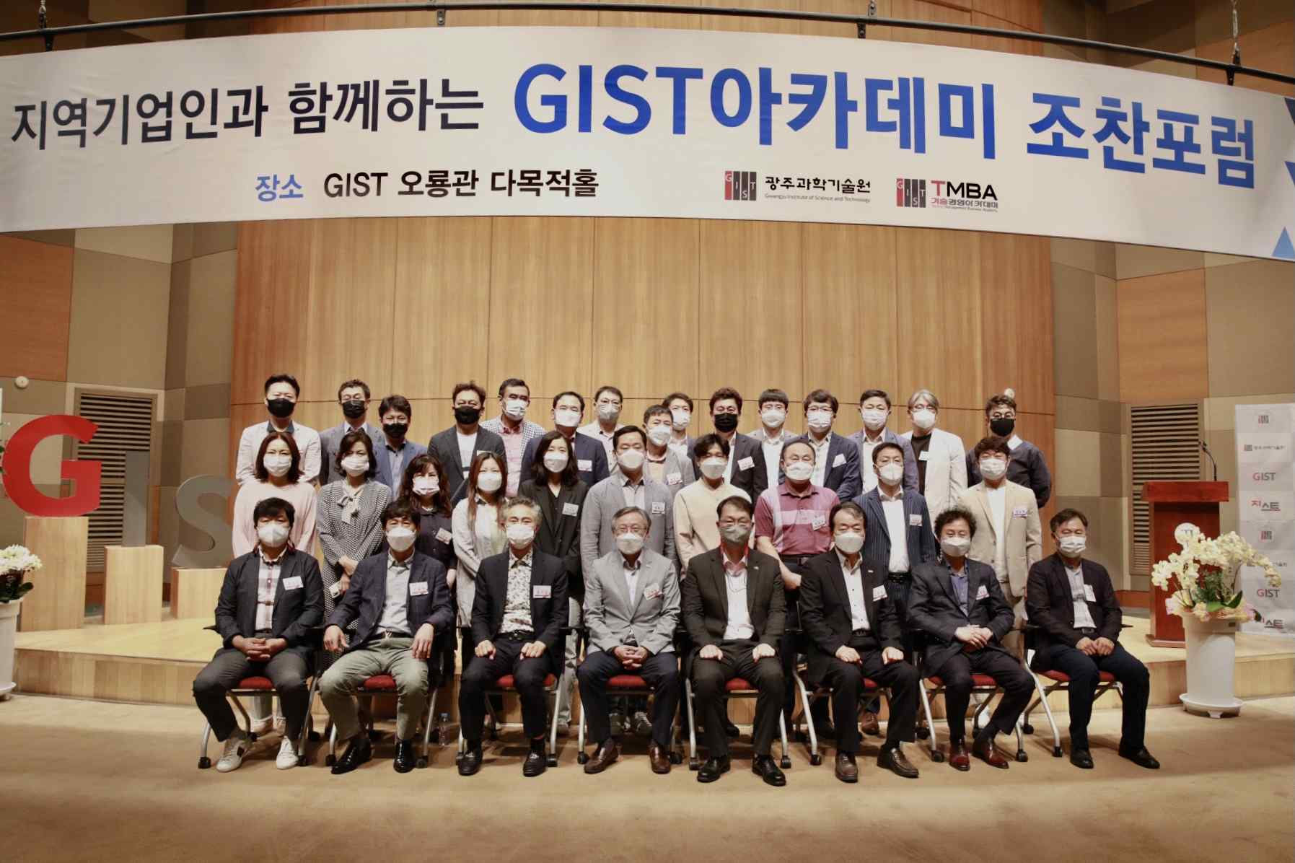
▲ GIST Academy May Breakfast Forum



