
Gwangju Institute of Science and Technology
Official Press Release — https://www.gist.ac.kr

Section of Dongsun Cho Nayeong Lee
Public Relations Section Chief Senior Administrator
062-715-2061 062-715-2062

Contact Person Young-hyun Joo, Administrator
for this Article Section of Planning
026-715-2978

Release Date 2021.05.27

GIST holds "The 1st KU-GIST Symposium" with Korea University for future social innovations

□ GIST (Gwangju Institute of Science and Technology, Acting-President In S. Kim) and Korea University (President Jin-taek Jeong) are considering the role of universities in our society for the post-corona/new-normal era and are seeking a new strategic partnership that transcends regions (metropolitan area/non-metropolitan area) and scale (university/specialized university).



∘ The two organizations signed an agreement last year to establish a comprehensive partnership. Since then, future innovation committees have been established at both schools, and efforts have been made to derive specific and substantive cooperation plans through mutual cooperation.

□ Through the activities of the Future Innovation Committee, both schools will cooperate with each other regarding ▲ faculty exchanges ▲ student and credit exchanges ▲ opening joint courses online ▲ opening a joint comparative department program ▲ participation in overseas exchange programs ▲ joint research in the fields of artificial intelligence (AI), data science (DS), and biomedical science ▲ joint research with overseas universities.

∘ As a result, from the second semester of this year, exchanges between teachers from both schools will begin. Through this, the plan is to create synergy between education and research by maximizing the unique characteristics of both schools.

□ The KU-GIST Symposium was held at Korea University on May 28 as the first step towards building a practical cooperative relationship. This symposium, which will broaden the scope of exchanges between the two universities, was held under the theme of 'KU-GIST Symposium for Innovative Materials,' and a total of 8 speakers, 4 from both schools, gave presentations.

∘ The first part of the symposium was hosted by Korea University KU-KIST Graduate School of Convergence Professor Gun-wook Wang, Korea University Professor Seok-won Hwang gave a presentation on 'soft, resorbable bioelectronics,' GIST Professor Jaeyoung Lee gave a presentation on 'graphene-incorporated hydrogels as new functional biomaterials,' Korea University Professor Cheol-Ho Lee gave a presentation on 'energy band engineering in 2D semiconductor heterojunctions,' and GIST Professor Sanghan Lee gave a presentation on 'photoelectrodes for efficient photoelectrochemical water splitting.'

▲ Korea University KU-KIST Graduate School of Convergence Professor Seok-won Hwang started the first presentation under the theme of 'soft, resorbable bioelectronics.' Professor Hwang expected that mechanically flexible, soluble and absorbable electronic systems can combine with the body to obtain meaningful information in various forms and provide new directions for various issues that existing biometric devices could not solve.

▲ GIST Professor Jaeyoung Lee presented research results on 'ene-incorporated hydrogels as new functional biomaterial,' which transcended the limits of the characteristics of hydrogels widely used in biomedical engineering and adding new important functions. Professor Lee developed a functional hydrogel in which graphene has new functions such as drug delivery, antioxidant properties, electrical conductivity, and high elasticity by controlling the dispersion, chemical state, and interconnectivity in the biopolymer hydrogel. He explained that it could make a great contribution to treatment and tissue regeneration.

▲ Korea University KU-KIST Graduate School of Convergence Professor Cheol-Ho Lee gave a presentation on the application of 2D semiconductor materials and devices, which are attracting attention as next-generation nanomaterials, under the topic of 'energy band engineering in 2D semiconductor heterojunctions.' Professor Lee had time to explain about band engineering technology in atomic-thick semiconductor heterojunctions and applications of ultra-low power, high-performance electronic devices and optoelectronic devices using this technology.

▲ GIST Professor Sanghan Lee, under the theme of 'photoelectrodes for efficient photoelectrochemical water splitting,' demonstrated that photoelectrolytes for efficient photoelectrochemical decomposition can increase hydrogen production efficiency if photoplasts for hydrogen production are manufactured in a specific crystal direction. Therefore, he emphasized that high-efficiency hydrogen production can be expected if photovoltaics are produced in a crystal direction suitable for each material.

∘ The second half of the symposium was hosted by GIST School of Materials Science and Engineering Professor Bong Joong Kim, Korea University Professor Myung-ki Kim gave a presentation on 'printable nanophotonics,' GIST Professor Chang Hyuck Choi gave a presentation on 'electrical double layer engineering for tailoring electrocatalysis,' Korea University Professor Yong-Joo Kim gave a presentation on 'supramolecular chemical biology with synthetic self-assembled systems,' and GIST Professor Seung Joon Yoo gave a presentation on 'enhancing the performance of supercapacitors with redox-active electrolytes.'

▲ Korea University KU-KIST Graduate School of Convergence Professor Professor Myung-ki Kim presented the topic of 'printable nanophotonics' where the development of chip-scale optical integrated circuits for large-scale data processing is emerging due to the rapid growth of video streaming and artificial intelligence. Explaining the background that very small nano-optical devices are essential, he said that commercialization in related fields is slow due to the lack of a technology that can selectively implant nano-optical devices in spaces that currently require them. Professor Kim presented the current status of the development of selective printable nanophotonics and explored the path for nanophotonics in the future.

▲ GIST Professor Chang Hyuck Choi gave a presentation on 'electrical double layer engineering for tailoring electrocatalysis,' observing changes in the catalytic reaction according to the structural change of the electric double layer in which the electrochemical reaction takes place and suggesting various strategies to control it

▲ Korea University KU-KIST Graduate School of Convergence Professor Yong-Joo Kim gave a presentation on 'supramolecular chemical biology with synthetic self-assembled systems' and revealed that a system made by self-assembly of molecules plays an important role in life phenomena and implemented various self-assembly systems based on synthetic molecules and convergence research with life sciences.

▲ GIST Professor Seung Joon Yoo explained high-capacity redox super that uses a faradaic energy storage mechanism by oxidation/reduction reaction of liquid electrolyte as the main energy storage source in addition to electric double layer capacitance to solve the problems of existing energy storage systems. Capacitors noticed the development. In his presentation, under the topic of 'enhancing the performance of supercapacitors with redox-active electrolytes,' in particular, redox supercapacitors are introduced in general, and the correlation between redox active electrolytes and porous electrodes to further improve redox supercapacitor performance. While explaining the research to identify the relationship, the core guidelines for the development of next-generation hybrid capacitors were presented.

□ GIST Acting-President In S. Kim said, "Through science and technology, we will lead social contributions through regional development and national innovation, reflecting changing social conditions due to COVID-19, and we will consider future social universities and education innovation together, and draw concrete and practical cooperation plans through mutual cooperation. The symposium is expected to be a new attempt at strategic cooperation to present a new paradigm for university education that pushes the boundaries of region and size."

□ Korea University President Jin-taek Jeong said, "As non-face-to-face education methods such as online lectures are rapidly spreading due to the COVID-19 pandemic, qualitative changes are required beyond the existing framework and limitations of university education. Korea University has established and operated the Next Normal Committee to lead this era change, presenting examples and standards throughout university education, research and administration, and fulfilling its national and contemporary mission. Today's symposium will be the first step in the process of the two institutions working together to respond innovatively to these changes and find a future-oriented university."

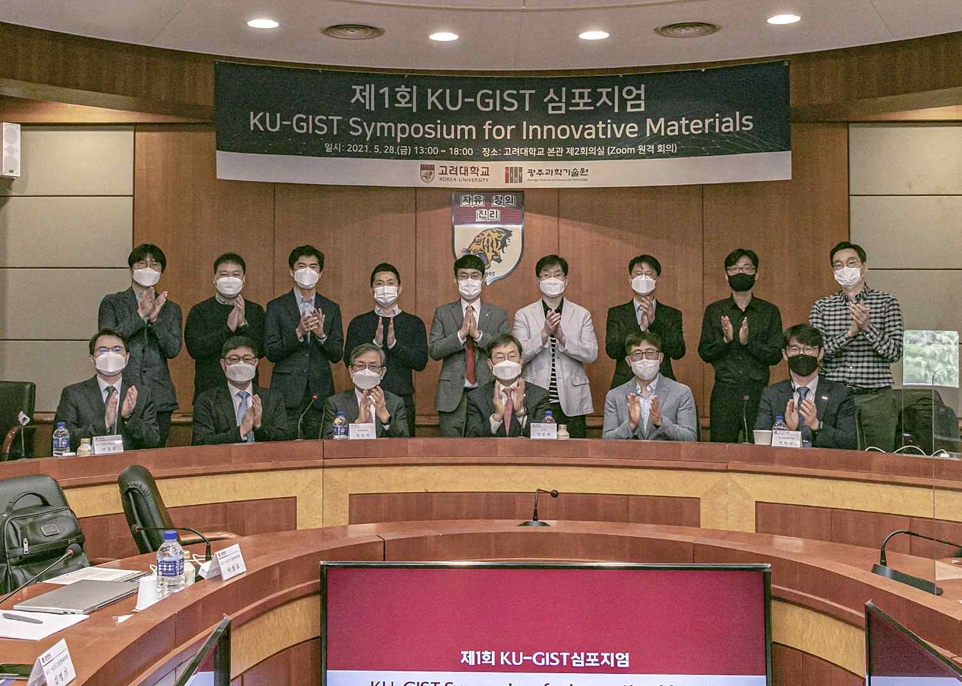
▲ From left in the front row: Korea University Planning and Budget Office Director Gil-soo Jang, Korea University KU-KIST Convergence Graduate School Dean Dong-joon Ahn, Korea University Vice President Jin-hee Yoo and Chair of the KU-GIST Future Innovation Committee, Korea University President Jin-taek Jeong, GIST School of Materials Science and Engineering Dean Inchan Kwon, and GIST Office of Planning Dean Myung-Han Yoon

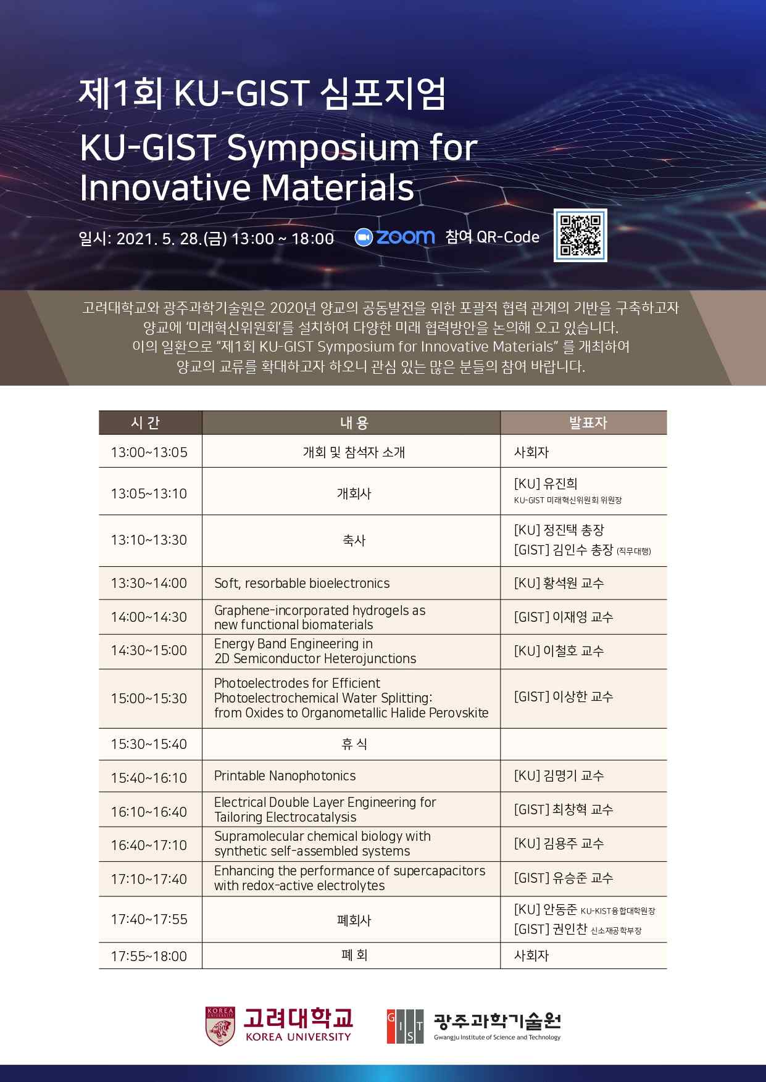
▲ KU-GIST Symposium poster



