
Gwangju Institute of Science and Technology
Official Press Release — https://www.gist.ac.kr

Section of Dongsun Cho Nayeong Lee
Public Relations Section Chief Senior Administrator
062-715-2061 062-715-2062

Contact Person Jisoo Moon, Administrator
for this Article Section of International Relations
062-715-6256

Release Date 2021.05.27

GIST holds various events for
foreign families during Family Month

□ GIST (Gwangju Institute of Science and Technology) celebrated Family Month in May by distributing traditional craft kits consisting of fans, kites, and refreshments to families of foreign members living on campus to help them learn about traditional Korean culture and to experience crafts.



∘ A total of 30 children from foreign families participated in this event and experienced Korea's traditional culture by making a Korean stingray fan. In addition, three winning works were selected and awarded among participants who submitted photos of their experience activities.

□ Ahmad Rathore of Pakistan participated in the event and said, "Flying a kite with my family helped me a lot in understanding Korean traditional culture. In the future, I really want to participate in events that I can do with my family."

□ This Family Day event for foreigners was based on the results of the 'GIST Domestic and Foreign Member Survey,' which was conducted in February with about 600 respondents from GIST-affiliated multinational laboratories, and was prepared to reflect the wishes of many members.

∘ Due to the high level of satisfaction from this event, a Korea culture quiz about 'How much do you know about Korea?' was held for foreign members on May 28 to enhance their understanding of Korean culture. GIST will continue to promote a global mindset among students.

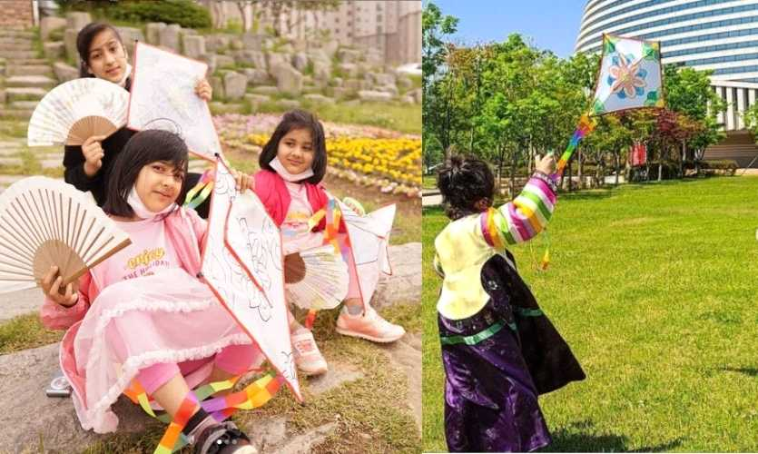
▲ Contest winners of the GIST Foreign Family Day event



