
Gwangju Institute of Science and Technology
Official Press Release — https://www.gist.ac.kr

Section of Dongsun Cho Nayeong Lee
Public Relations Section Chief Senior Administrator
062-715-2061 062-715-2062

Contact Person Deuk-jo Gong, Senior Researcher
for this Article Institute for Artificial Intelligence
062-715-2934

Release Date 2021.05.21

GIST selected as K-digital business operating organization

□ GIST (Gwangju Institute of Science and Technology) was selected as the operator of the K-Digital Platform, Training, and Credit projects organized by the Ministry of Employment and Labor in 2021.

∘ GIST will expand its connections with various industries such as finance and blockchain to train digital convergence specialists.



□ In 2021, K-Digital Platform, organized by the Ministry of Employment and Labor, is a project to support the establishment of digital new technology facilities for joint training centers, and GIST plans to provide customized education and support to local companies for five years.

∘ K-Digital Training, Credit is a project to train workers with basic digital skills through innovative technologies and training methods. GIST will train 90 per year in business and 2,000 specialists a year through the credit business and provide internships and employment in connection with CJ OliveNetworks, Megazone Cloud, Dream Ace, and Artificial Intelligence Association.

□ GIST Institute for Artificial Intelligence Director Heung-No Lee said, "Through this AI+X education field, we have stepped closer to our vision of a smart inclusive society. We will do our best to develop artificial intelligence and train working-level specialists."

□ Meanwhile, GIST Institute for Artificial Intelligence successfully completed the 'Dreaming Child (AI)' education contest last year to nurture AI startup specialists. This year, it plans to focus on operating programs to cultivate artificial intelligence professionals and promote international joint research and cooperation projects in the field of AI.

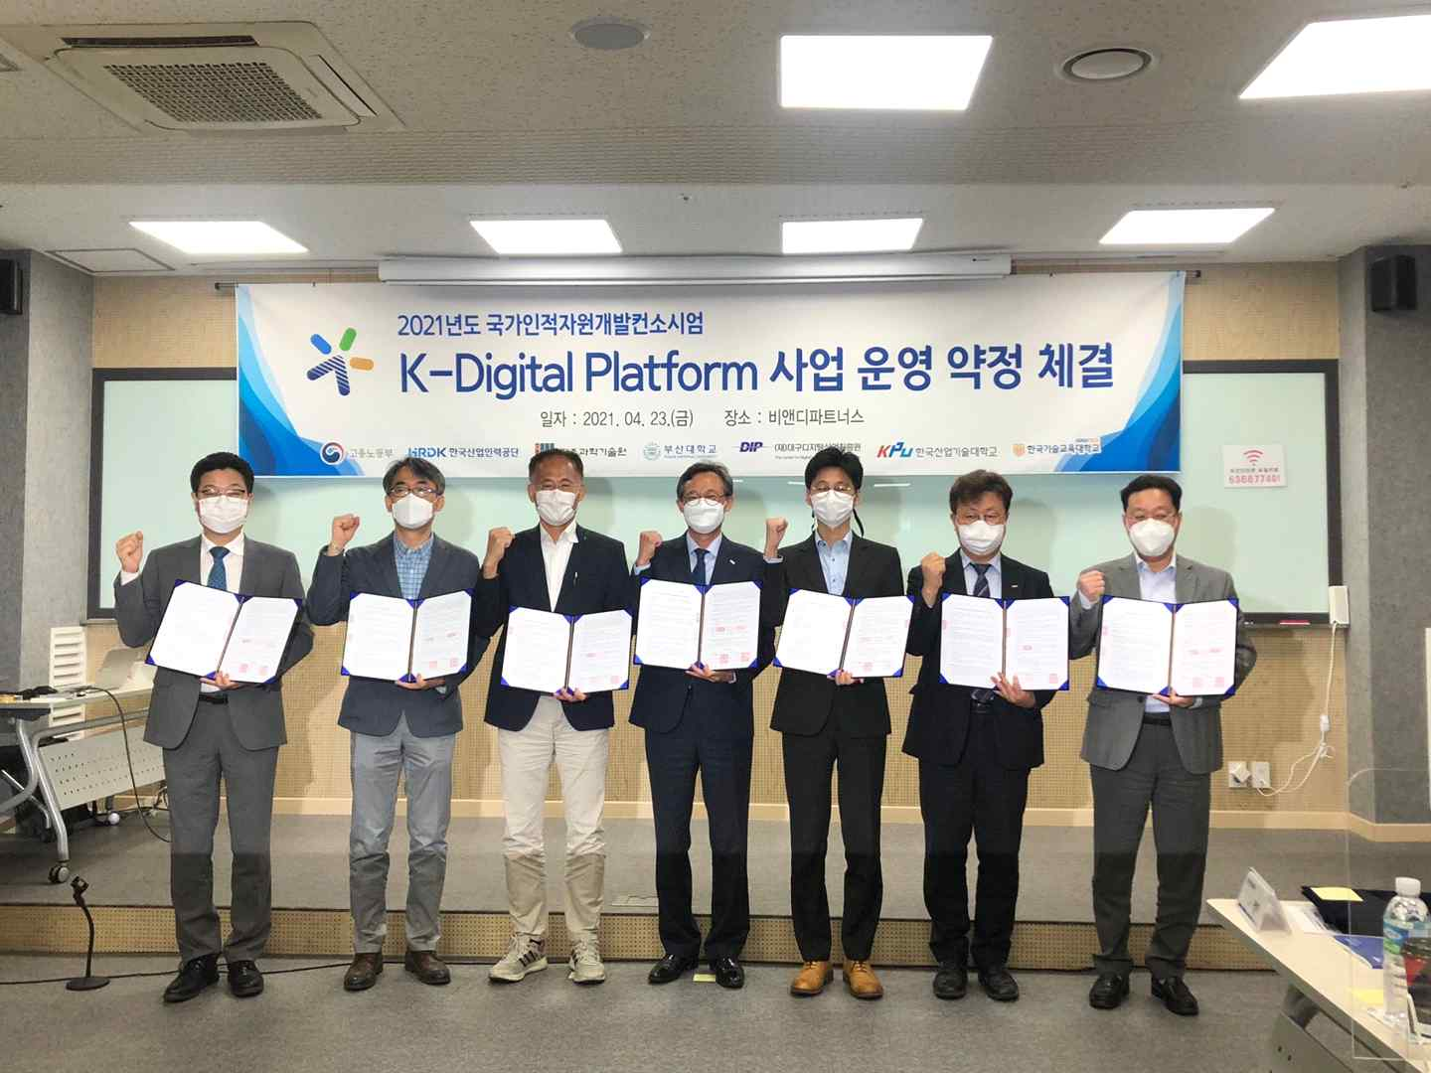
▲ Photo of the 2021 K-Digital Platform project organized by the Ministry of Employment and Labor



