
Gwangju Institute of Science and Technology
Official Press Release — https://www.gist.ac.kr

Section of Dongsun Cho Nayeong Lee
Public Relations Section Chief Senior Administrator
062-715-2061 062-715-2062

Contact Person Kyung-min Lee, Administrator
for this Article Energy Valley Institute of Technology
062-715-6971

Release Date 2021.05.12

GIST Energy Valley Institute of Technology hosts
KEPCO's 2021 Electric Data AI Competition

□ GIST (Gwangju Institute of Science and Technology) Energy Valley Institute of Technology (Director Kwanghee Lee) will hold the 2021 Electric Data AI Competition (new service development contest using power data).



∘ The 2021 Electric Data AI Competition (abbreviated 2021 EDACOM), hosted by the Ministry of Trade, Industry and Energy and jointly organized by GIST, KEPCO, and the Electric Power Group Company, is aimed at discovering a new business model that utilizes electric power big data. It will be held at the KEPCO Art Center in Seocho-dong, Seoul on Thursday, August 26th.

□ This competition is to discover new convergence services for the Korea Institute of Energy Technology Evaluation and Development, a new industry BM and service development and verification research project using electric power big data (research director: Professor Hee-ju Kim of Graduate School of Energy Convergence). It is held as part of realizing the commercialization of the business model.

□ The competition is at GIST to discover new convergence services for the Korea Institute of Energy Technology Evaluation and Development and is held as a part of discovering new convergence services for new industrial BM and service development and verification research projects using electric power big data (research manager: Professor Heeju Kim of Graduate School of Energy Convergence) and commercializing new business models.

∘ The competition schedule will be application submission (4.15~6.14) → document review (6.21~6.22) → data provision and service development (6.25~8.23) → final review and award (8.26).

□ It is divided into companies and individual (student) sectors, and teams or individuals who pass the first document screening use the provided power data to develop services. If data cannot be taken out, it can be developed at the data sharing center set up at KEPCO Art Center.

□ GIST Energy Valley Institute of Technology Director Kwanghee Lee (School of Materials Science and Engineering) said, "We hope that this competition will contribute to raising public interest in the use of power data, and we hope that it will contribute to revitalizing the new energy industry through the development of new energy services in the power field in the future."

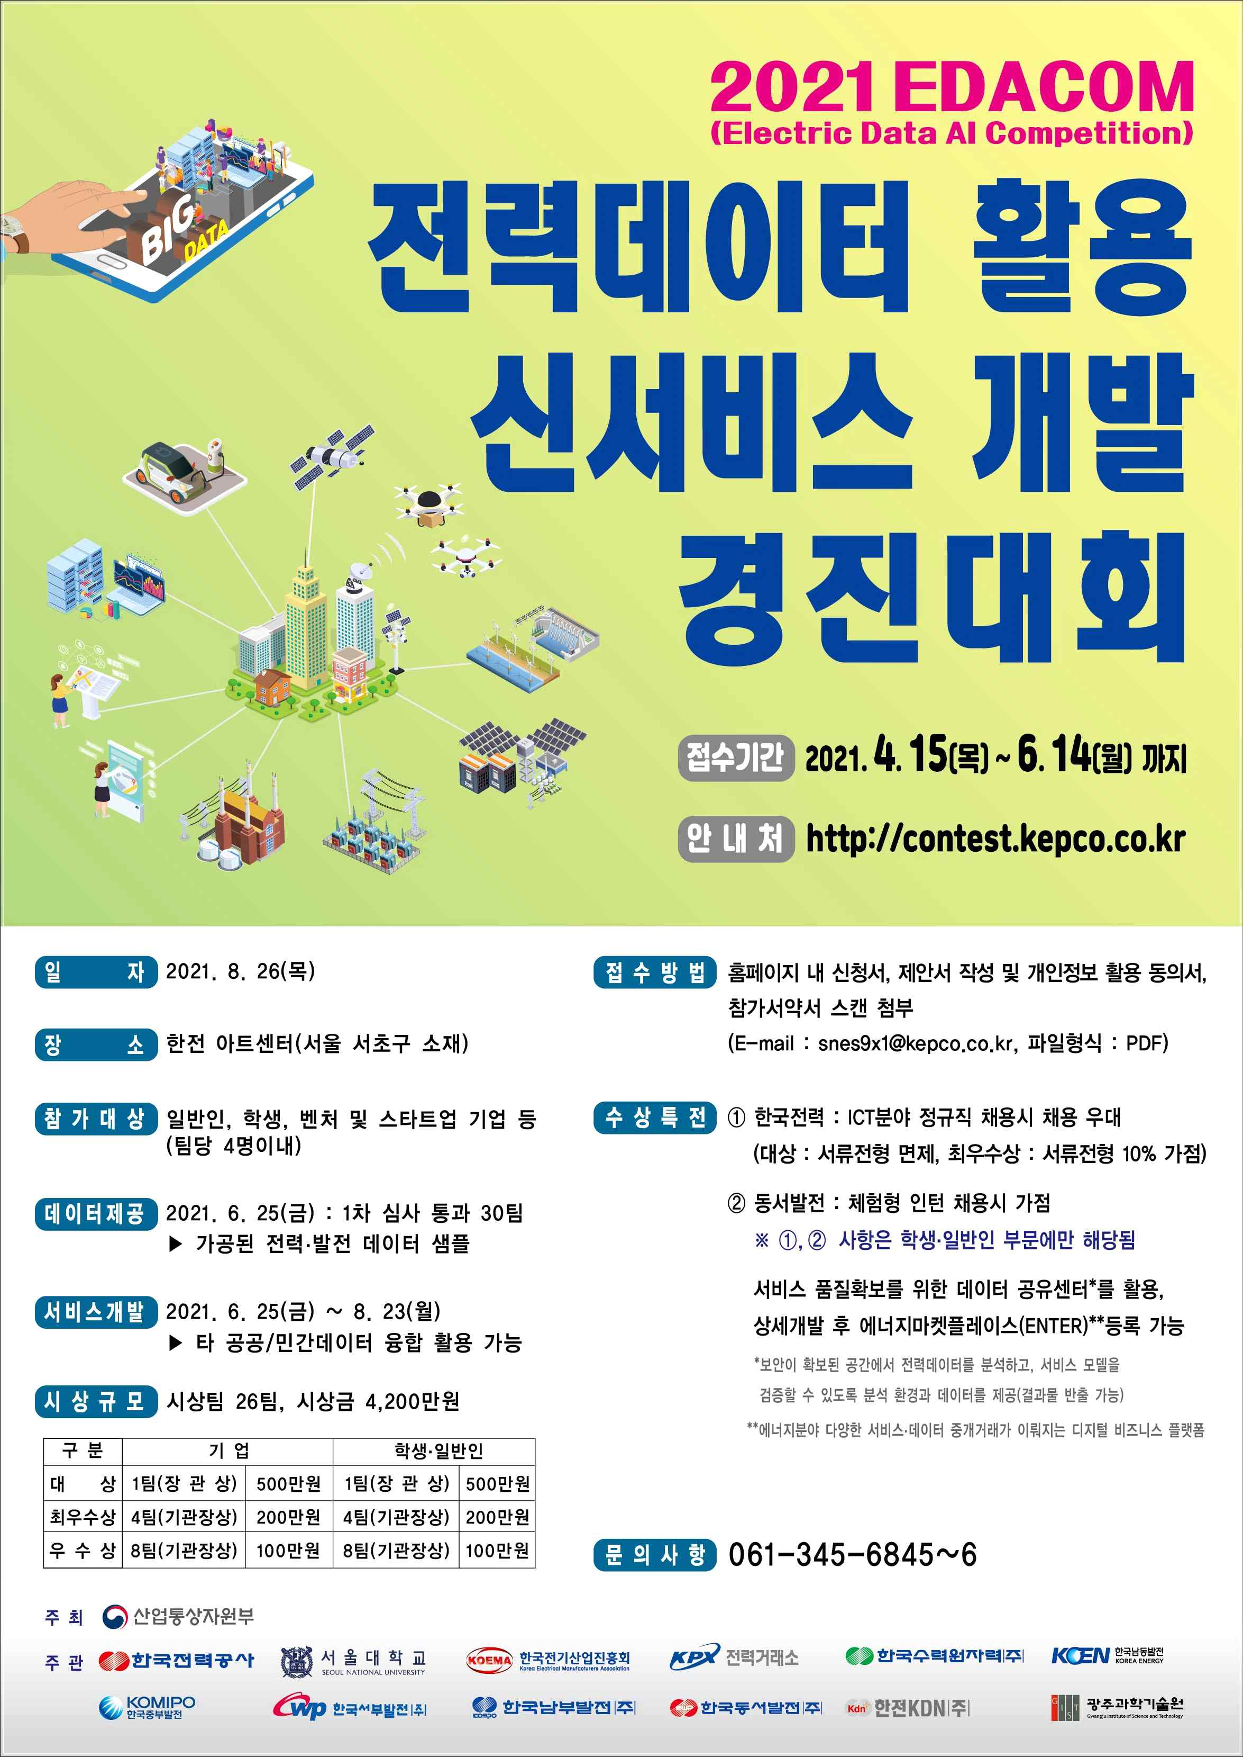
▲ 2021 Electric Data AI Competition poster



