
Gwangju Institute of Science and Technology
Official Press Release — https://www.gist.ac.kr

Section of Dongsun Cho Nayeong Lee
Public Relations Section Chief Senior Administrator
062-715-2061 062-715-2062

Contact Person Soo-jeong Shin, Administrator
for this Article GIST Academy
062-715-2624

Release Date 2021.04.26

GIST Climate Change Academy (GCCA) multi-faceted
efforts to counter the climate crisis

□ GIST (Gwangju Institute of Science and Technology) Climate Change Academy (GCCA) held a special lecture on the theme of the climate crisis and the era of transition as well as a special exhibition on the climate crisis in order to recognize the seriousness of the global climate crisis and understand how to respond to global warming.



□ International Climate and Environment Center CEO Won-tae Yoon, a global climate change expert, was invited to discuss the seriousness of the global climate crisis and ways to solve the climate environment problem under the theme of climate crisis and transition.

∘ CEO Yoon pointed out environmental climate change and the resulting crisis for humanity and emphasized the need to move away from the economic structure of fossil fuel production and consumption and the the need to create a new normal during the transition process.

∘ In particular, in response to the changed climate environment, he mentioned that the establishment of a system to proactively respond to climate disasters from follow-up to proactive prediction is needed.

□ In addition, the GIST Climate Change Academy met at the Gwangju National Science Museum to watch and experience their carbon footprint and learn how to cope with climate change, starting with the warning of the earth through a special exhibition (Climate Crisis, Act Now), audio-visual space, extinct animal and plant specimens, solar and wind energy exhibits, and carbon gas collection experience.

□ GIST Academy President Young-jip Kim (Vice President for Public Affairs) said, "Climate change adaptation and carbon neutrality are essential elements for the survival of humanity, and it is a time when nation-wide empathy and action to respond positively to such changes are needed more than ever. GIST will continue to strive to create new economic opportunities that will drive eco-friendly green growth by responding to climate change."

□ In December 2015, the GIST Climate Change Academy (GCCA) opened the fourth GIST Climate Change Academy (GCCA) to foster 21st-century experts who can understand and preemptively respond to various future societal problems in line with the Paris Climate Change Convention.

∘ Through regular lectures and GCCA courses, which are held every Wednesday at 7 p.m., opinion leaders from all walks of life, including governments, public institutions, and corporations, provide information on the latest industrial technologies necessary for the business environment as well as a wide human network.

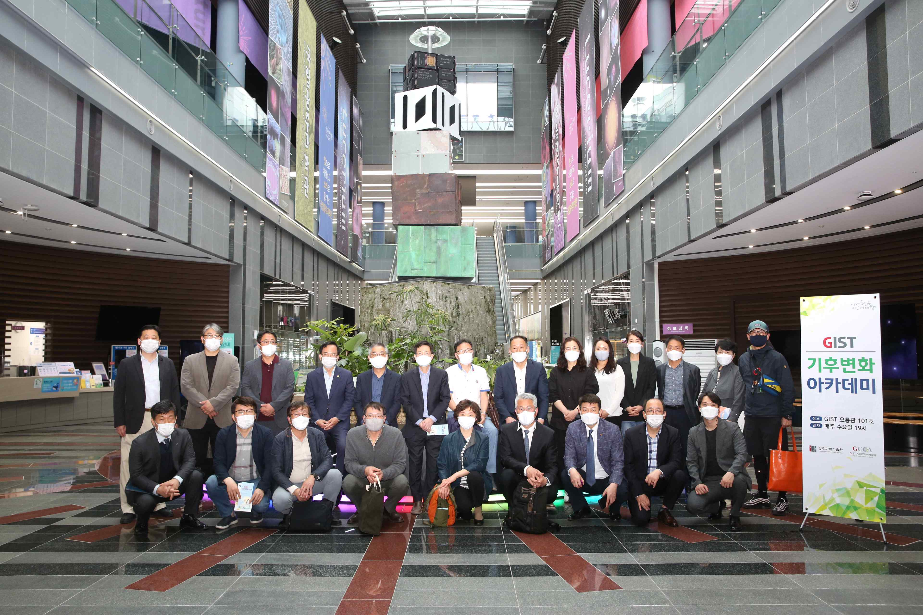
▲ GIST Climate Change Academy: Special Lecture on Climate Crisis
and Transition Period and Special Exhibition on Climate Crisis



