
Gwangju Institute of Science and Technology
Official Press Release — https://www.gist.ac.kr

Section of Dongsun Cho Nayeong Lee
Public Relations Section Chief Senior Administrator
062-715-2061 062-715-2062

Contact Person Gyu-rang Lee, Administrator
for this Article GIST Academy
062-715-2023

Release Date 2021.04.26

GIST Academy holds 'Convergence of Digital
and Content' breakfast forum in April

□ GIST (Gwangju Institute of Science and Technology) Academy hosted a breakfast forum with the theme of'Changes that Realistic Content Technology Brings' on April 26, 2021, at Oryong Hall with about 50 representative companies from the Gwangju-Jeonnam region in attendance.



□ The forum was held with a special lecture by District Holdings Co., Ltd., CEO Sung-ho Lee, which drew keen attention as digital content that breaks down art and commercial boundaries by presenting a virtual innovative space using digital media technology.

∘ CEO Lee emphasized that design trends will solve the problem of space as the environment of digital media platforms such as virtual reality, 3D stereoscopic images, and holograms changes, and the 'virtual experience' that completely replaces human senses will be advanced in the future.

∘ In addition, he mentioned that real experiences through realistic media technology is replaced by virtual experience, and convergence with other technologies such as brain medicine, wearable devices, robotics, and artificial intelligence is expected as a technology utility that lowers the social cost of the experience.

□ The GIST Academy Breakfast Forum provides opportunities for innovation, technology transfers, and industry-academia cooperation through lectures by experts from various fields to alumni and executives of local companies on the last Monday of every month.

∘ GIST Academy operates two courses: GIST Techno Management Business Academy (opened in 2010) and GIST Climate Change Academy (opened in 2016). Managers in each field contribute to revitalizing the regional economy and industry-academia cooperation by cultivating a corporate environment, a global management strategy, and a sense of culture through lectures by the best experts in Korea, and by forming a wide human network.

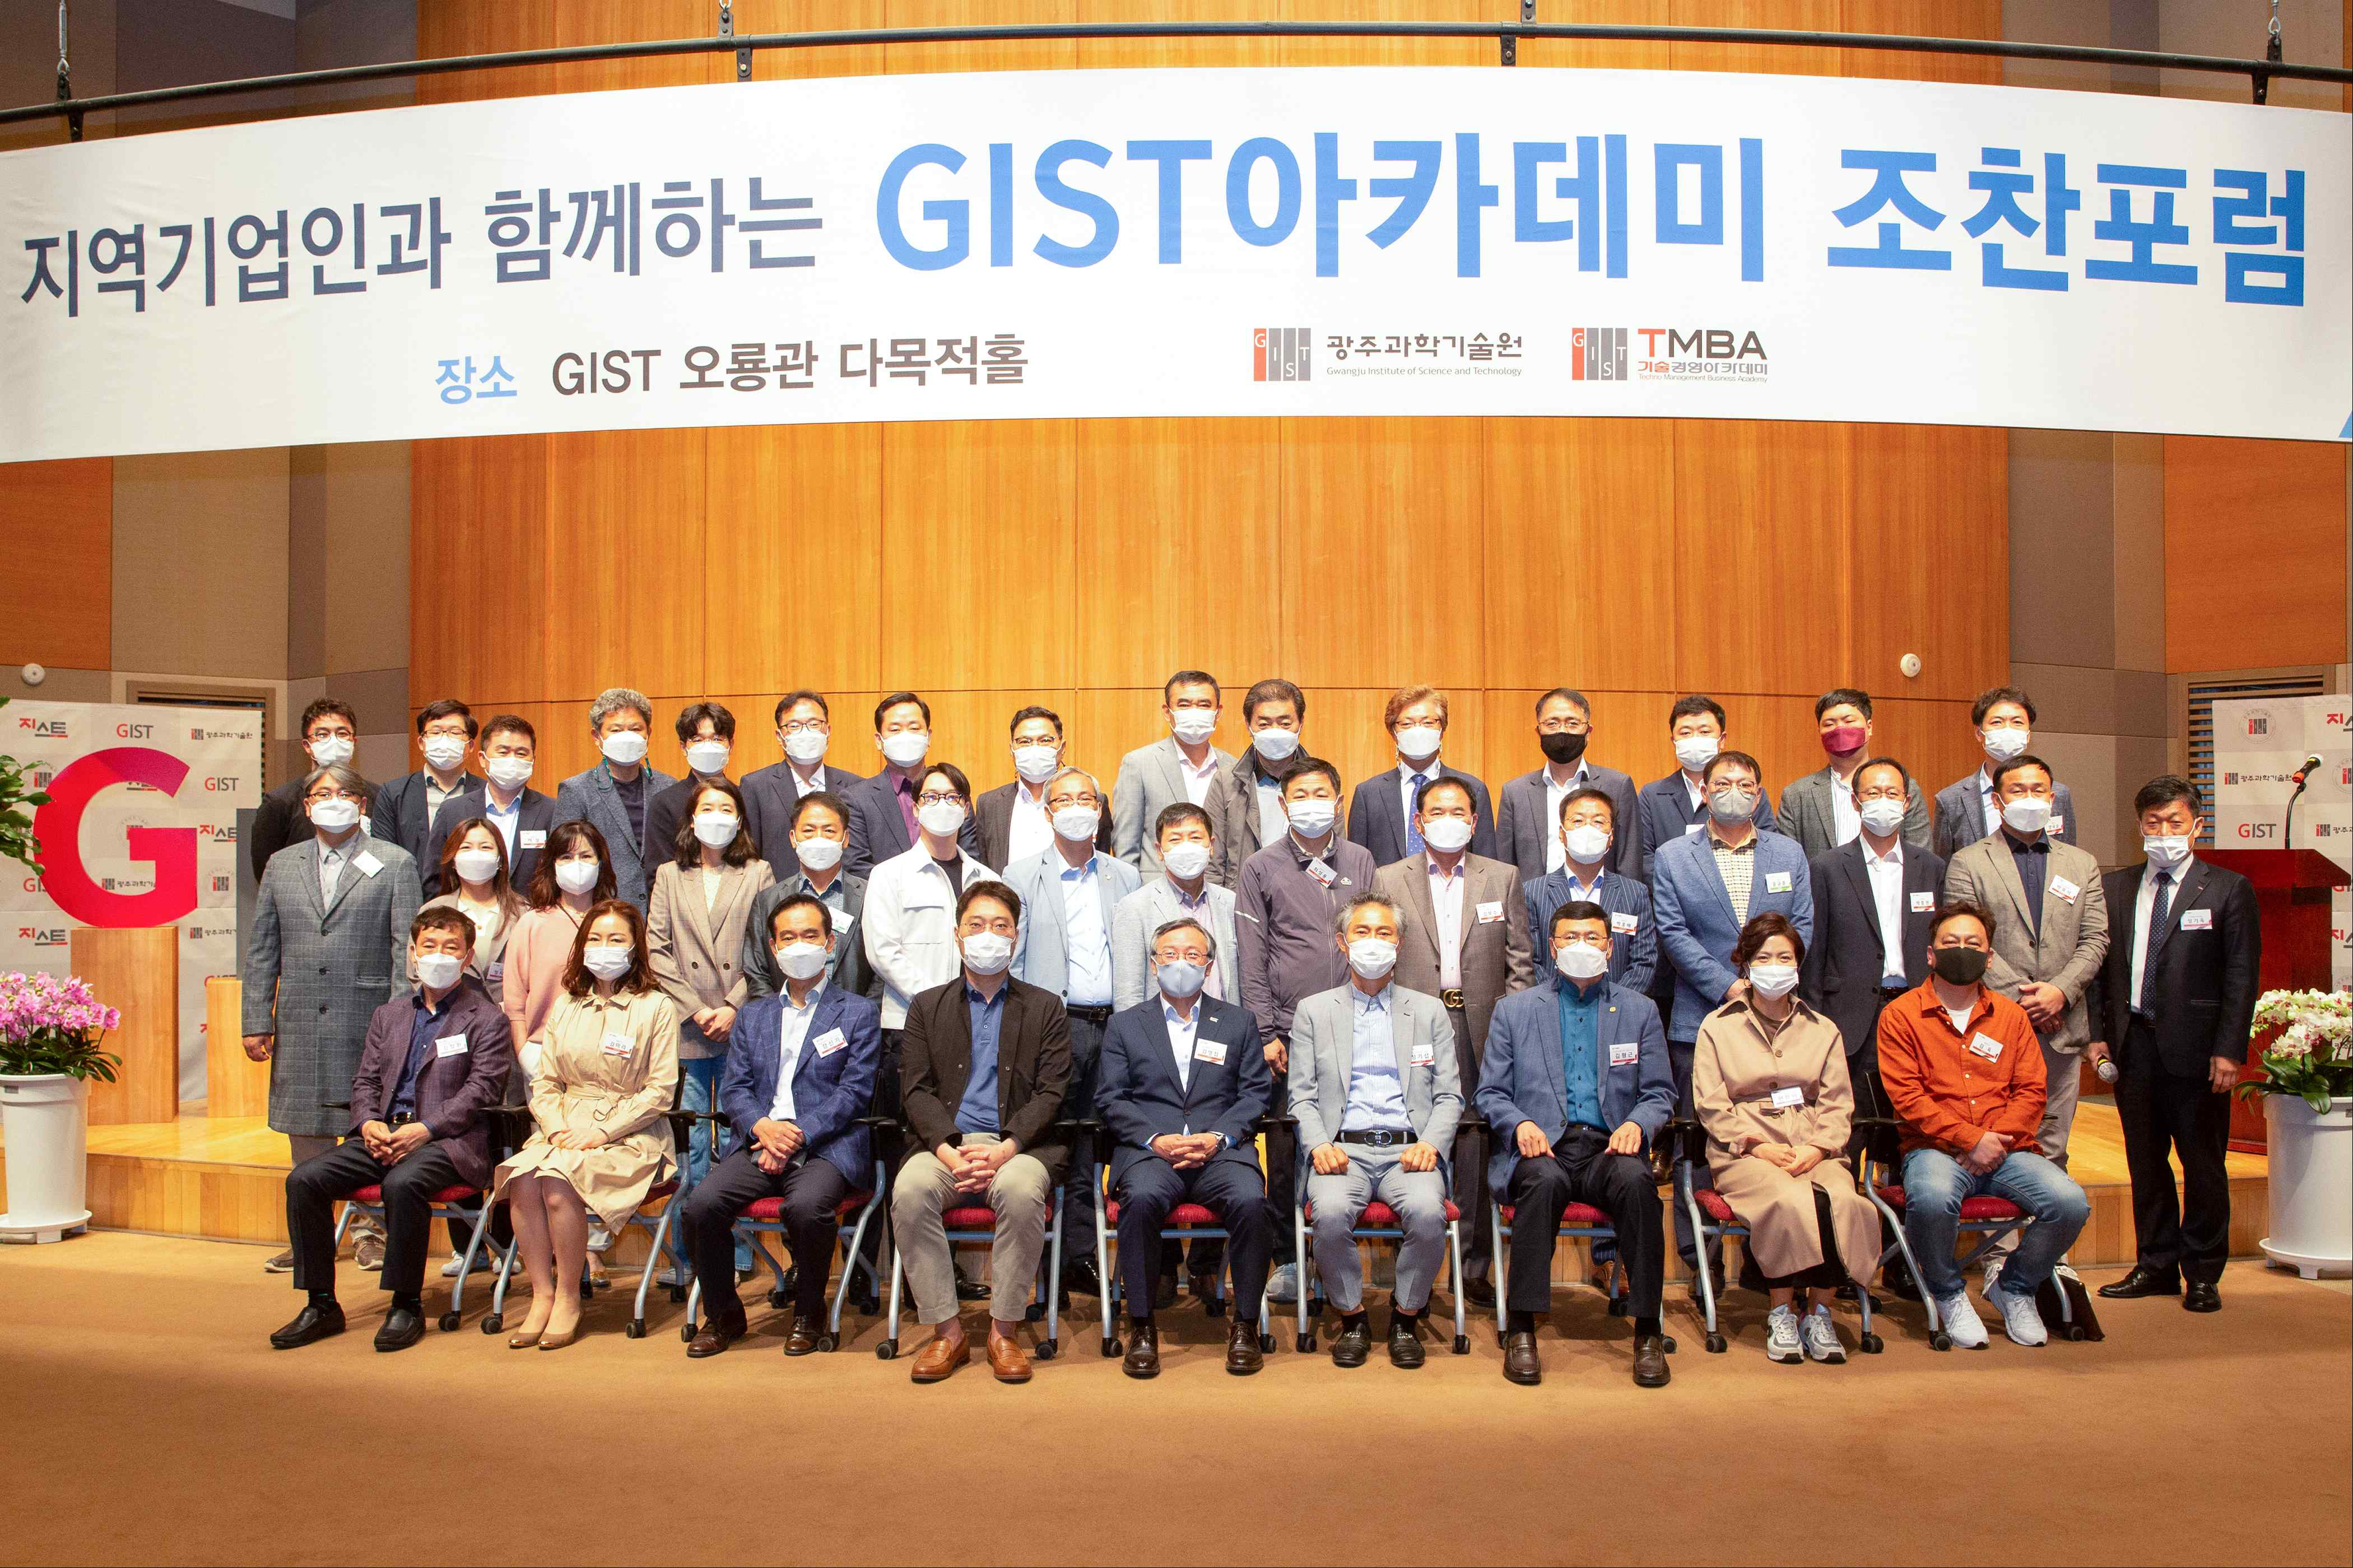
▲ GIST Academy holds breakfast forum in April



