
Gwangju Institute of Science and Technology
Official Press Release — https://www.gist.ac.kr

Section of Dongsun Cho Nayeong Lee
Public Relations Section Chief Senior Administrator
062-715-2061 062-715-2062

Contact Person Hyejin Lee, Administrator
for this Article Section of Public Affairs
062-715-2026

Release Date 2021.04.19

GIST holds an inaugural ceremony for
the social contribution group "PIUM"

□ GIST (Gwangju Institute of Science and Technology) held an an inauguration ceremony for the social contribution group "PIUM," which consists of 31 GIST students who will start social contribution activities in earnest.



∘ GIST students will become mentors and conduct real-time online mentoring on interesting science topics for underprivileged teenagers in order to spread a healthy science culture and fulfill their social responsibilities as a specialized university for science and technology.

□ PIUM (Positive, Interaction, Understanding, Mind), the new name of the GIST social contribution group, spreads the fragrance of GIST by sowing seeds and giving water and nutrition to our society through social contribution activities.

∘ GIST's Section of Public Affairs has been conducting various science camps and volunteer-based learning education programs for elementary, middle, and high school students since 2010. Starting this year, GIST's social contribution and career mentoring programs have been are integrated and expanded to be more systematic and efficient. In particular, it aims to provide a variety of educational and career experience programs that are difficult for students in underprivileged areas to easily access and to provide opportunities to improve science learning abilities and creative thinking.

∘ GIST's knowledge sharing programs include △ LAN Mentoring: online learning and career mentoring so that participants can join anytime and from anywhere △ Visiting Camp: in person mentoring by visiting middle and high schools △ GIST Science Camp: offering a variety of experiences in three different formats, including lectures by GIST professors and opportunities to experience research institute by visiting GIST.

□ GIST Vice President for Public Affairs Young-jip Kim said, "We hope that more students will have an opportunity to communicate, harmonize, and grow through participation in PIUM activities, and to become interested in educational service activities. GIST will further contribute to the development of a science culture by nurturing human resources through specialized social contribution activities in various fields of science and engineering."

□ Meanwhile, GIST was selected by the Ministry of Education and the Korea Science Foundation as the "2021 College for Career Exploration and Management Camp". The college career exploration camp is designed to ease the career gap of underprivileged students by selecting a university with a good career experience infrastructure and providing high-quality career experience programs to middle and high school students.

∘ Middle and high school students who wish to participate in the GIST career exploration camp can apply through the Ministry of Education-Dream Path Site (www.ggoomgil.go.kr).

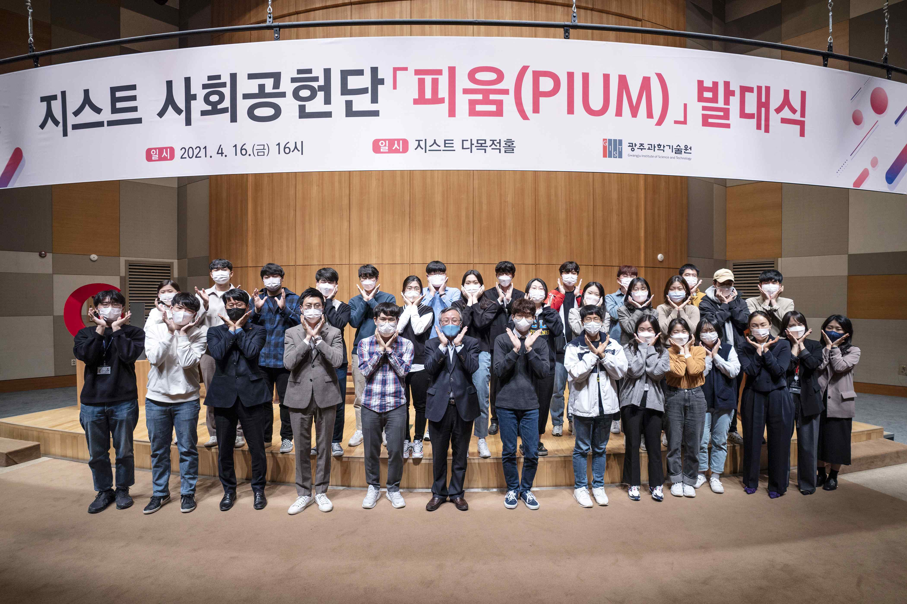
▲ Inaugural ceremony for the GIST social contribution group "PIUM"



