
Gwangju Institute of Science and Technology
Official Press Release — https://www.gist.ac.kr

Section of Dongsun Cho Nayeong Lee
Public Relations Section Chief Senior Administrator
062-715-2061 062-715-2062

Contact Person Jihoon Kim, Administrator
for this Article Section of International Relations
062-715-6252

Release Date 2021.04.16

British Ambassador to Korea visits GIST to discuss academic exchange cooperation and response to climate change

□ British Ambassador to Korea Simon Smith visited GIST (Gwangju Institute of Science and Technology, Acting President In S. Kim) on April 15, 2021, to discuss academic exchange cooperation and the international situation related to climate change.



∘ The British Ambassador's delegation listened to the current status of exchanges between GIST and British institutions as well as GIST's various activities related to climate change, which is of interest to Britain.

∘ Ambassador Simon Smith also introduced the British Turing Scheme, a new educational system called named after mathematician Alan Turing, which is an international aid program for British students to study and get a job abroad.

□ Students from the University of Edinburgh and Liverpool in the U.K. will attend GIST this year through GIST's Global Internship Program (GIP). In the future, GIST will promote exchanges with British universities through a review of the 'Turing Scheme.'

□ Meanwhile, GIST's Research Institute for Solar and Sustainable Energies established a cooperative international research relationship with Imperial College London in the UK since 2017 to provide a foundation for global joint research and is currently leading the next-generation energy field as a leader in new technology research.

∘ In addition, GIST's International Environmental Research Institute has attended the United Nations Conference on Climate Change (COP) since 2017 and is pursuing its activities as an observer of the United Nations Framework Convention on Climate Change (UNFCCC). The International Environmental Research Institute is scheduled to attend the 26th United Nations Conference on Climate Change (COP26) to be held in Scotland in November of this year.


▲ Photo 1. Meeting at the president's office with the British Ambassador to Korea

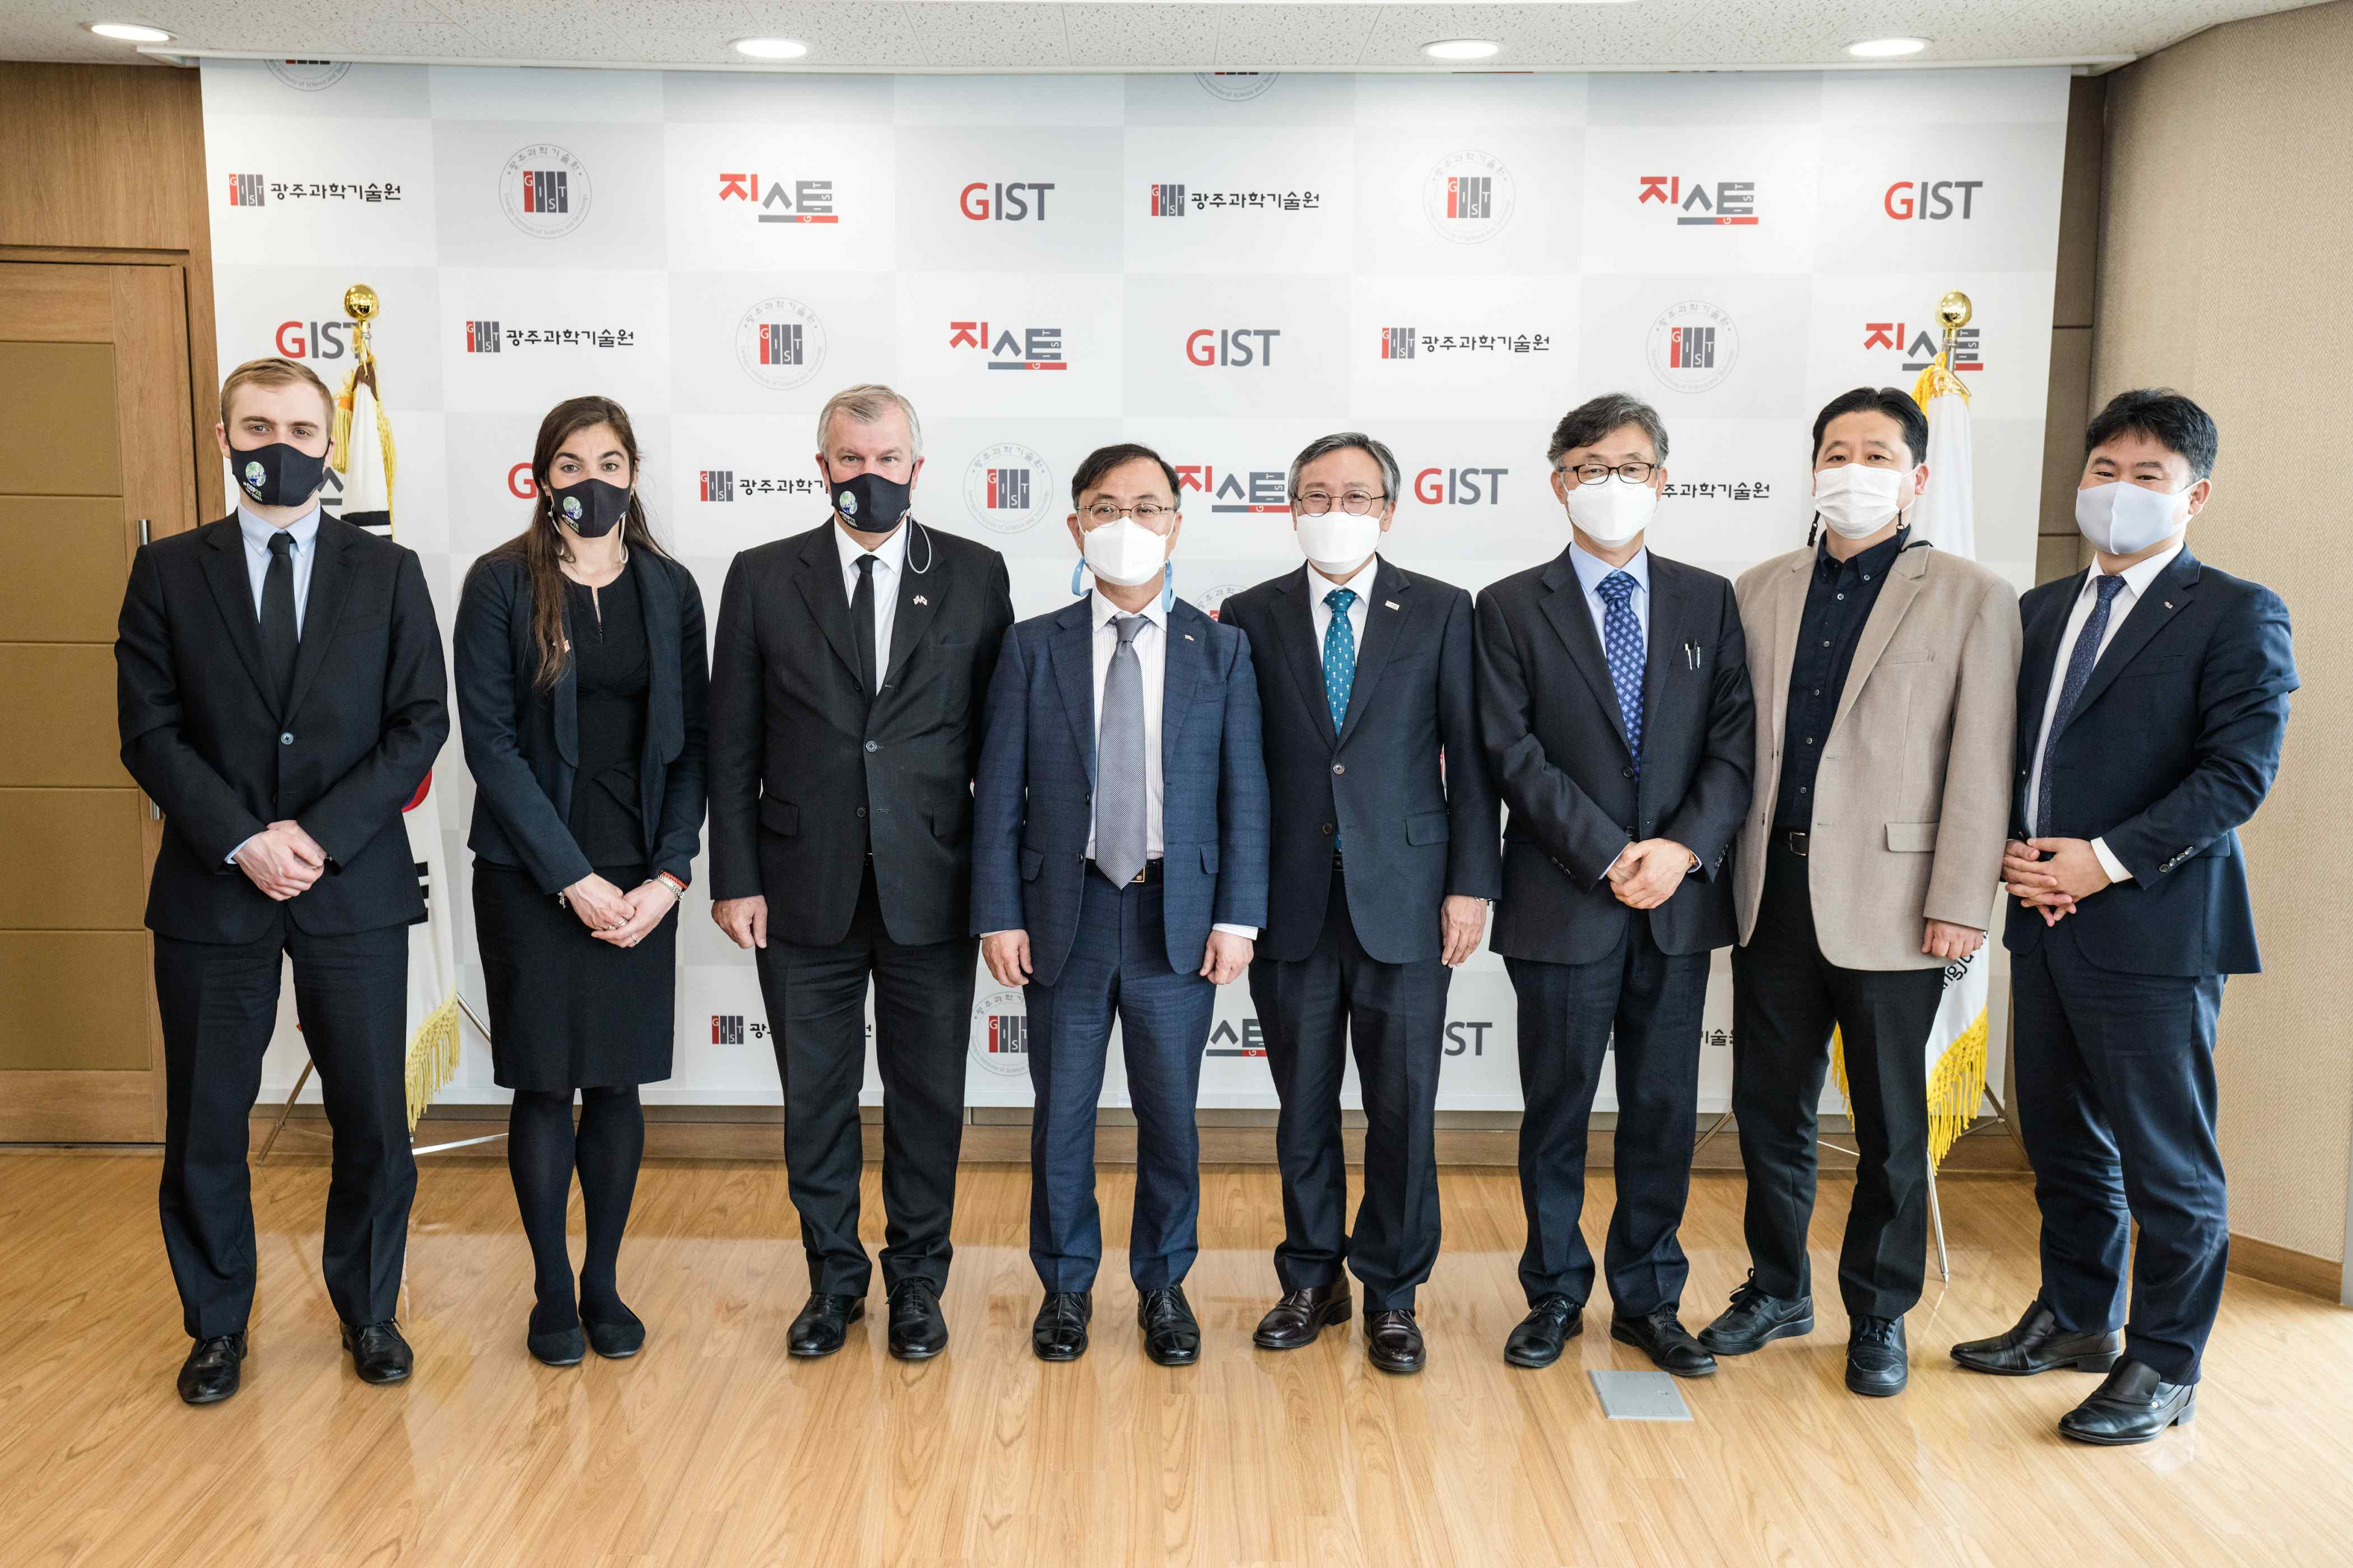
▲ Photo 2. Commemorative photo of the visit to GIST by the British Ambassador to Korea



