
Gwangju Institute of Science and Technology
Official Press Release — https://www.gist.ac.kr

GIST, Gwangju City, and CJ Olive Networks sign agreement
to promote artificial intelligence industries

□ GIST (Gwangju Institute of Science and Technology, Acting President In S. Kim) signed a business agreement on April 15, 2021, with Gwangju City and CJ Olive Networks to create an artificial intelligence-oriented city in Gwangju and develop national artificial intelligence industries.

∘ The agreement ceremony was held at the business room on the third floor of Gwangju City Hall and attended by GIST Acting Presient In S. Kim, Gwangju Metropolitan City Mayor Yong-sup Lee, and CJ Olive Networks CEO In-hyuk Cha.



□ The main contents of this agreement include: ▲ Gwangju City: Developing and operating a support program for nurturing the artificial intelligence industry, training for professionals, and employment-related programs ▲ CJ Olive Networks: Establishing a second research center in Gwangju to provide technical and policy advice for comprehensive IT services, such as artificial intelligence (AI) big data analysis, train human resources and create jobs ▲ GIST: Operate and provide artificial intelligence professional training programs, international joint research cooperation, and promotion of industry-university joint research with CJ Olive Networks.

□ GIST Acting President In S. Kim said, "I hope this agreement will serve as an opportunity for the successful development of the artificial intelligence industry. We will do our best to revitalize the local economy by training specialists and creating jobs that will lead the era of the 4th Industrial Revolution."

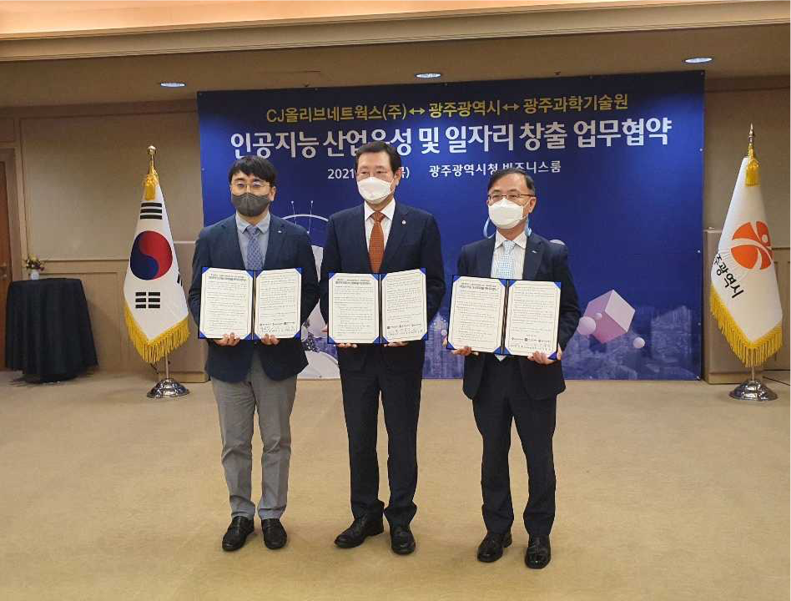
▲ GIST, Gwangju City, and CJ Olive Networks sign agreement to create an artificial
intelligence-oriented city in Gwangju and develop national artificial intelligence industries
From left: CJ Olive Networks CEO In-hyuk Cha, Gwangju Metropolitan
City Mayor Yong-sup Lee, and GIST Acting President In S. Kim



