
Gwangju Institute of Science and Technology
Official Press Release — https://www.gist.ac.kr

Section of Dongsun Cho Nayeong Lee
Public Relations Section Chief Senior Administrator
062-715-2061 062-715-2062

Contact Person Semi Park, Administrator
for this Article Section of Public Relations
062-715-2960

Release Date 2021.04.14

GIST PRESS publishes professional artificial intelligence book 'Practical Programming for Neural Network-Based Machine Learning'

□ GIST (Gwangju Institute of Science and Technology) PRESS, a publishing company, offers a specialized book for people interested in artificial intelligence. 'Neural network-based practical machine learning programming' was co-authored by GIST Artificial Intelligence Graduate School Research Professor Byung-rae Cha, Research Professor Sun Park, and Professor Jongwon Kim (Artificial Intelligence Graduate School Dean).



∘ This book was written to cultivate experts in the field of artificial intelligence who will lead the 4th Industrial Revolution. The case for artificial intelligence in specialized fields such as automobile, energy, healthcare, etc. is explained step by step along with the basics of machine learning, semi-supervised learning, transfer learning, and joint learning so that anyone from beginners to experts in the field can use it.

□ Research Professor Byung-rae Cha published 'Open Source Programming Using BIG-π3' at GIST PRESS as a co-author with Research Professor Sun Park and Professor Jongwon Kim. This is the second specialized book published by GIST PRESS.

□ 'Neural network-based practical machine learning programming' can be purchased through online and offline bookstores nationwide after April 12, 2021.

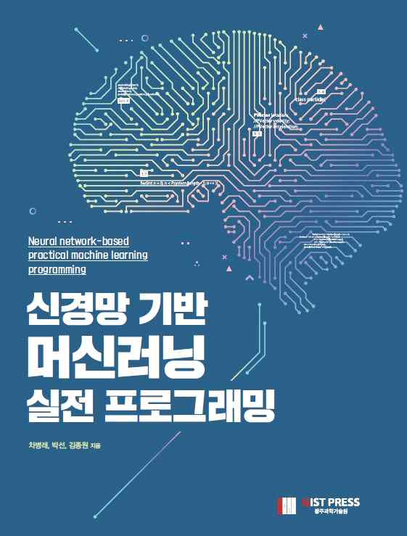
[Book Cover]



