
Gwangju Institute of Science and Technology
Official Press Release — https://www.gist.ac.kr

Section of Dongsun Cho Nayeong Lee
Public Relations Section Chief Senior Administrator
062-715-2061 062-715-2062

Contact Person Bo-young Son, Administrator
for this Article GIST Business Incubator
062-715-6305

Release Date 2021.04.13

GIST recruits entrepreneurs specializing in the artificial intelligence field for the '2021 Preliminary Start-up Package'

□ GIST (Gwangju Institute of Science and Technology) will recruit prospective entrepreneurs specializing in the artificial intelligence field for the '2021 Preliminary Start-up Package' by the 19 of this month to support prospective start-ups with innovative technology.



∘ The 'preliminary start-up package' support project of the Ministry of SMEs and Startups provides an average of 51 million won of commercialization funds per person to help support the start-up businesses of prospective founders while providing practical start-up support with start-up education and mentoring, market linkage, and global entry.

□ GIST plans to select a total of 35 people for in the specialized field without age and residential area restrictions by evaluating documents and presentations.

∘ GIST will support the successful start-up of companies by with dedicated support, by forming investment organizations and securing investments, by supporting technology transfers, and by providing start-up space.

□ Prospective entrepreneurs who want to apply for preliminary start-up package support specializing in the artificial intelligence field can apply online by selecting 'Preliminary Start-up Package Organization-Gwangju Institute of Science and Technology' on the K-Startup website by 18:00 on April 19, 2021.

∘ Qualifications for applicants are those who have no experience in start-ups as of the date of public announcement (21.3.30) or who have no businesses registered (individual, corporate) in their name. Those who have experienced business closure can apply only if they plan to start a business (company) that produces different products or services. If a business (company) that produces products and services in the same industry is scheduled to start a business, it can be applied only after three years of closure and two years after bankruptcy.

□ GIST Business Incubator Director Byung-kwan Jo said, "We will do our best to revitalize the local economy with the success of startup companies in the artificial intelligence field by actively utilizing GIST's start-up infrastructure."

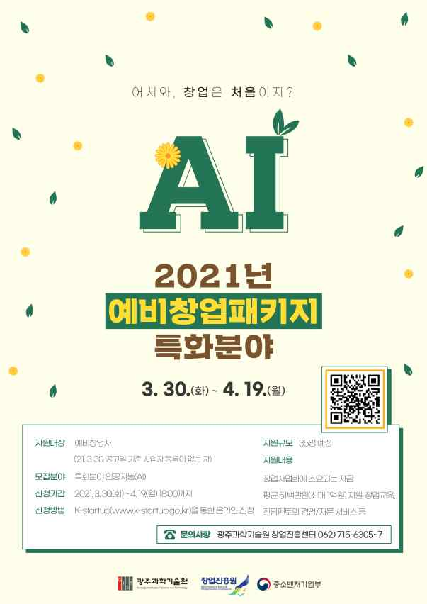
▲ '2021 Preliminary Start-up Package' promotion poster



