
Gwangju Institute of Science and Technology
Official Press Release — https://www.gist.ac.kr

GIST signs business agreement with local universities
for crisis response and development

□ GIST (Gwangju Institute of Science and Technology) signed a business agreement with 16 universities in Gwangju City, the Gwangju City Council, and the Gwangju Metropolitan Office of Education to promote crisis response and mutual cooperation on pending educational issues at local universities.

∘ The agreement ceremony was held in a conference room on the third floor of the Gwangju City Hall and was attended by GIST Acting President In S. Kim, Gwangju Metropolitan City Mayor Yong-seop Lee, Gwangju City Council Chairman Yong-jip Kim, Gwangju Metropolitan Office of Education Superintendent Hwi-guk Jang, and the heads of 16 local universities.



□ The main contents of the agreement include: ▲ Organization and joint response with the 'Gwangju Metropolitan City University Development Cooperation Group' to respond to the crisis and development of local universities ▲ Gwangju City: General operation of the University Development Cooperation Group, Gwangju Metropolitan Office of Education and local universities: dispatch and support for working-level personnel ▲ Laying the foundation for the development of regional-linked industries by creating new knowledge through training and research activities of experts with sustainable competitiveness ▲ Improvement of relevant laws and systems to resolve university and interdisciplinary imbalances and to ensure the effectiveness of local university development policies and ▲ Promoting curriculum specialization to create new growth engines in the fields of artificial intelligence, healthcare, automobiles, energy, and cultural contents, and to actively cooperated to expand youth jobs.

□ GIST Acting President In S. Kim said, "To overcome the current crisis situation, we must respond as a community and not as individual universities. GIST will do its best in mutual cooperation to overcome the crisis of regional universities and find a breakthrough in regional development."

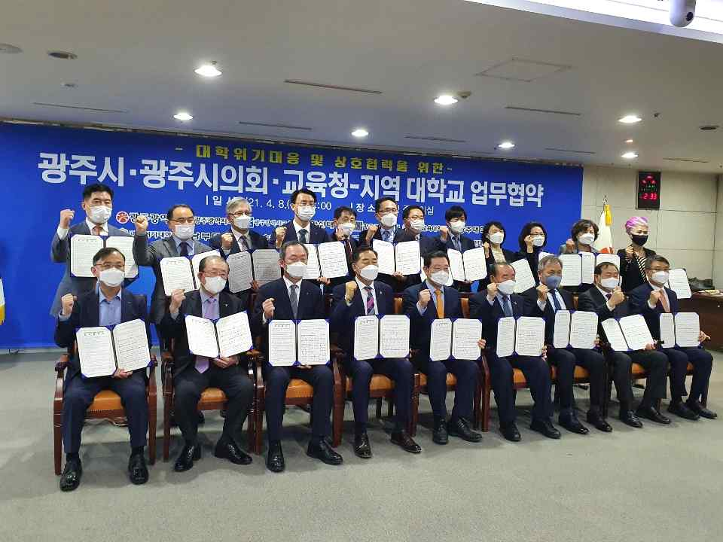
▲ Business agreement group shooting



