
Gwangju Institute of Science and Technology
Official Press Release — https://www.gist.ac.kr

Section of Dongsun Cho Nayeong Lee
Public Relations Section Chief Senior Administrator
062-715-2061 062-715-2062

Contact Person Su-il Kang, Administrator
for this Article International Environmental Research Institute
062-715-3371

Release Date 2021.04.06

GIST to commence project to supply water purifiers
to Cambodia for safe drinking water



□ GIST (Gwangju Institute of Science and Technology) International Environmental Research Institute (Director Kyoung-Woong Kim) signed an agreement (MoU) last December with the Secretary-General of the National Sustainable Development Committee under Cambodia's Ministry of Environment to supply water purifiers to Cambodia in accordance with the pro bono (free) technical support project* of the United Nations Framework Convention on Climate Change.

* pro bono technical support project: project in which the implementing agency provides free technical support for proposals received from developing countries

∘ The project distributes and installs gravity membrane filtration systems for villages and homes in rural Cambodian villages through the Climate Technology Center and Network (CTCN)*, continuously monitors water quality and health, operates and manages the water purification devices, and holds various activities such as educational workshops for children.

* Climate Technology Center and Network: An international organization based on the United Nations Framework Convention on Climate Change to promote the development and transfer of accelerated climate technology based on demand from developing countries for energy-efficient, low-carbon and climate-elastic development.

□ The GIST Hope Water Purifier is a water treatment device developed by the International Institute of Environmental Research in Cambodia in 2006 to support developing countries that lack drinking water. It uses a membrane to purify water using gravity without any additional energy supply.

∘ It can efficiently remove particulate pollutants and bacteria in the water and can be used for at least 10 years without special maintenance, so local people can manage it very easily.

□ In addition to local water quality experts, domestic gender experts and economic experts are expected to analyze the cost-effectiveness of the water purifiers and to evaluate the project from the perspective of gender inclusion and strengthen gender mainstreaming, which are expected to be synergistic in international development cooperation projects.

∘ Director Kyoung-Woong Kim said, "The Cambodian government has a strong will to share many of Korea's experiences and solve practical challenges through this project. In particular, experts from various fields are expected to participate in creating an extremely exemplary international climate technology cooperation project model."

□ The GIST International Environmental Research Institute was established in 2001 with the aim of establishing a UN University Research Institute and has successfully operated the UN University-GIST Sustainable Science and Technology Joint Program from 2004 to 2018.

∘ The institute has contributed greatly to international research and development cooperation, fostering environmental experts, and strengthening capabilities to solve environmental problems in developing countries. Since 2014, it has actively engaged in international development cooperation in the water sector. Since 2016, it has actively participated in international climate technology cooperation and response to climate change through the technology mechanism of the United Nations Framework Convention on Climate Change (UNFCCC).

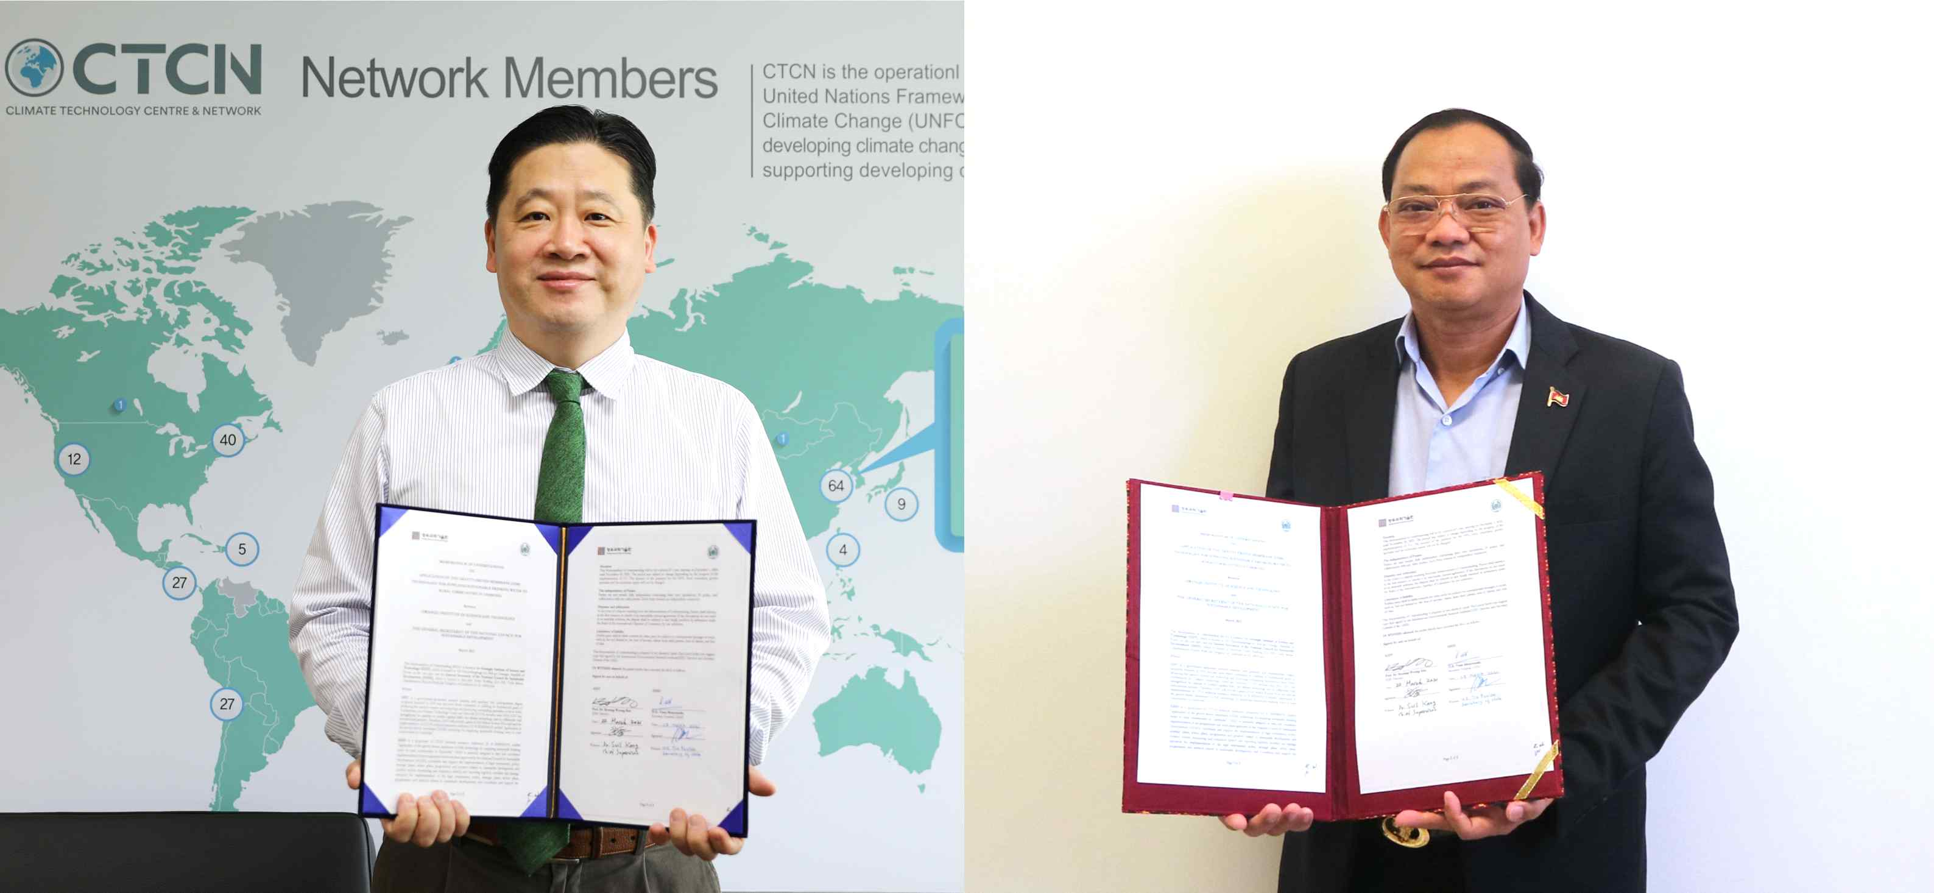
▲ [Photo] Memorandum of understanding signing for the pro bono technology support project under the United Nations Framework Convention on Climate Change (from left): International Environmental Research Institute Director Kyoung-Woong Kim and Cambodia's Environment Committee for Sustainable Development Secretary-General H. E. Vann Monyneath



