
Gwangju Institute of Science and Technology
Official Press Release — https://www.gist.ac.kr

Section of Dongsun Cho Nayeong Lee
Public Relations Section Chief Senior Administrator
062-715-2061 062-715-2062

Contact Person Byung-kwan Jo, Director
for this Article GIST Business Incubator
062-715-6300

Release Date 2021.03.30

GIST strengthens support system for
technology entrepreneurship in 2021

□ GIST (Gwangju Institute of Science and Technology, President Kiseon Kim) reorganized and strengthened its support system for technology start-ups in 2021 to systematically share information on technology start-ups and provide one-stop start-up services.



∘ Based on years of experience in supporting start-ups, the GIST Business Incubator has produced a "GIST Startup Guidebook" for start-ups, technology commercialization, and overall business support. Through this accelerating program, a one-stop service approach was established to support start-ups from the idea stage to investment linkage by utilizing the direct guide method of a professional investment company.

□ The accelerating program, which is promoted by the Business Incubator, is a program that supports successful technology start-ups through commercialization intensive mentoring, which goes beyond the excellent research performance and simple funding of laboratories. In the process of discovering research results, a professional investor directly visits GIST's laboratory for consultation and discovers research results that are directly linked to GIST's development project programs.

∘ As a major achievement in 2020, ENC Co., Ltd. and Olive Biotheraputics Co., Ltd. attracted 4.7 billion won and 200 million won in direct investment, respectively, and were selected for the TIPS program. Poel Co., Ltd. and SB BioScience Co., Ltd., a student start-up company, have also attracted 200 million won and 40 million won in direct investment, respectively, and will be recommended for the TIPS program in 2021.

□ GIST plans to strengthen the technology start-up support system to expand the foundation of the start-up culture.

∘ In line with the non-face-to-face trend, the scope of activities for existing start-up supporter has been expanded online. In addition to building a video production room for various media production, it provides a service (Start-up A to Z program) that can accelerate understanding of the entire start-up ecosystem from the idea stage to the establishment and investment stage.

∘ The student start-up club is going to discover excellent student start-up companies by strengthening flexible club activity support and operation through differential support based on the feasibility of items and the process of materialization.

∘ In addition, it plans to maintain student start-up support programs through more substantial operations such as intensive start-up camp, start-up idea contest, student mock start-up program, and start-up mini school.

□ GIST Business Incubator Director Byung-kwan Jo said, "We will continue to communicate with our members for a more systematic start-up support service at GIST to provide excellent start-up performance while considering and strengthening what is needed in the area."

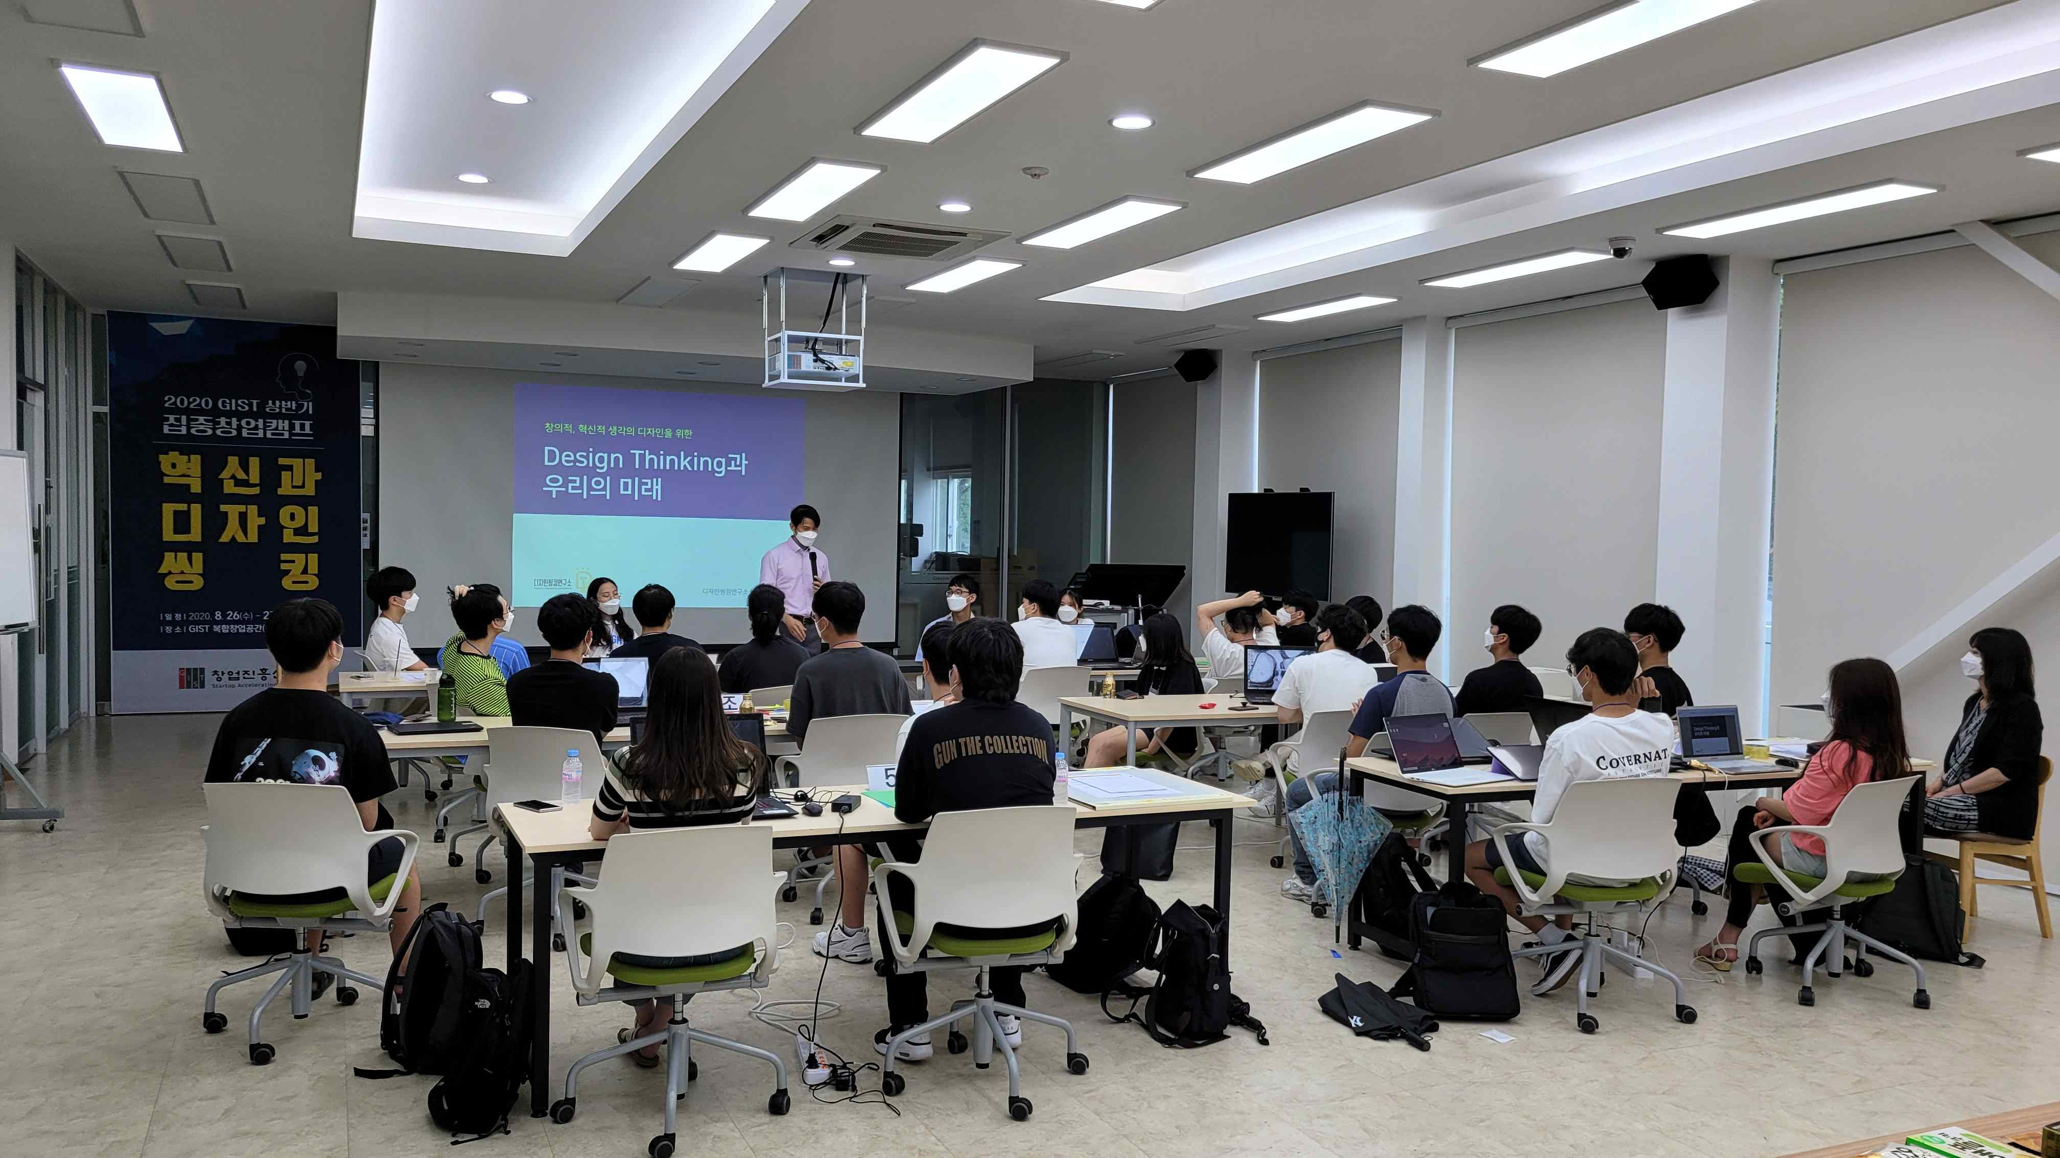
▲ Intensive Startup Camp for the first half of 2020: Lecture by
the Director of the Korea Design Thinking Research Institute



