
Gwangju Institute of Science and Technology
Official Press Release — https://www.gist.ac.kr

Section of Dongsun Cho Nayeong Lee
Public Relations Section Chief Senior Administrator
062-715-2061 062-715-2062

Contact Person Hyejin Lee, Administrator
for this Article Section of Public Affairs
062-715-2026

Release Date 2021.03.29

GIST expands social contribution activities
specializing in science and engineering

□ GIST (Gwangju Institute of Science and Technology, President Kiseon Kim) will expand its social contribution program starting with the inauguration ceremony of the "GIST PIUM Group" in early April to begin full-fledged activities this year in order to spread a healthy culture of science and fulfill its social responsibilities as a specialized university for science and technology.



° PIUM (P: positive, I: interaction, U: understanding, M: mind), the new name of the GIST Social Contribution Group, is meant to spread the scent of GIST throughout society by sowing seeds and providing nourishment with water and fertilizer through social contribution activities, just as with blooming flowers.

□ Recently, GIST was selected by the Ministry of Education and the Korea Science and Creativity Foundation to run the 2021 College Career Search Camp. The college career exploration camp is designed to ease the career gap of underprivileged students by selecting a university with a well-equipped career experience infrastructure and providing high-quality career experience programs to middle and high school students.

□ GIST has been conducting various science camps and volunteer educational services for elementary, middle, and high school students since 2010. Starting this year, GIST has integrated and expanded its social contribution and career mentoring programs to seek systematic and more efficient ways to operate them.

° In particular, GIST aims to provide a variety of educational and career experience programs that are difficult for students in underprivileged areas to easily access and to provide opportunities to improve science learning abilities and creative thinking.

□ GIST's Knowledge Sharing Program will operate under three formats: △ LAN Cable Mentoring: Online learning and career mentoring using Zoom so that students can participate anytime, anywhere △ Visiting Camp: Mentoring for artificial intelligence education conducted by visiting the affiliated school during vacation △ GIST Science Camp: Science Camps (GIST Professor's Lecture Program, GIST Research Center, Experience Program, etc.) that invite students to GIST.

° In addition, GIST plans to conduct a social contribution academy program to invite leaders, a program to promote volunteer work through the operation of social service classes, and a program to deliver donations to institutions in need of help.

□ GIST President said, "With the keen interest and support of the nation and local people, GIST has grown into a university recognized for its global research achievements despite its short history. With social contribution activities specialized in science and engineering in various fields, we will fulfill GIST's calling and contribute more to mutual growth with the local community."

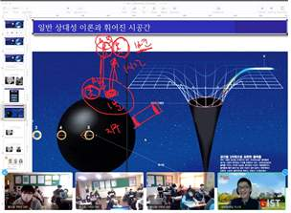
▲ GIST Online Science Class using Zoom

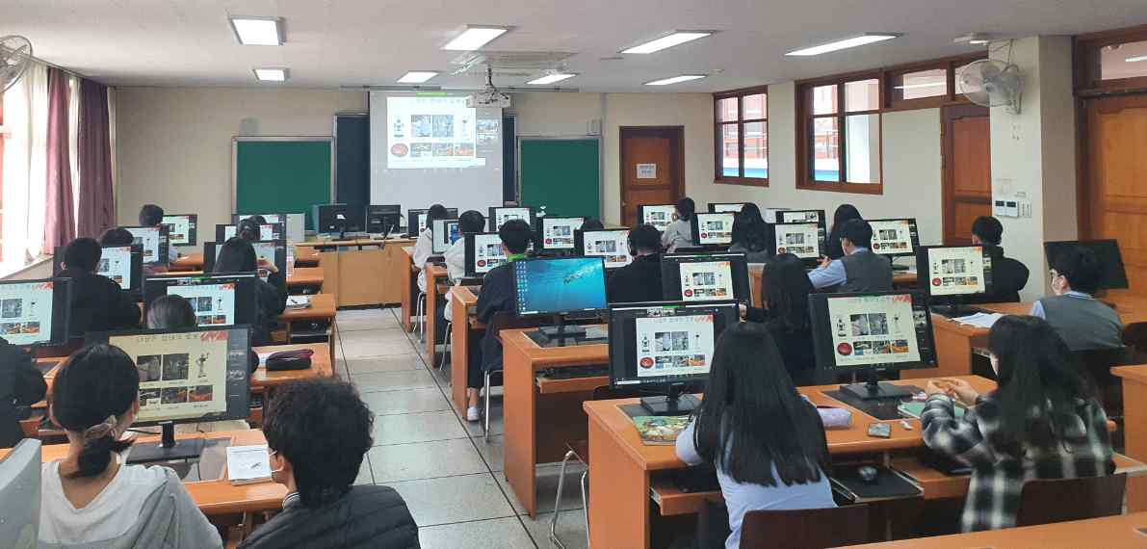
▲ Participation in GIST Online Science Class



