
Gwangju Institute of Science and Technology
Official Press Release — https://www.gist.ac.kr

Section of Dongsun Cho Nayeong Lee
Public Relations Section Chief Senior Administrator
062-715-2061 062-715-2062

Contact Person Gyu-rang Lee, Administrator
for this Article GIST Academy
062-715-2623

Release Date 2021.03.24

GIST Techno Management Business Academy (GTMBA) hosts inauguration for a new alumni president and donation ceremony for the development fund

□ GIST (Gwangju Institute of Science and Technology, President Kiseon Kim) Techno Management Business Academy (GTMBA) (President Kyung-hyun Song) held the 7th General Assembly of GTMBA and the inauguration ceremony for the general alumni president on March 23, 2021, at GIST Oryong Hall.



∘ To prevent the spread of COVID-19, strict social-distancing rules were observed during the event, which was attended by GIST Vice President for Public Affairs Young-jip Kim, CEO of Kyunghyang Industrial Co., Ltd., Kyung-hyun Song, 40 alumni, and Gowoon City I Co., Ltd., Chairman Ki-seop Jeong who was elected as the 4th president of the alumni association.

□ In addition, a donation ceremony was held for Han Young P&S Co., Ltd., CEO Yoon-seop Kim who donated 100 million won for the Development Fund. He had previously donated 20 million won.

∘ Yoon-seop Kim is the CEO of Hanyoung P&S Co., Ltd., which specializes in manufacturing molds, household appliances, and lighting products. He has won the Gwangju Metropolitan Government Export Grand Prize, the Minister of Trade, Industry and Energy Award, the Deputy Prime Minister of the Ministry of Strategy and Finance, and the National Assembly Speaker Award.

□ CEO of Kyunghyang Industrial Co., Ltd., Kyung-hyun Song, who served as the 3rd president of the alumni association, said, "In the meantime, the alumni association has not only contributed to the win-win development between alumni companies but has also endeavored to develop GTMBA and the local community. Once again, I would like to thank the executives who have helped me carry out the heavy responsibility as president over the past two years as well as the senior and junior alumni who have always provided me with support and encouragement."

□ Gowoon City I Co., Ltd., Chairman Ki-seop Jeong, who was elected as the 4th president of the alumni association, said, "To further develop the existing business conducted by alumni association, GIST will do its best to cooperate with the best research-oriented universities and GTMBA alumni companies to lead and take responsibility for the future of the region. We will develop GTMBA into the best business academy by promoting communication and exchange among alumni."

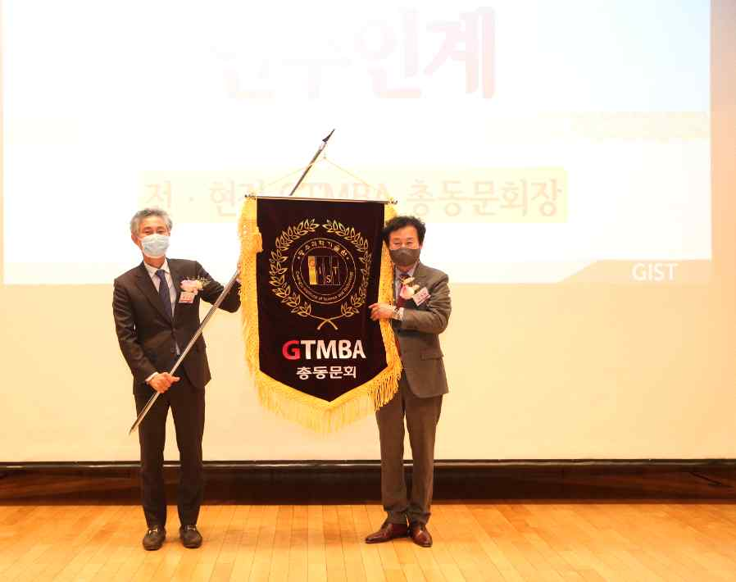
[Photo 1] Ki-seop Jeong, the 4th president of the alumni association, is taking the
GTMBA flag from Kyung-hyun Song, the 3rd president of the alumni association

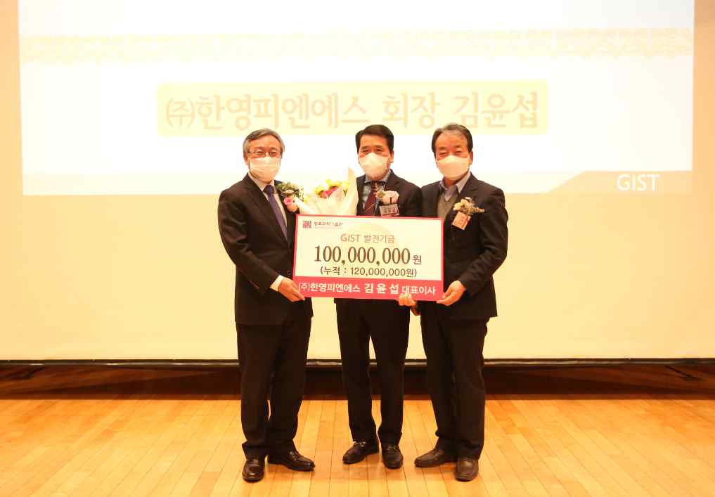
[Photo 2] GIST Vice President for Public Affairs Young-jip Kim, Han Young P&S Co., Ltd.,
CEO Yoon-seop Kim, and GIST Development Fund Chairman Jung-joo Ko



