
Gwangju Institute of Science and Technology
Official Press Release — https://www.gist.ac.kr

Section of Dongsun Cho Nayeong Lee
Public Relations Section Chief Senior Administrator
062-715-2061 062-715-2062

Contact Person You Seung Su, Administrator
for this Article Section of Public Affairs
062-715-2025

Release Date 2021.03.04

GIST signed a business agreement with the Pyeongdong Industrial Complex Operation Council to
revitalize local industries

□ GIST (Gwangju Institute of Science and Technology, President Kiseon Kim) held a business agreement ceremony (MoU) on March 4, 2021, with the Pyeongdong Industrial Complex Management Council (Chairman Bo-gon Kim) to revitalize local industries such by participating in industry-academia cooperation projects and by training skilled specialists.



∘ The signing ceremony was held at GIST with GIST President Kiseon Kim, Pyeongdong Industrial Complex Management Council Chairman Bo-gon Kim, and key officials in attendance.

□ Contents of the agreement includes ▲ joint participation in government industry-university cooperation support projects ▲ mentoring management advisors and supporting network deployment ▲ joint use of S/W and H/W owned by the institution ▲ operating programs and field training to develop customized human resources and support the revitalization of start-ups ▲ personnel exchanges with GIST Artificial Intelligence Research Center and AI Graduate School and ▲ other details necessary to promote exchange and cooperation were included.

□ GIST President Kiseon Kim said, "GIST and the local community will grow together in the future through a friendly cooperative relationship with the Pyeongdong Industrial Complex, which is the representative industrial complex in our region. GIST will actively cooperate and provide generous support for the development of local industries."

□ Pyeongdong Industrial Complex Management Council Chairman Bo-gon Kim said, "Through the business agreement with GIST, the companies in the Pyeongdong Industrial Complex are expected to be reborn as smart factories. We are thankful for GIST's active cooperation."

∘ GIST has recently taken the lead in regional development and training local specialists by signing business agreements with organizations in the Gwangju-Jeonnam region, such as the Gwangju Social Service Institute, the Gwangju Design Promotion Institute, KEPCO KDN, and the Gwangju Metropolitan Council for Sustainable Development.

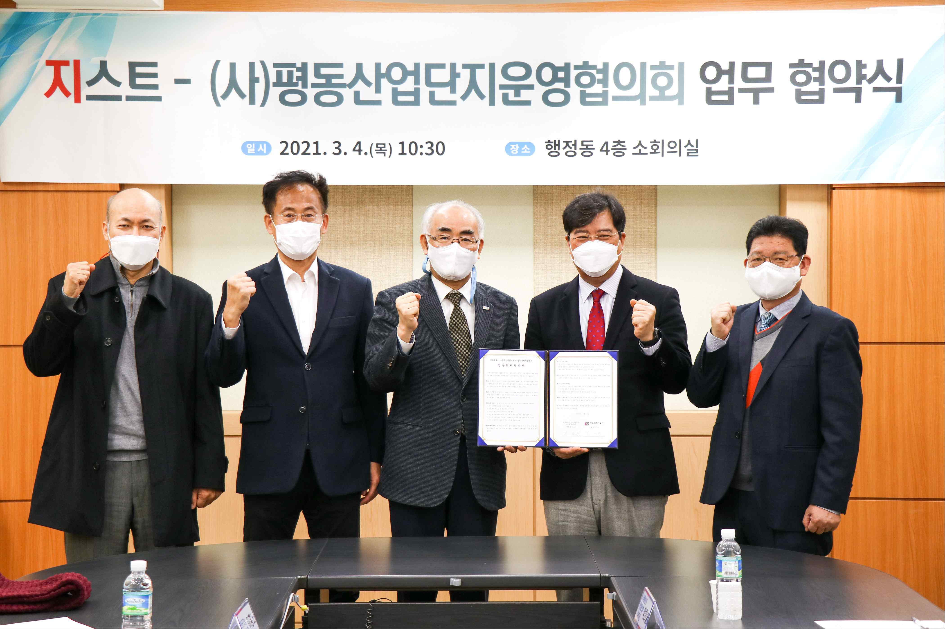
▲ GIST signs an MoU with the Pyeongdong Industrial Complex Management Council
to revitalize local industries such by participating in industry-academia
cooperation projects and by training skilled specialists

From left: AI Graduate School Dean JongWon Kim, GIST Institute for Artificial Intelligence
Director Heung-No Lee, President Kiseon Kim, Pyeongdong Industrial Complex Management Council Chairman Bo-gon Kim, and Pyeongdong Industrial Complex Management
Council Secretary-General Hee-sul Park



