
Gwangju Institute of Science and Technology
Official Press Release — https://www.gist.ac.kr

Section of Dongsun Cho Nayeong Lee
Public Relations Section Chief Senior Administrator
062-715-2061 062-715-2062

Contact Person Sung-joo Kim, Administrator
for this Article Section of Student Services
062-715-3605

Release Date 2021.02.24

GIST hosts matriculation ceremony for the 2021 school year

□ GIST (Gwangju Institute of Science and Technology, President Kiseon Kim) held the "2021 Matriculation Ceremony" on February 24, 2021, at GIST's Oryong Hall, which was attended by about 20 people, including representatives of students entering the school, representatives of the presidential scholarship students, and key officials.



∘ In the first half of this year, a total of 428 students, including 215 students in the undergraduate program, 115 students in the master's program, 53 students in the integrated master's and doctoral program, and 45 students in the doctoral program are expected to learn and study as members of GIST.

□ In particular, to prevent the spread of COVID-19, the matriculation ceremony was reduced by only having the minimum number of people in the venue in a similar manner to the earlier degree conferment ceremony.

∘ Those who could not attend the event, such as students and parents, etc., were able to watch the entrance ceremony in real time through online YouTube streaming.

□ The matriculation ceremony begins with an academic report from the Office of Academic Affairs Dean Kangwook Kim, which was followed by the declaration of admission by President Kiseon Kim with student representatives: ▲ Chang-woo Ji (physics, Ph.D.) ▲ Ji-min Son (AI, integrated program) ▲ Young-woong Kim (mechanical, master's program) ▲Yustina Chrisceline Kezia (material, master's program) ▲ with the GIST admission oath being read by Jae-woo Jeong (liberal arts, undergraduate) and ▲ the presidential scholarship certificate was awarded to Dong-woo Kang (liberal arts, undergraduate).

□ President Kiseon Kim said, "While at GIST, I hope you will constantly ask questions and explore in order to plan your future. I urge you to think fiercely about how future research activities can contribute to industrial development and further the public welfare of mankind. GIST will do its best to help you grow into an individual who is truly oriented towards global science and technology."

□ The total number of regular applicants for GIST's undergraduate program in 2021 was 897, the highest number ever with a ratio of 44.85:1. GIST became Korea's first "Liberal Arts College" to train a a small number of elite global science and technology leaders with humanities literacy through various mandatory lectures in the fields of humanities, society, and arts, as well as science and engineering subjects such as mathematics and science.

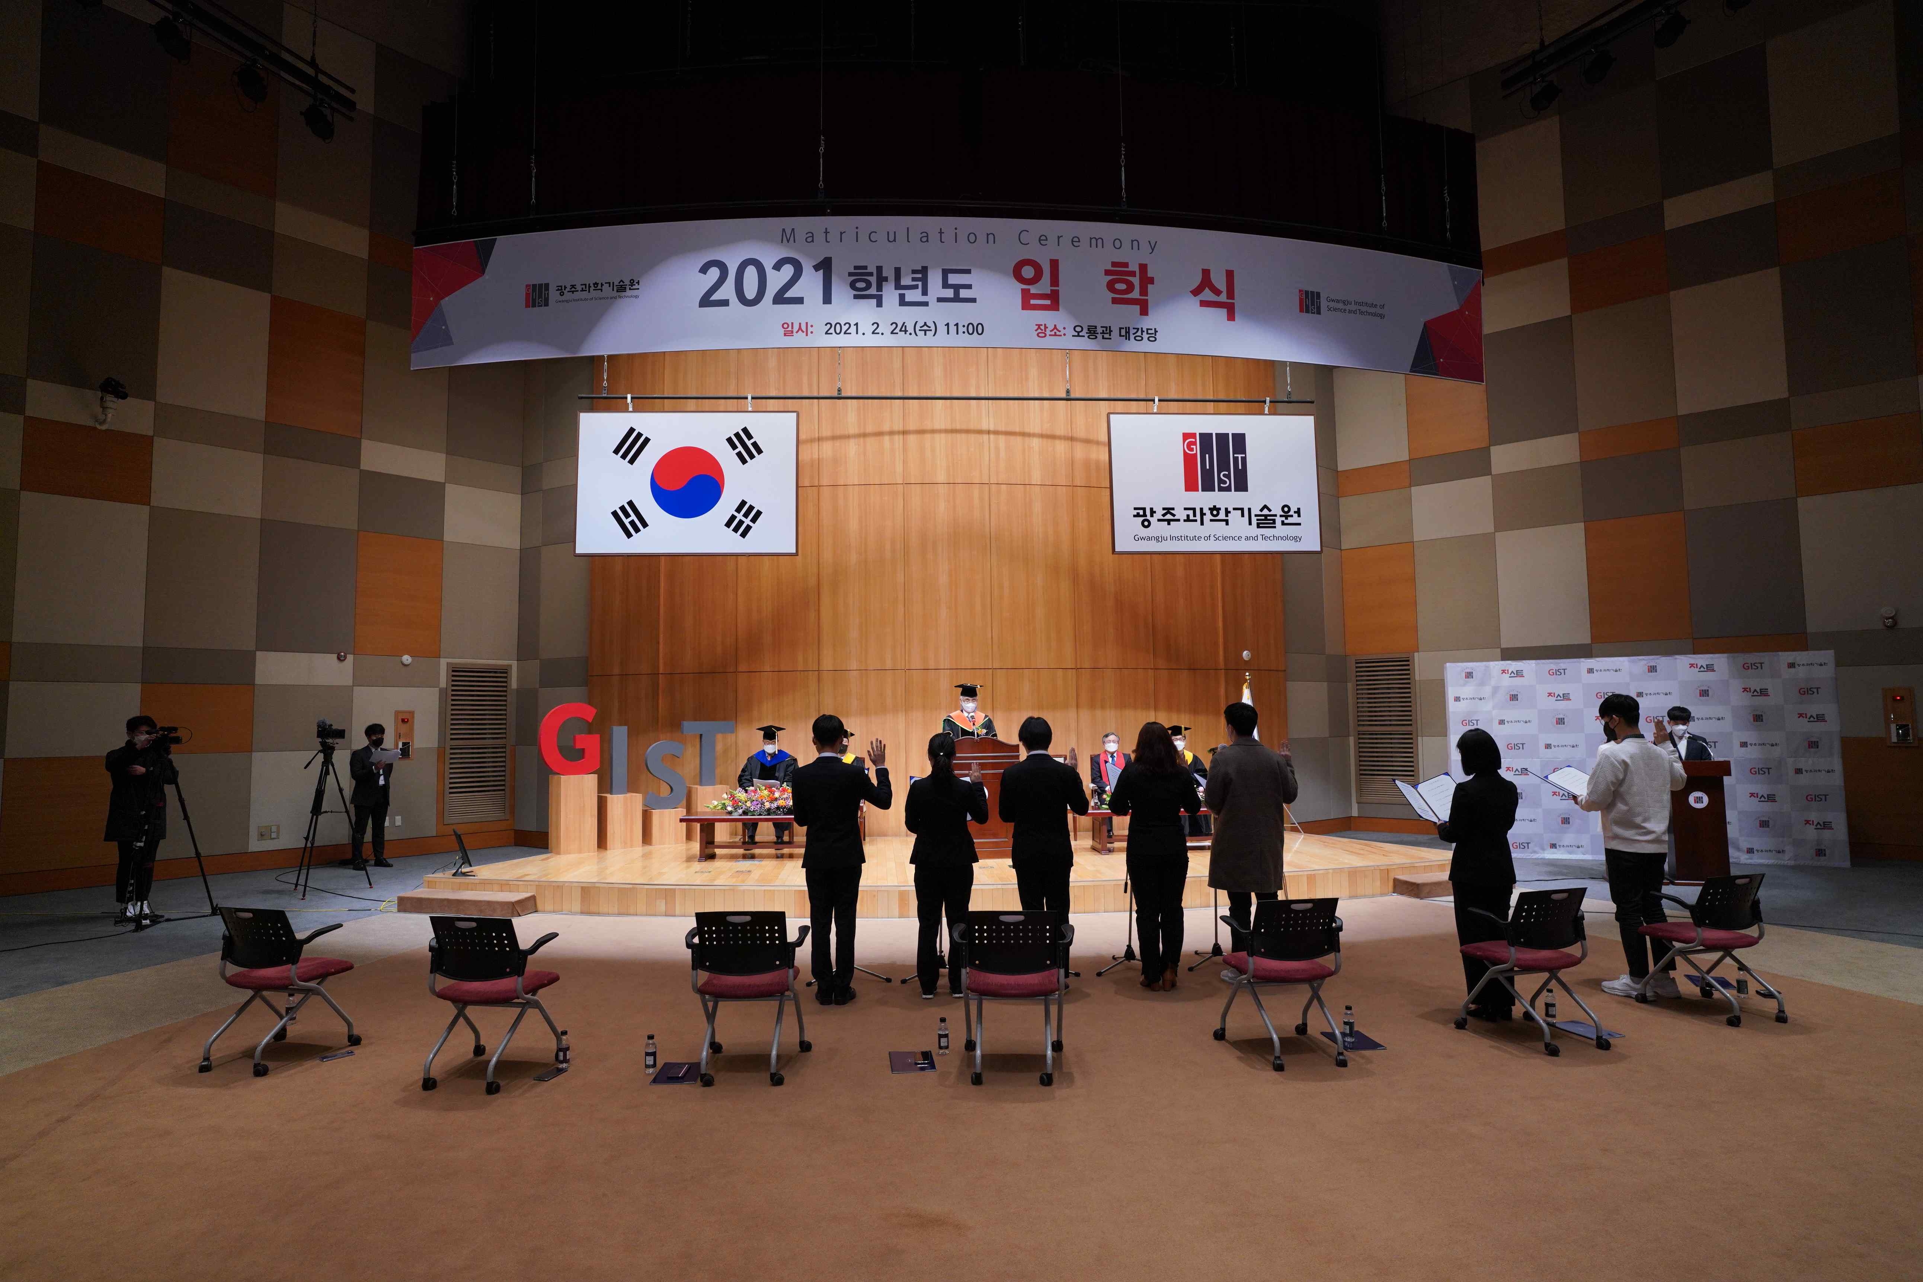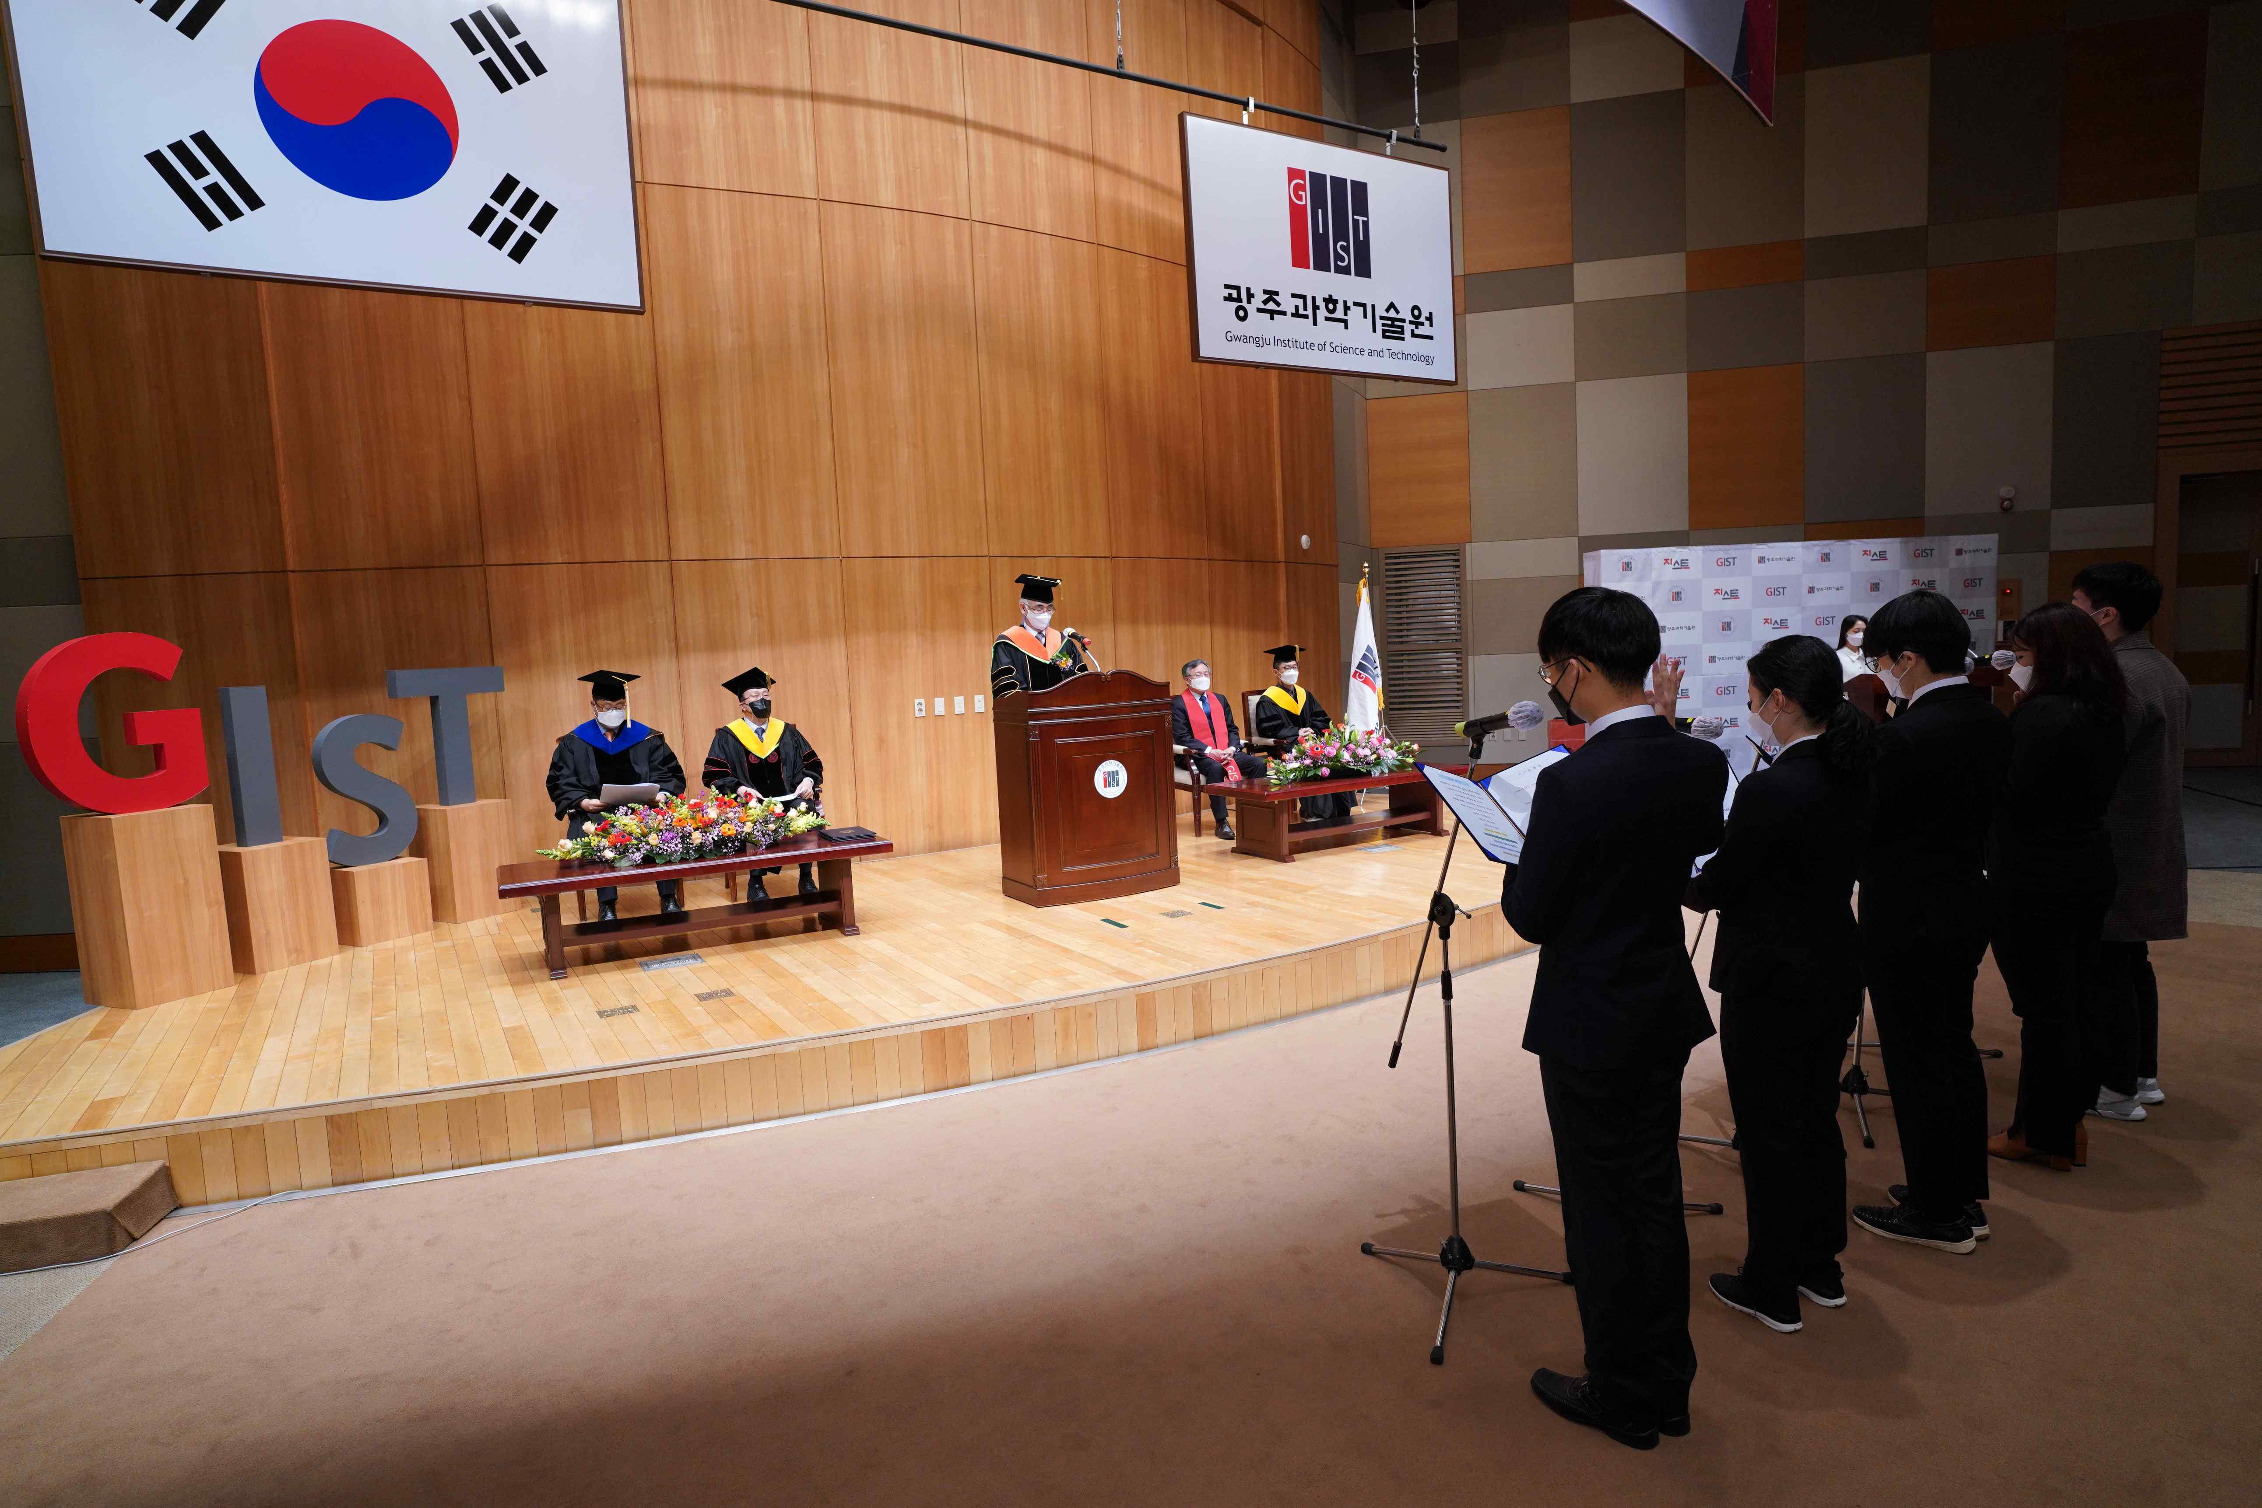
▲ GIST hosts matriculation ceremony for the 2021 school year



