
Gwangju Institute of Science and Technology
Official Press Release — https://www.gist.ac.kr

Section of Dongsun Cho Nayeong Lee
Public Relations Section Chief Senior Administrator
062-715-2061 062-715-2062

Contact Person Sung-joo Kim, Administrator
for this Article Section of Student Services
062-715-3605

Release Date 2021.02.19

GIST hosts the 2020 Degree Conferment Ceremony

□ GIST (Gwangju Institute of Science and Technology, President Kiseon Kim) hosted the '2020 Degree Conferment Ceremony' Oryong Hall on February 19, 2021, which was attended by more than 50 people including key figures, notable degree conferees, and representatives of the graduates.



∘ At the ceremony, a total of 292 people, including 69 doctoral degrees, 109 masters, and 114 undergraduates, were awarded degrees.

□ In particular, to prevent the spread of COVID-19, a video containing messages from teachers and students was produced and screened at the degree conferment ceremony.

∘ Degree recipients and parents who could not attend the event were able to watch the graduation ceremony in real time through online YouTube streaming.

□ An average of about six papers were published by the 69 Ph.D. recipients in Science Citation Index (SCI) registered journals during their studies.

∘ While enrolled in the Ph.D. program, approximately six papers per person were published in SCI journals with an average of 2.72 first-author papers per person and an average of 3.17 co-author papers per person.

□ In particular, Dr. Won-jun Lee (advisor: Professor Myung-Han Yoon) of the School of Materials Science and Engineering conducted a doctoral study on the subject of a new crystallization pathway using solution process large area printing and low-temperature photoactivation of next-generation functional metal oxide based electronic and energy materials. He has co-authored a total of 14 papers (5 as first-author) in renowned international academic journals (SCI-level) in the material science field as well as two book chapters for international-level books. In addition, he was awarded the Minister of Science and ICT Award at the degree conferment ceremony for his outstanding achievements, including the excellence award presented by the Korean Institute of Metals and Materials in 2019 and 2020, and the Best Paper Award from the Korea Institute of Materials Research in 2021.

∘ Gil-joo Lee (advisor: Professor Young Min Song), who received a doctorate from the School of Electrical Engineering and Computer Science, was selected as a GIST scholarship student with excellent admissions scores and was admitted into the integrated master's and doctoral program. During his four years and six months of study, he published a total of 32 SCI papers, including 15 hesitant papers, and published a number of papers in top-notch journals such as Nature Electronics and Science Advances and has been selected for the Global Ph.D. Fellowship (Korea Research Foundation), Robert S. Hilbert Memorial Student travel grant (OSA), Samsung Human Tech Paper Contest Gold and Encouragement Awards, Qualcomm-GIST innovation award, and 2019 Korea's Top 10 Nanotechnology. In honor of the will of the late Professor Baek Woon-chul, the first professor at GIST, at the graduation ceremony, he won the Haerim Baek Un-chul Information and Communication Award, which is given to one of the most talented students in the School of Electrical Engineering and Computer Science.

∘ The President's Award was received by Dr. Seok-yoon Moon (School of Earth Sciences and Environmental Engineering, advisor: Professor Youngjune Park) and Dr. Ji-Hoon Kim (Institute of Integrated Technology, advisor: Professor Hyeong Jin Kim). Chung-eung Ahn (physics major) graduated with the highest grade in the undergraduate program and was awarded a certificate and medal.

□ At the ceremony, President Kiseon Kim said, "I sincerely congratulate you on today's graduation, especially with the unexpected obstacles over the past few years such as COVID-19. I hope that you will become a heart-warming scientist who adds value to the lives of people and mankind with the capabilities and pride gained from GIST."

□ GIST, which celebrates its 28th anniversary this year, has been promoting educational innovations as an international campus as well as overseas cooperative research so that it can lead national science and technology education and research based on convergence and internationalization.

∘ GIST was ranked 4th in the world in 2020 (#1 in Korea for 13 consecutive years) in the category of 'citations per professor,' which shows the academic influence of the institution's research capabilities and results, and it was recognized internationally for its excellent research capabilities. In addition, GIST is leading a key role in the Gwangju AI cluster project, and is faithfully fulfilling its establishment goal of leading the national mission of science and technology development and leading regional industries, such as the establishment of the Artificial Intelligence Graduate School and the Graduate School of Energy Convergence.

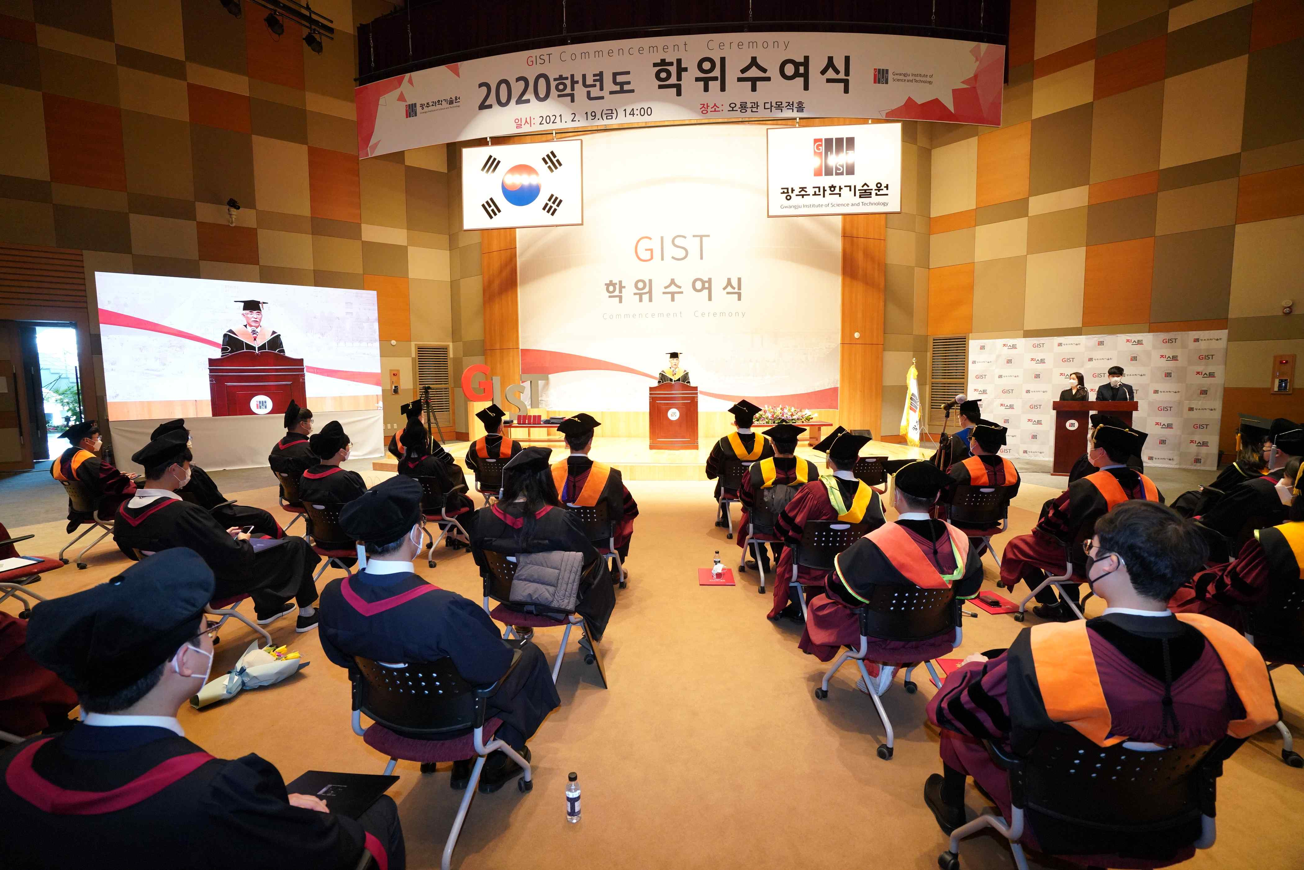
▲ [Photo 1] GIST 2020 Degree Conferment Ceremony

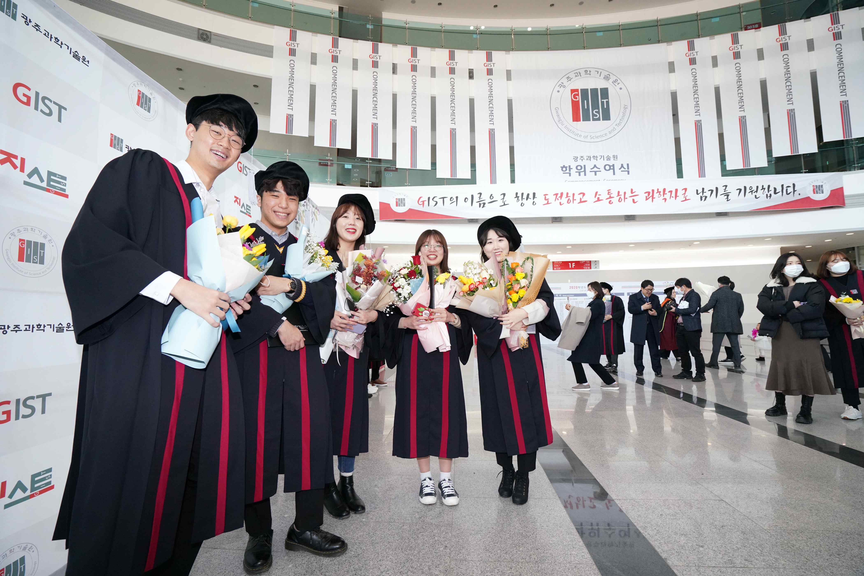
▲ [Photo 2] Graduating undergraduates at Oryong Hall
for the 2020 Degree Conferment Ceremony



