
Gwangju Institute of Science and Technology
Official Press Release — https://www.gist.ac.kr

Section of Dongsun Cho Nayeong Lee
Public Relations Section Chief Senior Administrator
062-715-2061 062-715-2062

Contact Person Annsun Jung, Administrator
for this Article Section of Public Affairs
062-715-5028

Release Date 2021.02.09

Professor Jong Hyun Lee donates 100 million won
to the GIST Development Fund

□ Professor Jong Hyun Lee in the School of Mechanical Engineering at GIST (Gwangju Institute of Science and Technology, President Kiseon Kim) donated 100 million won for the development of the School of Mechanical Engineering and the Department of Biomedical Science and Engineering.



∘ The donation ceremony was held in the president’s office on February 9, 2021, with the presence of the President Kiseon Kim, the Vice President for Academic Affairs Jong-In Song, the Vice President for R&D In S. Kim, the Vice President for Public Affairs Young-jip Kim, the Office of International and Public Affairs Dean Joon Ha Kim.

□ In the donation ceremony, Professor Jong Hyun Lee said, “As a professor at GIST, I felt rewarded that the school had grown greatly and many talented students were raised from it. I made donation for GIST to go further on the stage of the world. I hope it can be used for the cultivation of talented students and the development of the School of Mechanical Engineering and the Department of Biomedical Science and Engineering.”

□ The donated money of 100 million won will be used partly of 70 million won for the development of the School of Mechanical Engineering and partly of 30 million won for the development of the Department of Biomedical Science and Engineering.

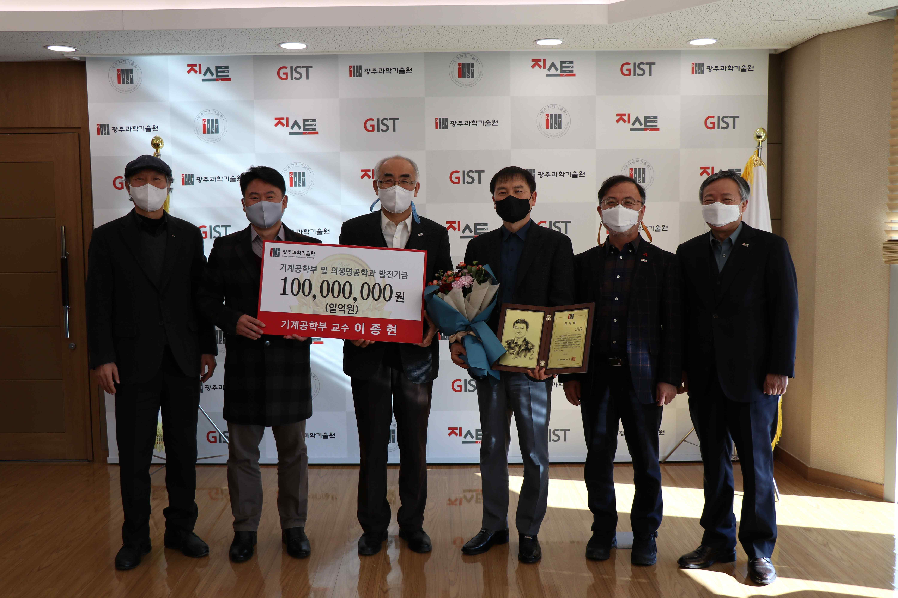
▲ Picture 1 (from left): Vice President for Academic Affairs Jong-In Song, Office of International and Public Affairs Dean Joon Ha Kim, President Kiseon Kim, Professor Jong Hyun Lee, Vice President for R&D In S. Kim, and Vice President for Public Affairs Young-jip Kim

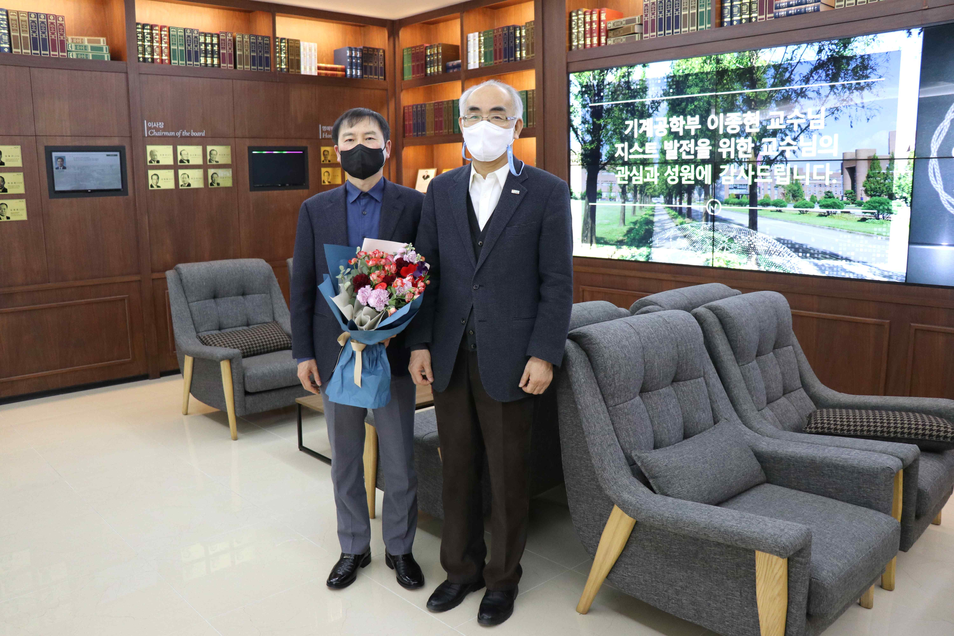
▲ Picture 2 (from left): Professor Jong Hyun and President Kiseon Kim
at the first floor of the Administration Building



