
Gwangju Institute of Science and Technology
Official Press Release — https://www.gist.ac.kr

Section of Dongsun Cho Nayeong Lee
Public Relations Section Chief Senior Administrator
062-715-2061 062-715-2062

Contact Person Seung-jae Lee, Section Chief
for this Article Artificial Intelligence Graduate School
062-715-6351

Release Date 2021.02.05

GIST Artificial Intelligence Graduate
School holds signboard ceremony



□ GIST (Gwangju Institute of Science and Technology, President Kiseon Kim) held a signboard ceremony at TED Hall on the first floor of the Education Research Support Center of the AI Graduate School (Dean JongWon Kim) on February 4, 2021, to support the successful promotion of the Artificial Intelligence Graduate School.

∘ To prevent the spread of COVID-19, the event was held with only key officials attending, including Minister Ki-young Choi of the Ministry of Science and ICT, GIST President Kiseon Kim, and Gwangju Metropolitan City Culture and Economy Deputy Mayor In-cheol Cho.

∘ The signboard ceremony opened with pre-ceremony events, such as a visit to the AI+X (Artificial Intelligence Convergence) research facility of the GIST AI Graduate School, a demonstration of an autonomous driving simulator, and a concerted performance by human and artificial intelligence composers. Next, GIST President Kiseon Kim gave a welcoming speech, the Minister of Science and ICT and the Gwangju Deputy Mayor gave congratulatory remarks, and the Director of Information and Communication Planning and Evaluation Institute gave an encouraging speech. Afterwards, progress reports from the Artificial Intelligence Graduate School were provided, and it ended with the unveiling of a signboard symbolizing the Artificial Intelligence Graduate School designated by the Ministry of Science and ICT.

□ The GIST Artificial Intelligence Graduate School opened in March 2020 to cultivate high-end entrepreneurship-oriented students to lead education, research, and entrepreneurship. From last year, it is planning to select 50 new students with integrated master's and doctoral degrees and develop them into world-class doctoral-level specialists in four to five years.

∘ To this end, 12 full-time professors who are global AI experts are expected to be hired by 2023, and 30 adjunct professors are participating to strengthen AI+X education and research.

□ GIST's Artificial Intelligence Graduate School is characterized by an industry-oriented, full-cycle curriculum that focuses on demonstration-oriented artificial intelligence convergence in preparation for start-ups. In other words, the curriculum was developed to conduct education and research to cultivate innovative specialists for each AI+X field.

∘ It operates as an industry-oriented, field-oriented curriculum ranging from basic artificial intelligence subjects, core subjects, start-ups, and field application and diffusion to cultivate artificial intelligence expertise and convergence capabilities.

□ GIST is focusing on education and research centered on three major specialized areas (healthcare, automobiles, and energy) in Gwangju to build an artificial intelligence start-up ecosystem that continues education, research and start-up thanks to the creation of the only national artificial intelligence convergence complex.

∘ In addition, it is expected to create synergy effects by providing empirical experiences to startup-oriented researchers by linking the ultra-large AI computing center and the empirical infrastructure built in the artificial intelligence complex with education and research programs.

∘ GIST has been striving for research and development since the end of last year by building an AI-X computing cluster based on NVIDIA's latest DGX-A100 GPU system and all-flash ultra-high-speed storage for the first time in Korea.

□ GIST President Kiseon Kim said, "GIST Artificial Intelligence Graduate School has an excellent research environment, including excellent faculty, accumulated global convergence research results, and regional infrastructure to build an advanced AI cluster. In line with the national policy of artificial intelligence powerhouse, GIST will actively take the lead in fostering global-level artificial intelligence convergence specialists who solve science and technology problems faced by companies by understanding core technologies of artificial intelligence."

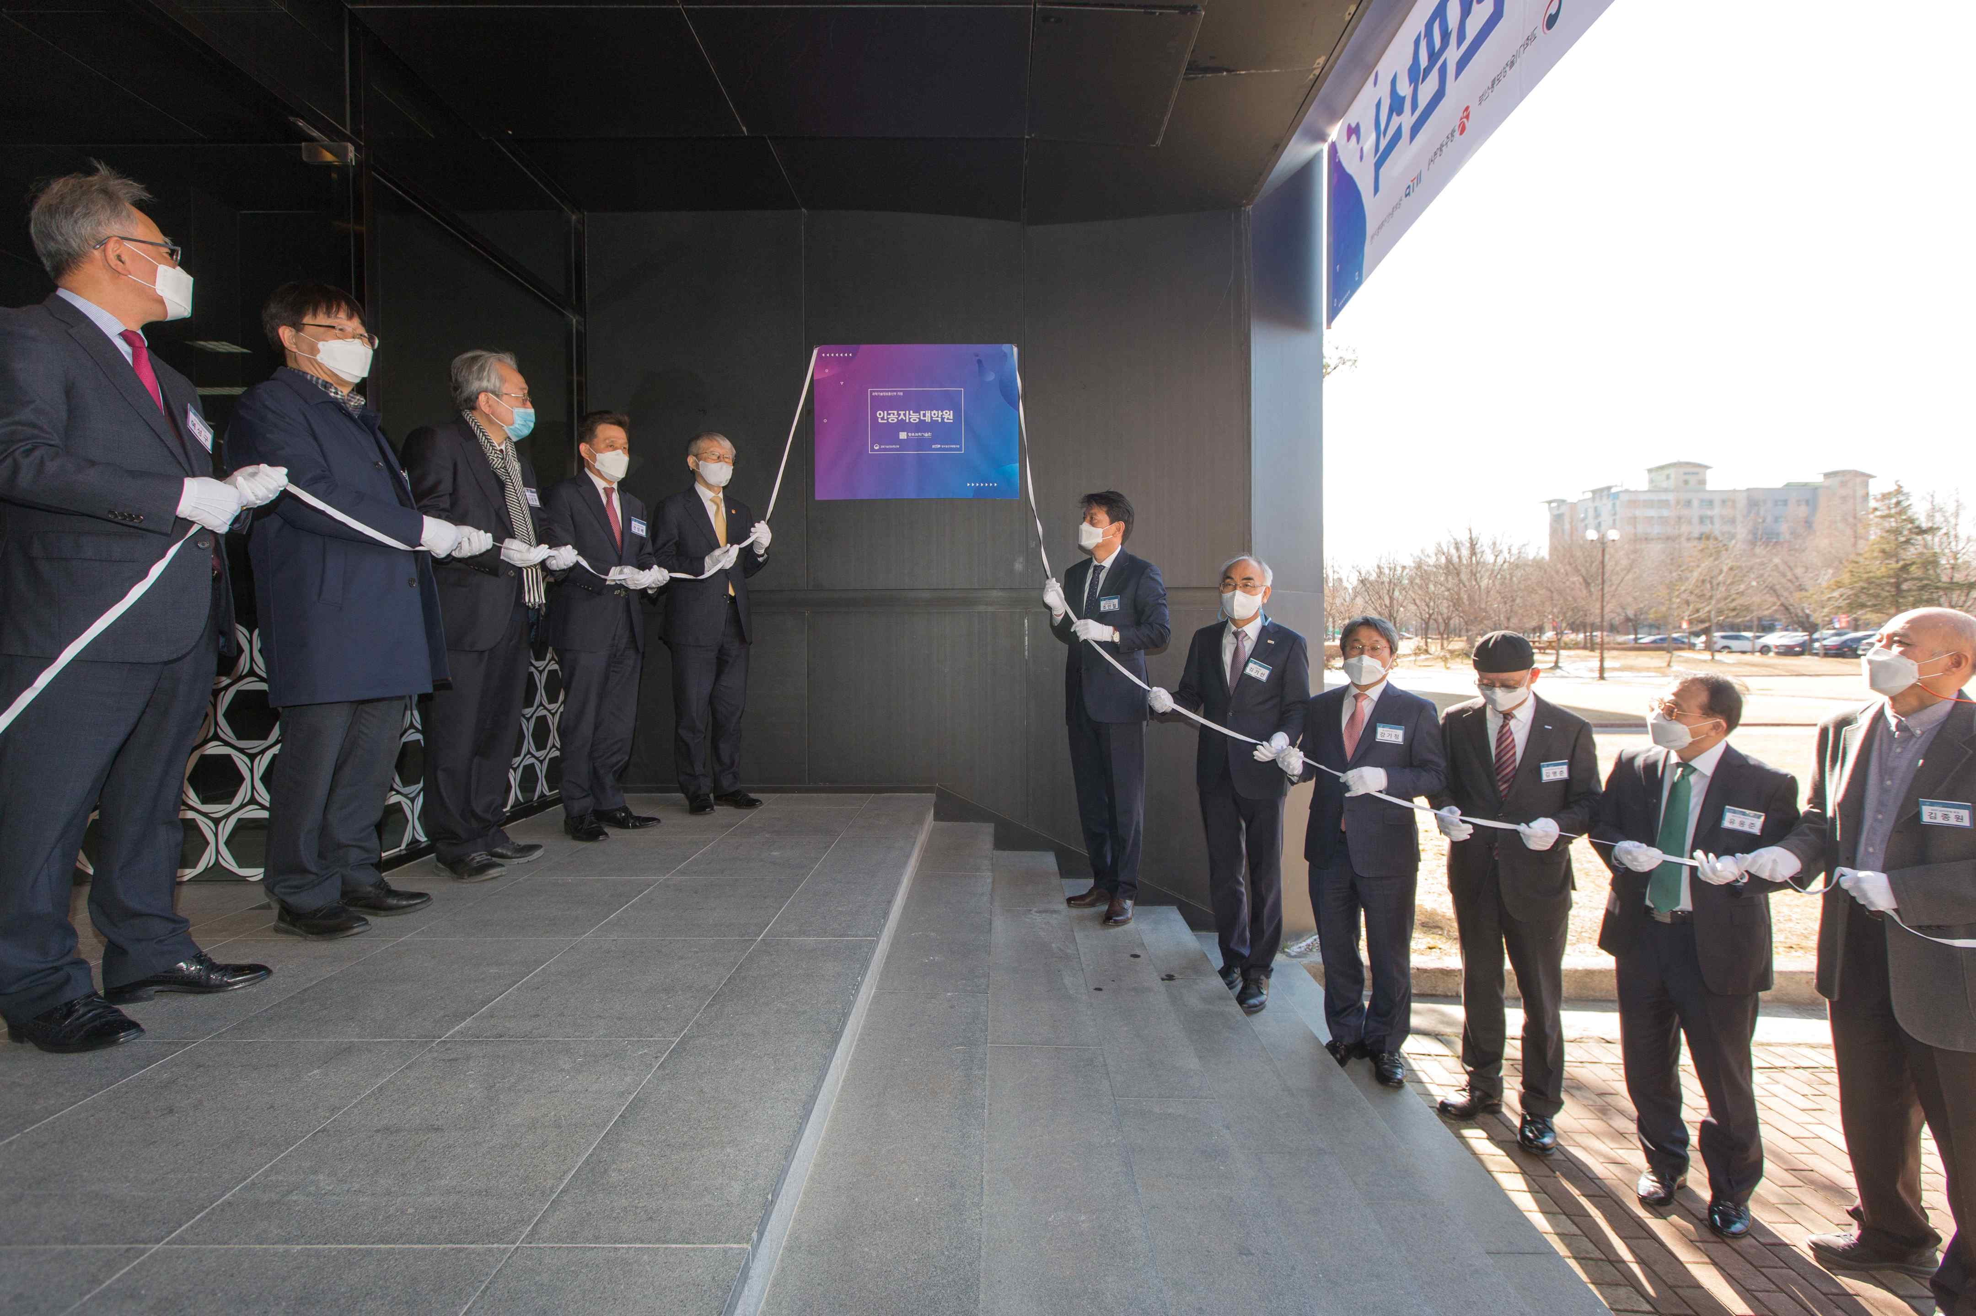
▲ Photo 1: GIST Artificial Intelligence Graduate School signboard ceremony

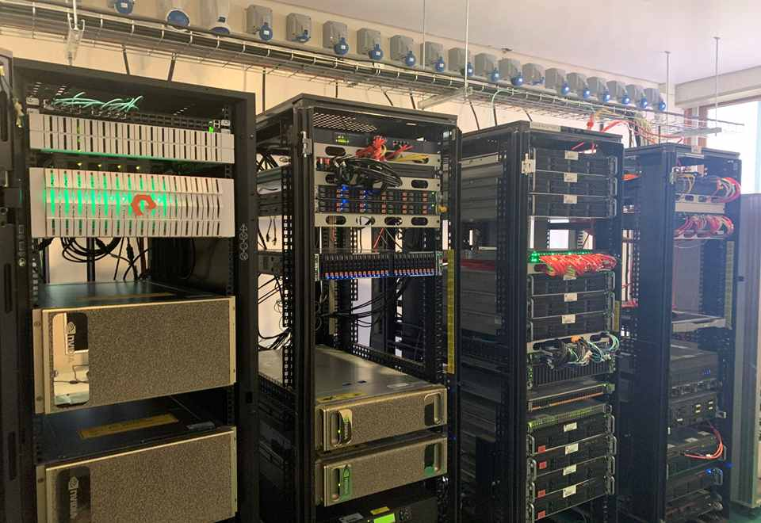
▲ Photo 2: GIST Artificial Intelligence Graduate School AI-X Computing Cluster



