
Gwangju Institute of Science and Technology
Official Press Release — https://www.gist.ac.kr

Section of Hyo Jung Kim Nayeong Lee
Public Relations Section Chief Senior Administrator
062-715-2061 062-715-2062

Contact Person Jin-sung Kim, Administrator
for this Article Information and Communication
Convergence Research Center
062-715-6956

Release Date 2020.12.23

GIST holds a technology transfer briefing to localize
marine equipment that relies on 95% imports



□ GIST (Gwangju Institute of Science and Technology, President Kiseon Kim) Information and Communication Convergence Research Center held an online briefing session on December 22 for the transfer of technologies for the local development of an acoustic marine monitoring equipment.

∘ Marine equipment technology is combines IT (information technology), MT (marine technology), ET (environmental technology), etc., and is is attracting attention as a promising industry in the future as it can be used to create new high-value-added marine industries such as development of underwater resources, global warming research, defense as well as renewable energy industry, offshore farming, and fishing.

□ This briefing session was hosted online by the Ministry of Oceans and Fisheries and the Korea Institute of Fisheries Science and Technology Promotion in accordance with the government's policy to prevent the spread of COVID-19 and was organized by the GIST Information and Communication Convergence Research Center, the Ministry of Oceans and Fisheries, and officials from the Korea Institute of Marine Fisheries Science and Technology Promotion. Implementing agencies and cooperative organizations and related companies (UST21, Geosystem Research, San Engineering, Baekgeon Dredging) participated in the meeting.

□ The "Marine Acoustic Sounding and Physical Property Monitoring Device Localization Development" project of the Ministry of Oceans and Fisheries' "Marine Equipment Development and Infrastructure Construction Project" was carried out over eight year from 2013 to 2020 with 9 domestic patent registrations and 2 technology transfers. The project was successfully promoted and applied for 5 international patents and 21 domestic patents.

∘ The results of ▲ "high-resolution multi-beam sounding device and high-efficiency module localization development (MBES: Multi Beam Echo Sounder)" and ▲ "Marine property monitoring remote transmission system localization development (OPMS: Ocean Properties Monitoring System)" is a technology that detects obstacles or topography, collects marine information in a certain area of the sea, and provides information that can respond to aquaculture, fisheries, and marine disasters. A technology transfer briefing session was held to contribute to actual corporate sales through technology transfer and to realize job creation, ocean exploration, and advanced research/observation.

□ ▲ High-resolution multi-beam sounding equipment is a world-famous MultiBeam Echosounder, Projector & Receiver (number of beams, carrier frequency, Along-track beam width, Across-track beam width), Sonar Processor Unit Compared to (Max Swath Range, depth resolution, maximum detection depth), it achieved the same level as the world's highest level, and the manufactured device has been verified by the National Oceanographic Research Institute. ▲ The acoustic sensor of the marine property monitoring system also achieved the same level of world technology for transmission voltage sensitivity, transmission sensor underwater impedance, reception voltage sensitivity, and beam pattern by acoustic transducers equipment. Completion of public certification.

□ ▲ The high-resolution multi-beam sounding device is a projector & receiver (multi-beam, carrier frequency, Along-track beam width, Across-track beam width), which is the world-famous MultiBeam Echosounder device from Reson, Denmark. Compared with the Sonar Processor Unit (Max Swath Range, depth resolution, maximum detection depth), it achieved the same level as the world's highest level, and the manufactured device was verified by the National Oceanographic Research Institute. ▲ The acoustic sensor of the marine property monitoring system also achieved the same level of world technology for transmission voltage sensitivity, transmission sensor underwater impedance, reception voltage sensitivity, and beam pattern by acoustic transducers equipment. The National Defense Science and Technology Research Institute completed the certification.

∘ Therefore, by developing marine equipment that relies on imports for 95% of the current results of technology transfer, it is possible to replace imports of more than KRW 10 billion and KRW 30 billion of similar equipment annually, and it is expected to export equipment and secure various source technologies to global markets of KRW 500 billion or more.

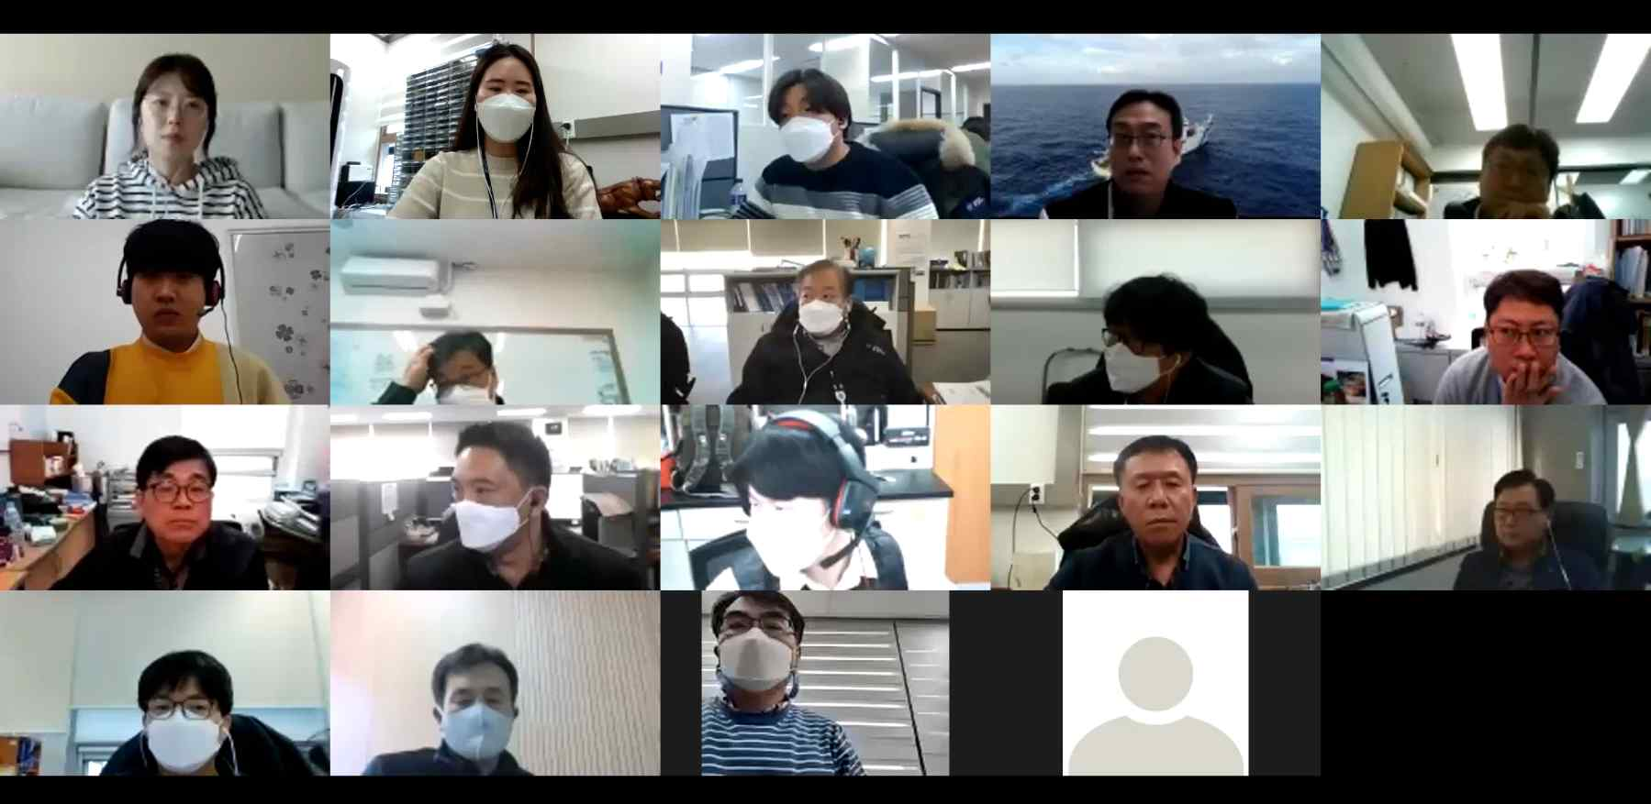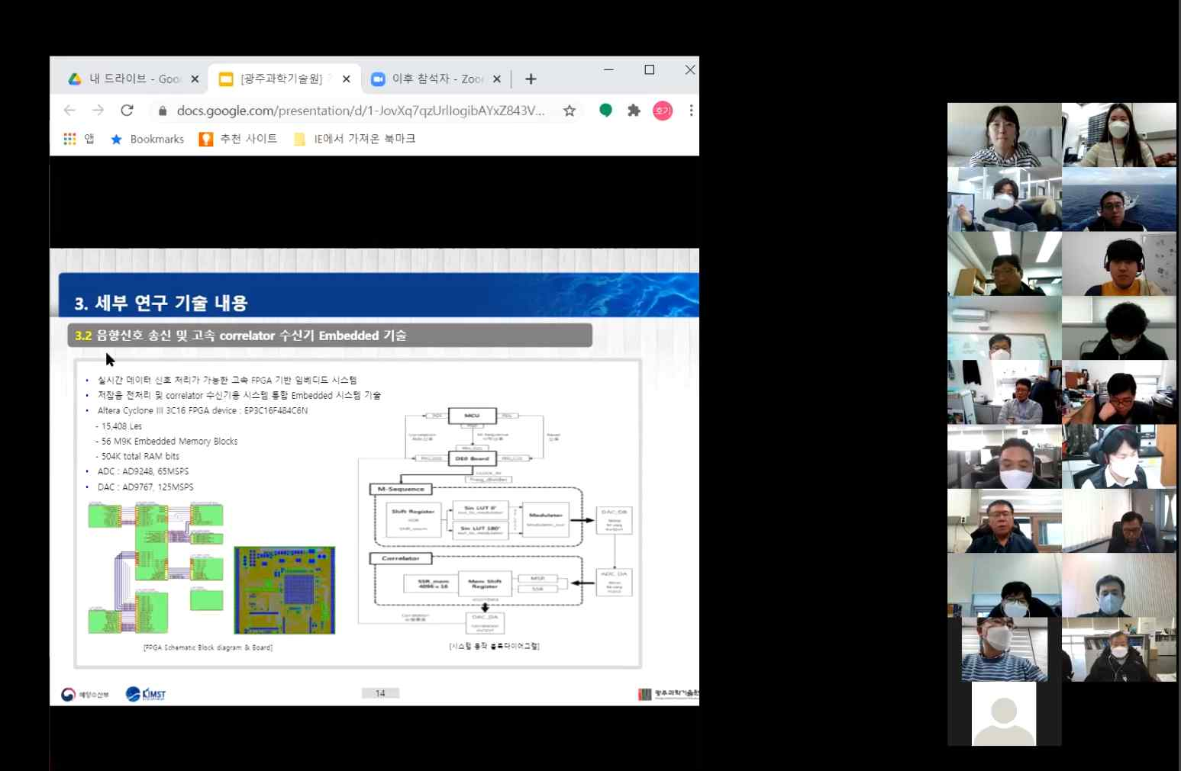
▲ Holding an online briefing session for technology transfer to localize marine equipment



