
Gwangju Institute of Science and Technology
Official Press Release — https://www.gist.ac.kr

Section of Hyo Jung Kim Nayeong Lee
Public Relations Section Chief Senior Administrator
062-715-2061 062-715-2062

Contact Person Tae-wook Kim, Researcher
for this Article GIST Korea Culture Technology Institute
062-715-4930

Release Date 2020.12.18

GIST Korea Culture Technology Institute hosts 'CT Imagination Room Exhibition'... realize your imagination

□ GIST (Gwangju Institute of Science and Technology, President Kiseon Kim) Korea Culture Technology Institute (Director Moongu Jeon) hosted the 2020 'CT Imagination Room Exhibition,' which turned imagination into reality, at the GIST Dasan Building from December 16 to 17.



∘ This exhibition allowed the public to experience various exhibits in a large stage setting space so that the major research achievements of the GIST Korea Culture Technology Institute for this past year can be seen at a glance.

□ Major research outcomes included ▲ realistic smart media wall platform technology that enables interaction ▲ platform technology that converts an exhibition's rich cultural life descriptions at museums, art galleries, etc. into Korean sign language for the hearing impaired ▲ Virtual underwater environment experience technology was exhibited based on Korea's ocean and weather data.

∘ ▲ Applied with realistic smart media wall platform technology that enables interaction, "Asian Culture Map-Ramayana Road" is an interactive information exploration type exhibition that combines Asian cultural resources and cultural technologies of the Asia Culture Center. While researching and developing the element technologies of the intelligent agent-based smart media wall platform, the historical trend of Asian culture was visualized on a map with the theme of "Ramayana," an Asian epic that is representative of Asia's "development."

∘ ▲ The platform technology that converts an exhibition's rich cultural life descriptions at museums and art galleries into Korean sign language for the hearing impaired is an evaluation of the usability of prototypes for providing real-time text and Korean sign language conversion services. It has been developed to allow users to experience the translation of comb-pattern, plain-patterned, long-range, and hologram exhibition contents in sign language.

∘ ▲ The "Water Has Memory" exhibition, developed based on the virtual underwater environment experience technology based on Korea's ocean and weather data, is a project under development as an entry in the "Ars Electronica" contest, which is a global media art festival in 2021. Based on Korean traditional values and mythical elements, the goal was to propose a'synergistic coexistence paradigm' based on' respect and reverence', rather than establishing a hostile relationship between nature, science, and development. The artificial intelligence character "Madam Yongshin" lives in the virtual sea and changes in response to real-time Korean oceanic and weather data. Audiences can have a visual experience of going back and forth between the calm and deep sea and the colorful and lively sea created by colorful creatures.

□ Director Moongu Jeon said, "The technologies introduced at this performance exhibition will be displayed and demonstrated through the completion of technologies using artificial intelligence based interactions in the future. The research center wants to create and develop a variety of interesting cultural contents that the general public can enjoy."

□ The GIST Korea Culture Technology Institute was established in April 2013 to conduct cultural technology research based on exchanges and convergence among various academic fields, including science and technology, design, culture and arts, and humanities. The institute carried out projects for designating policies on cultural technology research and development, projects for strengthening science and culture exhibition services, and cooperative planning projects for supporting convergence arts creation of the Korean Culture and Arts Council. Recently, the government is actively conducting research and development of cultural technology to utilize artificial intelligence real-time media facade mapping technology for a number of performances and exhibition contents and drive the development of a national cultural industry.

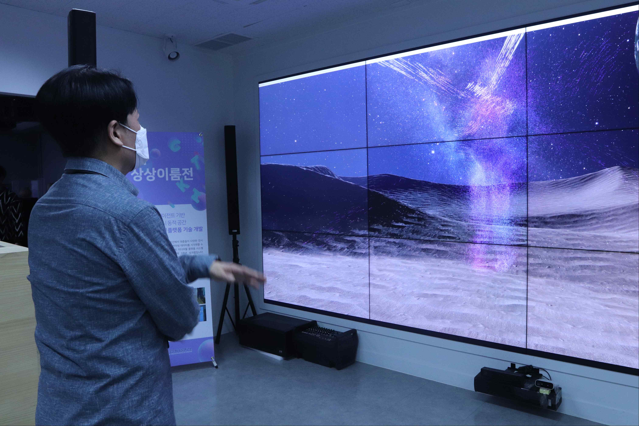
▲ Photo 1. Interactive information search type exhibition demonstration

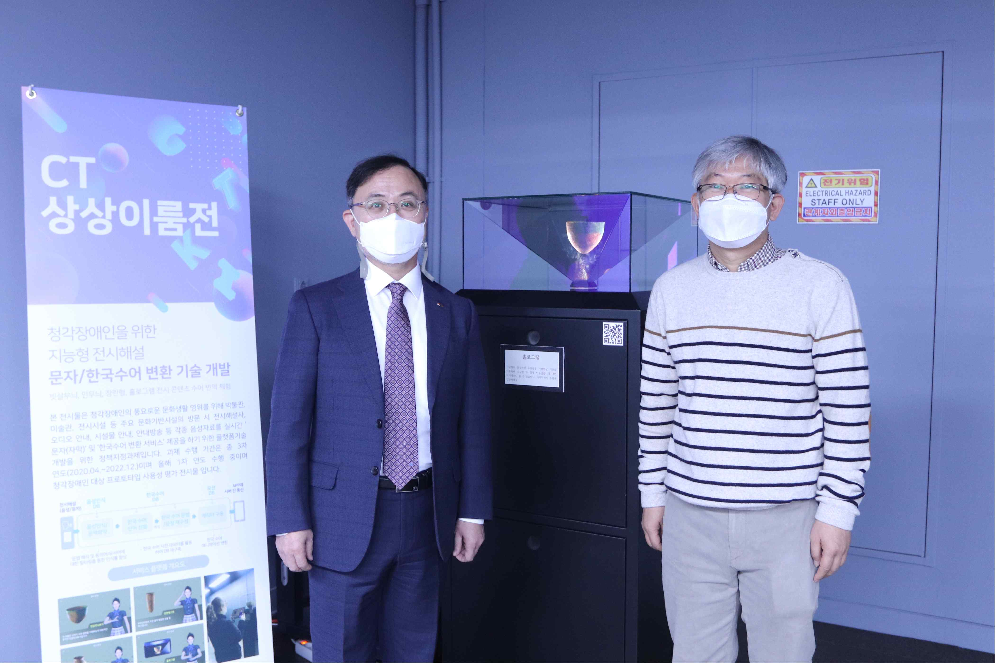
▲ Photo 2. Exhibition Commentary Korean Sign Language Transformation
Platform Technology (Hologram) _ From left: Vice President of R&D In S. Kim
and Korea Culture Technology Institute Director Moongu Jeon

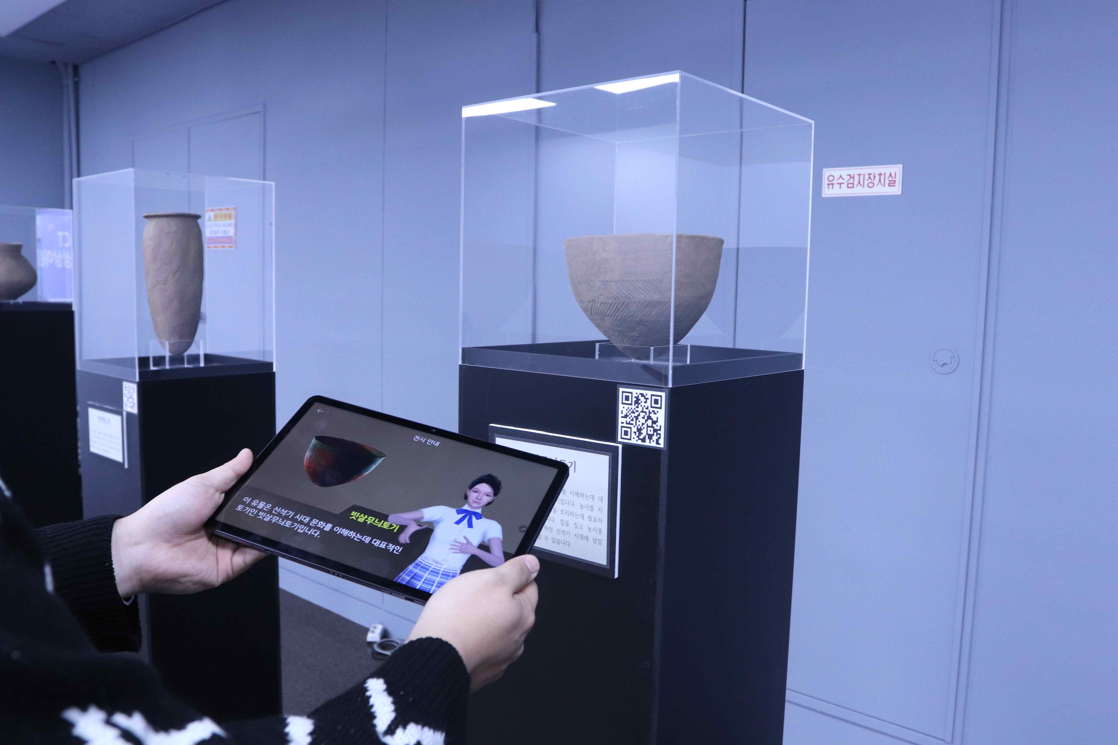
▲ Photo 3. Exhibition commentary Korean sign language
conversion platform technology (comb-patterned earthenware)

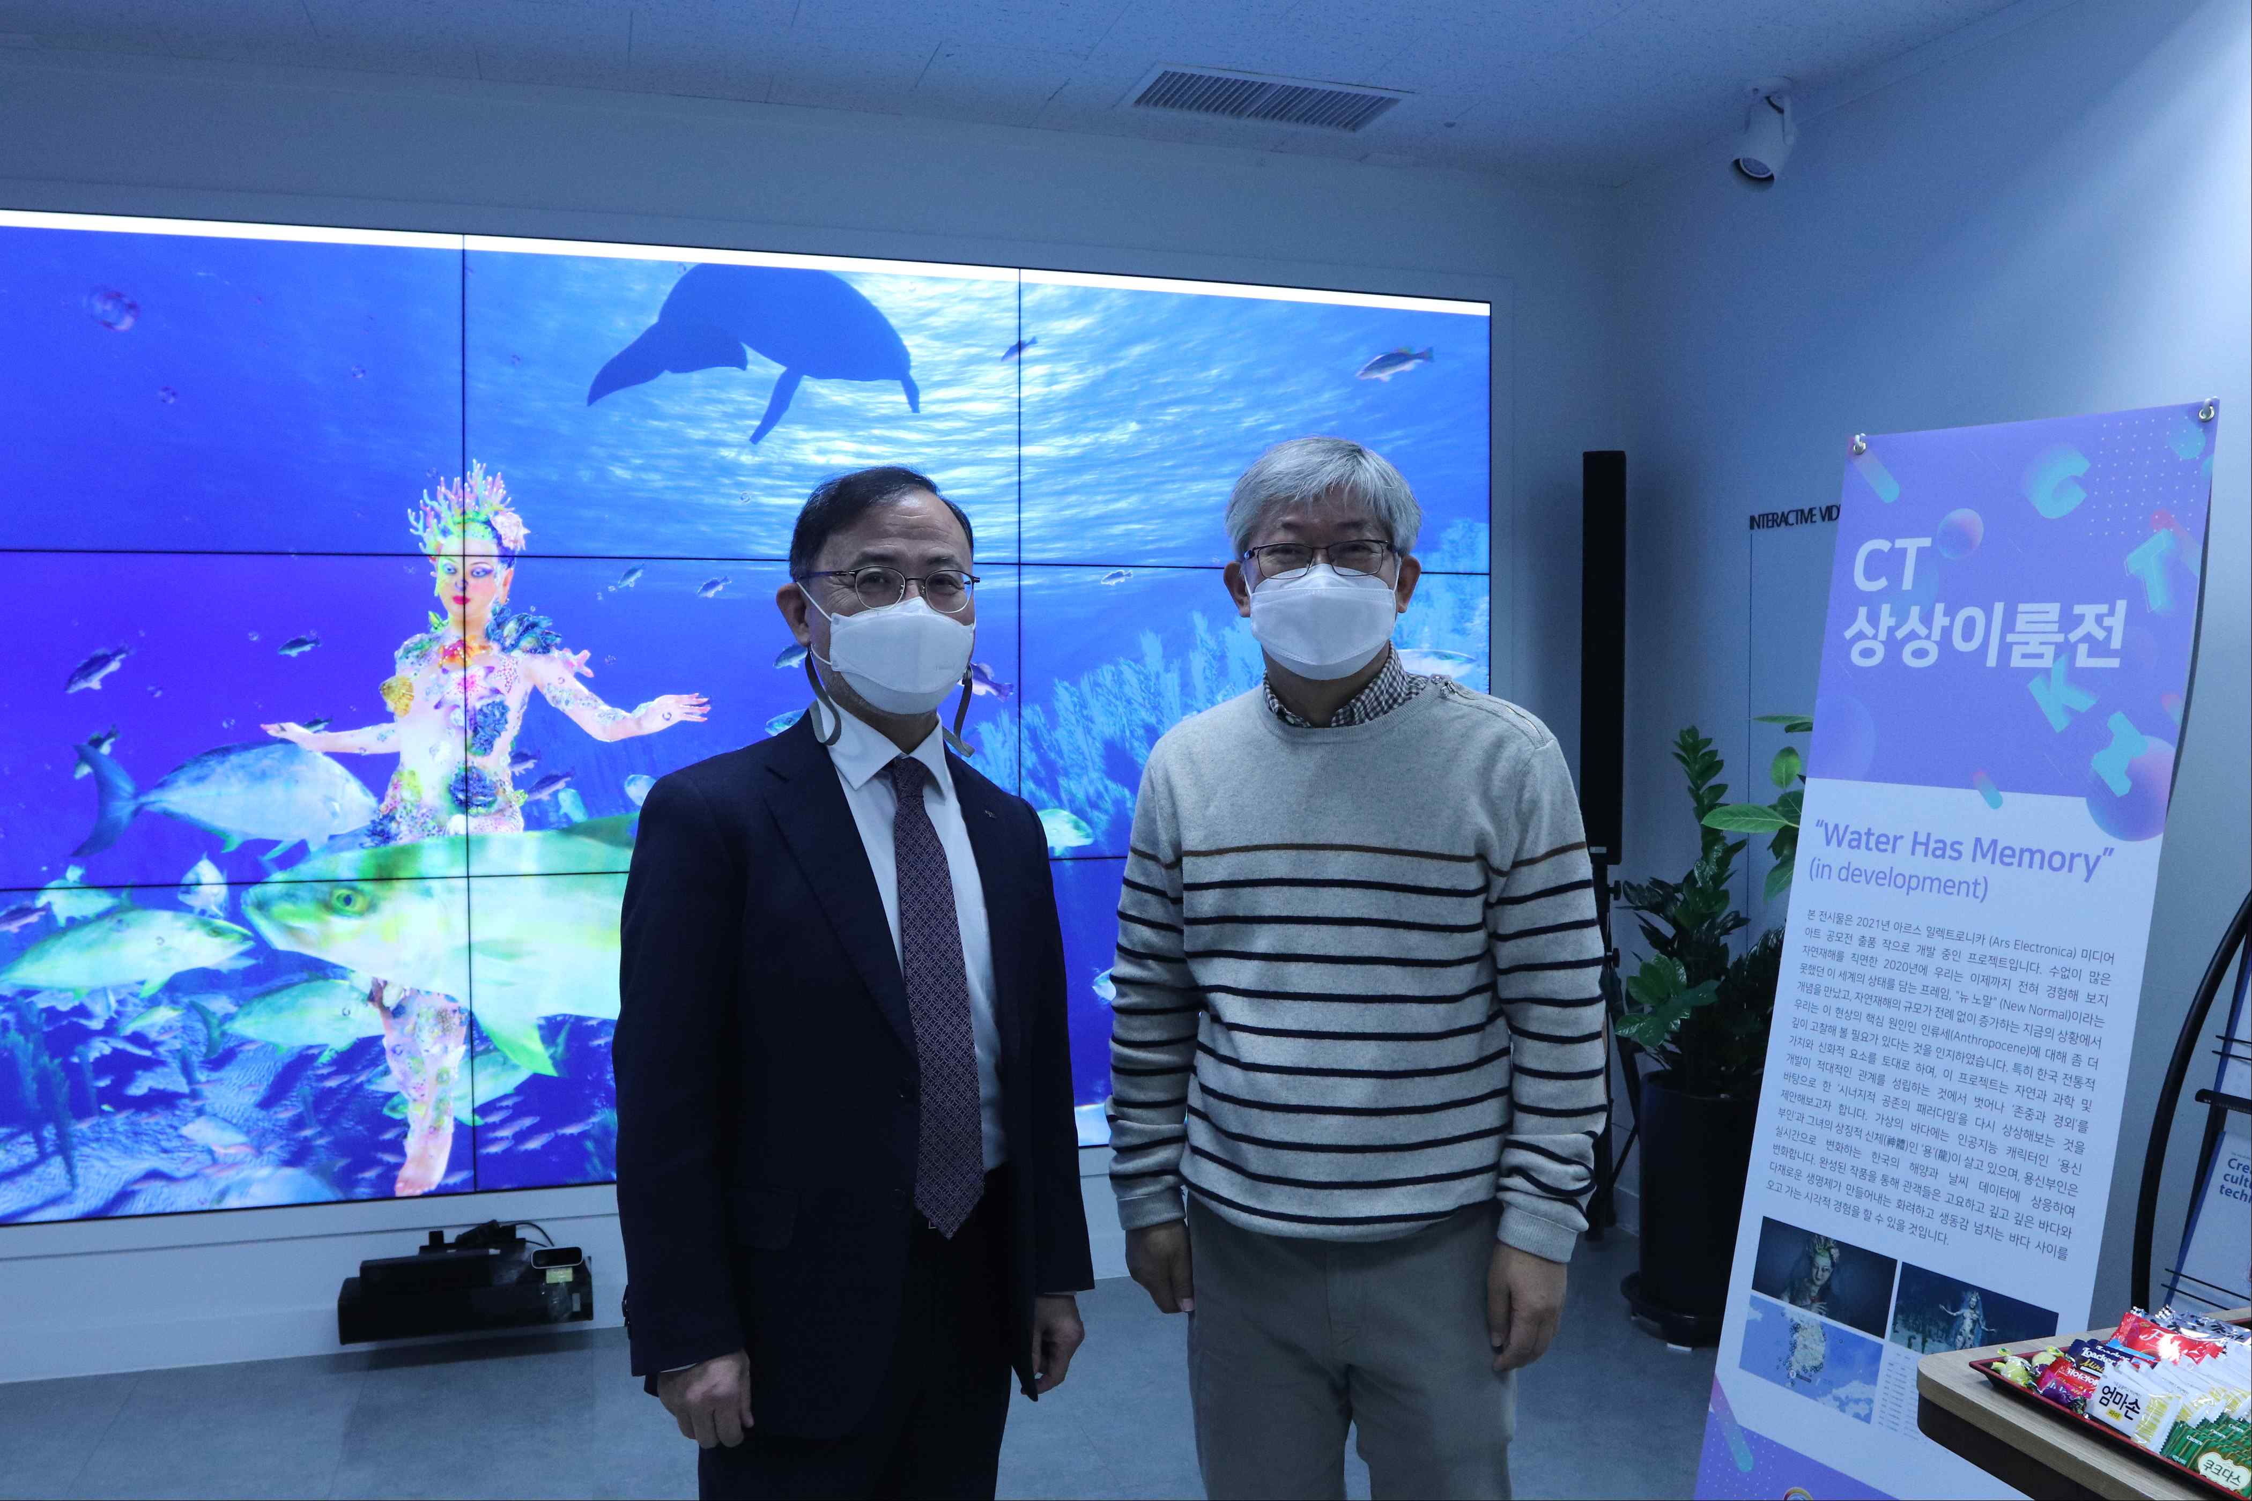
▲ Photo 4. Virtual Undersea Environment Experience Technology
(Water Has Memory) _ From left: Vice President of R&D In S. Kim
and Korea Culture Technology Institute Director Moongu Jeon



