
Gwangju Institute of Science and Technology
Official Press Release — https://www.gist.ac.kr

Section of Hyo Jung Kim Nayeong Lee
Public Relations Section Chief Senior Administrator
062-715-2061 062-715-2062

Contact Person Seung Su You, Administrator
for this Article Section of Public Affairs
062-715-2025

Release Date 2020.12.17

GIST signs agreement with the Gwangju Institute of Design Promotion for integrated design research and industrialization

□ GIST (Gwangju Institute of Science and Technology, President Kiseon Kim) signed a business agreement on December 16 with the Gwangju Institute of Design Promotion (Director Sung-ho Wi) for the promotion of local industries and the development of both organizations for the popularization of design.



∘ The agreement ceremony was held via video conference at each organization with the attendance of GIST President Kiseon Kim, Gwangju Institute of Design Promotion Director Sung-ho Wi, and other officials.

□ The main contents of the agreement includes ▲ joint discovery and implementation of artificial intelligence industry-related projects in Gwangju ▲ participation in joint projects (research, exhibition, and events) related to the Gwangju Design Biennale ▲ joint discovery and implementation of the central government public project proposals (convergence research, dissemination/distribution) and ▲ matters related to joint public relations between the two organizations.

□ GIST President Kiseon Kim said, "This business agreement is expected to have a positive effect on industrialization of design and fostering regional flagship industries for public experience and enjoyment of design, such as holding the Gwangju Design Biennale. In the future, we will actively pursue joint projects for regional development, such as design convergence research, which will be based on various exchanges and cooperation."

□ Gwangju Institute of Design Promotion Director Sung-ho Wi said, "The Gwangju Design Biennale is solidifying its position as an international event in Gwangju. During the 2021 Gwangju Design Biennale (theme:'D-Revolution'), we will try to attract visitors so that foreign students can also visit the Design Biennale."

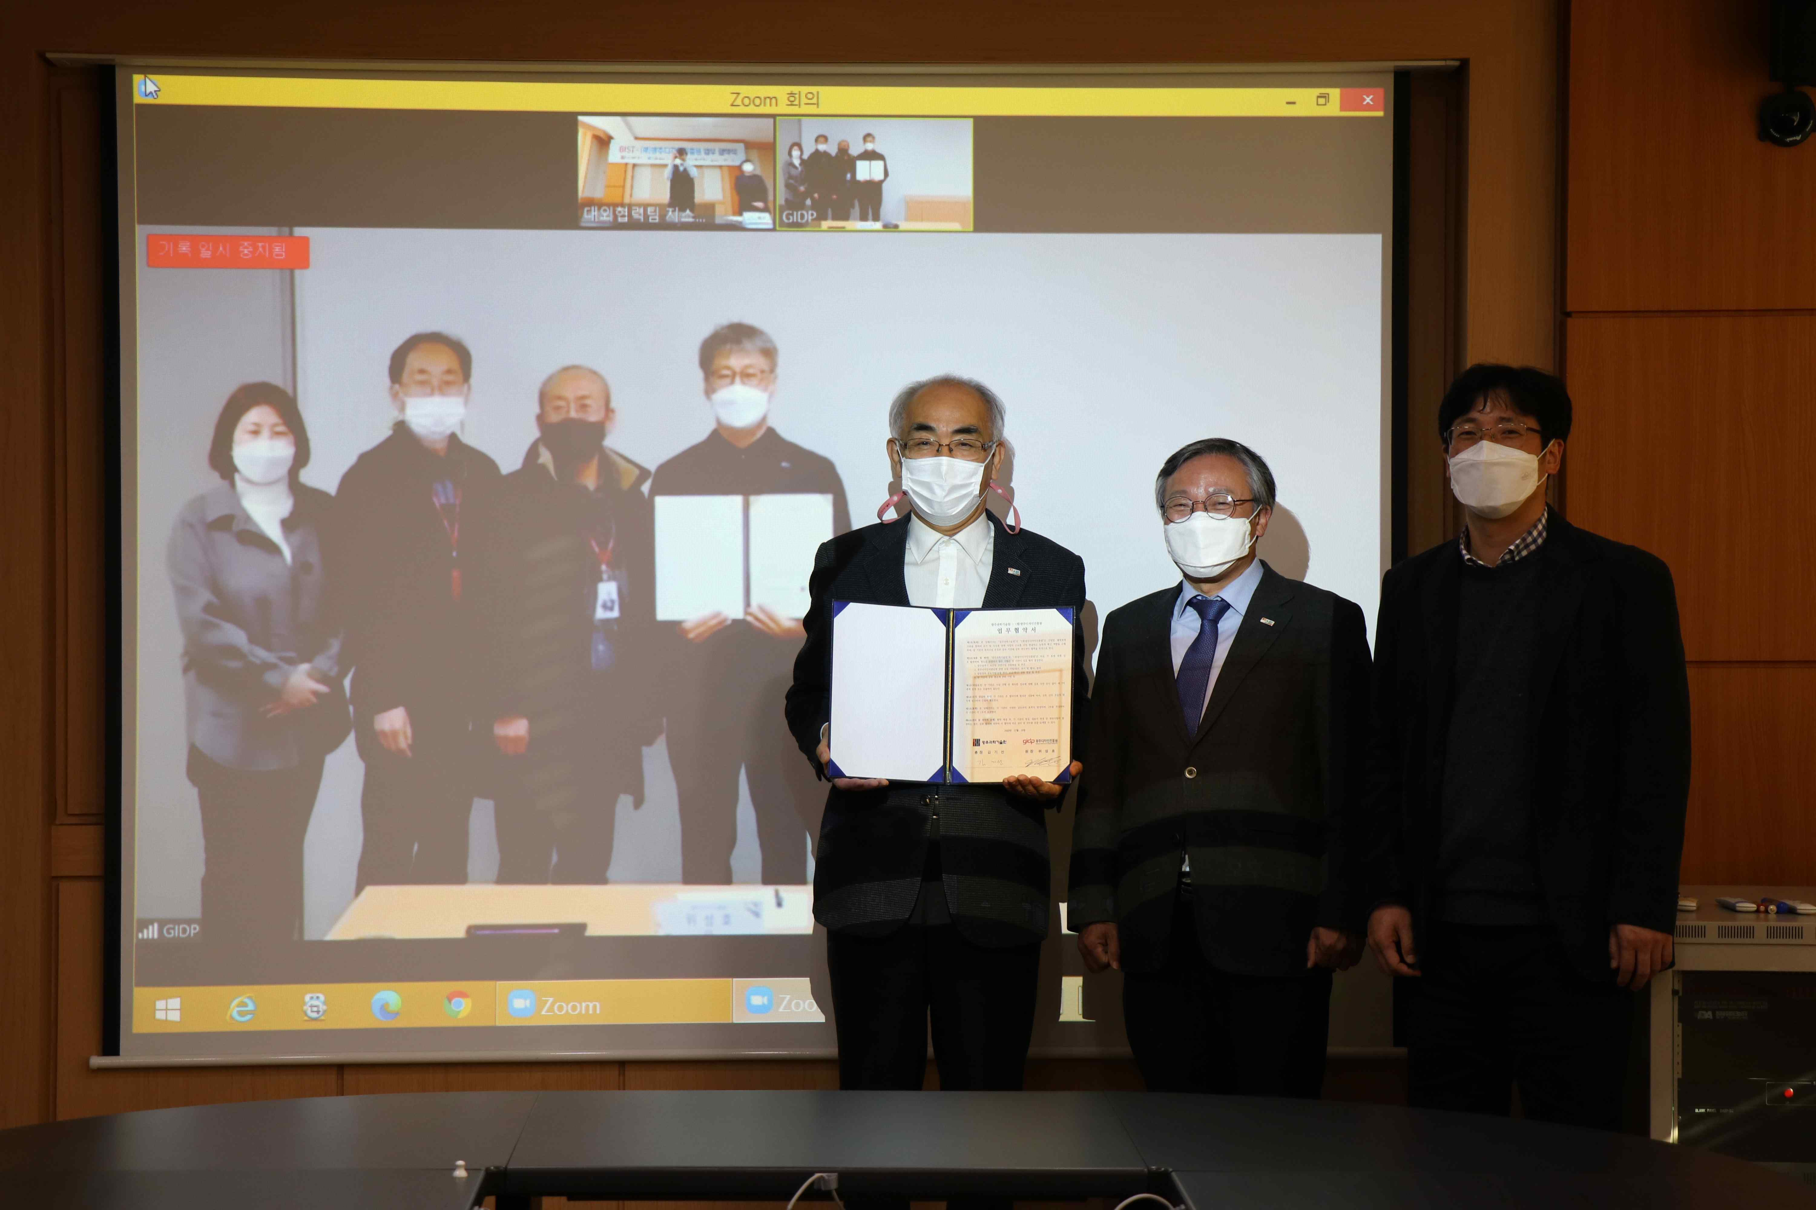
▲ GIST signed a business agreement with the Gwangju Institute of Design Promotion (From left: Gwangju Institute of Design Promotion Education Event Team Leader Yoon-joo Jung, Planning and Management Division Director Min-seok Yoon, Design Invitational Headquarters Director Jang-Gyu Cho, Director Sang-Ho Wi, GIST President Kim Ki-seon, Vice President for Public Affairs Young-jip Kim, and Office of International and Public Affairs Dean Sung-Gyoo Park)



