Gwangju Institute of Science and Technology
Official Press Release — https://www.gist.ac.kr

Section of Hyo Jung Kim Nayeong Lee
Public Relations Section Chief Senior Administrator
062-715-2061 062-715-2062

Contact Person Duk-jo Kong, Senior Researcher
for this Article GIST Institute for Artificial Intelligence
062-715-6916

Release Date 2020.12.17

GIST successfully concludes AI start-up contest

□ GIST (Gwangju Institute of Science and Technology, President Kiseon Kim) Institute for Artificial Intelligence (Director JongWon Kim) successfully completed the "Dreaming Child (AI)" competition on December 5th and 12th.

∘ This contest was promoted by the Ministry of Science and ICT and the Gwangju Metropolitan City as the'Artificial Intelligence-centered Industrial Convergence Integrated Complex Project,' hosted by the Artificial Intelligence Industry Convergence Project Group (Director Cha-sik Lim), and organized by GIST.



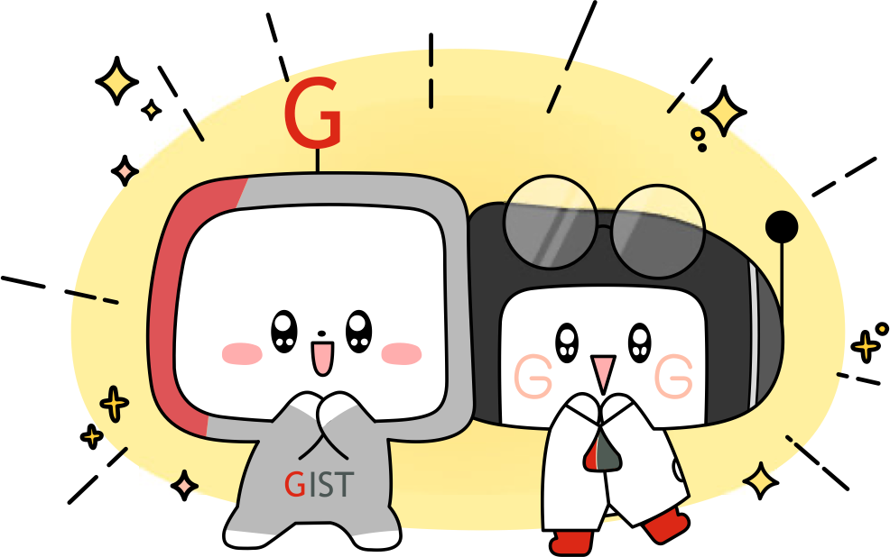
□ To prevent the spread of COVID-19, this competition strictly complied with the safety rules in accordance with the quarantine guidelines issued by the government and the city of Gwangju. A total of 128 teams participated in an on-off mix method competition, and the final winners of each of the four categories were screened after a fierce preliminary and final round.

∘ The winning team by category were ▲ Healthcare: Cor-BERT team (Team Representative Hae-ri Bae, GIST) "Development of new drugs using artificial intelligence (AI)" ▲ Energy: Cognitive Performance Team (Team Representative Jae-seok Park, Kyungpook National University) "Natural Language Processing (Chatbot)" ▲ Automotive: Kim Moon-bak Team (Team Representative Su-ho Kim, KISTI) "Flying drones accurately recognizes the object and designates the exact location on the GUI" ▲ Open Challenge: GISTIK Team (Team Representative Woo-Seok Song, GIST) "Automatically generate/search for drama background music." In addition, they present technology development strategies and business models.

∘ ▲ The winning team in the healthcare field, the Cor-BERT team, was highly praised for its technological maturity compared to the other teams and its potential for development in the future. ▲ The winning team in the energy field, the Cognitive Performance Team, was evaluated for outstanding technical and business feasibility of the proposed open domain chatbot solution. ▲ Kim Moon-bak Team, the winning team in the automotive field, was recognized for its excellence in its commercialization plan, which suggests a safe driving route according to the condition of the road identified by drones. ▲ GISTIK Team, the winning team in the open challenge field, was honored with the title due to its outstanding specificity in the business model applied to web dramas.

□ Including the winning teams, eight teams in the healthcare and automobile category, six teams in the energy category, and seven teams in the open-challenge category were selected, with a total of 29 teams winning awards. The top-ranked team will receive 20 million won in prize money and Gwangju Metropolitan City Mayor's Award, which will be presented at the Artificial Intelligence Merit Awards held at the Ramada Hotel on December 29. The second place winner was given 8.5 million won in prize money and the GIST Presidential Award, while the third and fourth place were awarded 5 million won and 2.5 million won, respectively.

∘ In-gu Lee of Cor-BERT, the winning team in the healthcare category, said, "I would like to thank the team members who worked hard with the GIST Institute for Artificial Intelligence, and especially GIST AI Graduate School Professor Hojung Nam for her guidance. It was a very beneficial experience to study practical business models and think about pending issues, and I want to challenge myself on a bigger world stage in the future."

∘ Jae-seok Park of the Cognitive Performance Team, the winning team in the energy category, said, "Participating in this Dreaming Child competition gave me an opportunity to grow and learn a lot. To solve the proposed natural language processing problem, I thought about and tried various things. In the process of searching various papers to improve performance and in considering various conditions such as business models, technical completeness, and serviceability in the process of developing ideas, this was an opportunity for personal growth. Thank you to the AI Industry Convergence Project Group and LG Electronics for hosting and planning this program, and it would be great if this opportunity could continue to be held in the future."

∘ Soo-ho Kim of the Kim Moon-bak Team, the winning team in the automotive category, said, "To apply what we learned from the KISTI big data training course and to prepare for the Dreaming Child competition, I learned the importance of constructing a dataset for image classification. In the process of doing this, we were able to solidify our understanding of the overall process of deep learning and improve our problem-solving ability using deep learning. In addition, it was a good time to think about business models using drones, and I will study more in this field and try to become an expert in the future."

∘ Gyu-min Cho of the GISTIK Team, the winning team in the open challenge category, said, "GISTIK composes a bgm suitable for the input image using a genetic algorithm, and we produced a program that matches the scene and bgm with CNN. I was able to compete in this competition because there was someone who encouraged me to be strong every day and was on my side, such as my professor who supported me and helped me every day and my lab colleagues who were always by my side. Thanks to them, I was able to have a rare experience not only in producing programs but also in establishing business models and receiving evaluations about them, so I would like to take this opportunity to say thank you."

□ The 'Dreaming Child (AI)' contest is the largest in Korea, with a total prize of KRW 187 million with participation from large corporations like Amazon Web Services (AWS), NVIDIA, Intel, LG Electronics, CJ OliveNetworks, and the Korea Photonics Technology Institute.

∘ Companies presented problems in the fields of healthcare healthcare, smart home appliances, drones, autonomous driving, and power demand forecasting, and participants attempted to solve the company's current problems during the the competition.

□ The pending issues presented by the companies were ▲ NVIDIA: "Using artificial intelligence GPU technology to minimize and prevent the spread of viruses such as COVID-19" ▲ LG Electronics: "Face and voice recognition for smart home appliances" ▲ Intel: "Drones accurately recognize objects as they fly and position them in a GUI" ▲ AWS: "Designing an autonomous driving algorithm and mounting it on a deep racer simulator to drive on an offline track in the shortest time and on the correct path" ▲ CJ OliveNetworks: "Automatic background music generation, virtual fitting" ▲ Korea Photonics Technology Institute: "Power usage prediction using existing power usage records."

□ GIST President Kiseon Kim said, "This achievement is the result of the hard work of all GIST members under the goal of human-centered artificial intelligence research and development. In the future, GIST will continue to do its best to warm and enrich the world by solving social problems and developing good technologies for the safety and health of all humanity."

□ Gwangju City Hall announced that it plans to give preferential treatment to the winning team of this competition as an artificial intelligence-centered industrial convergence complex project with start-up and commercialization consulting, prototyping cost support, matching companies with demand, and start-up space support.

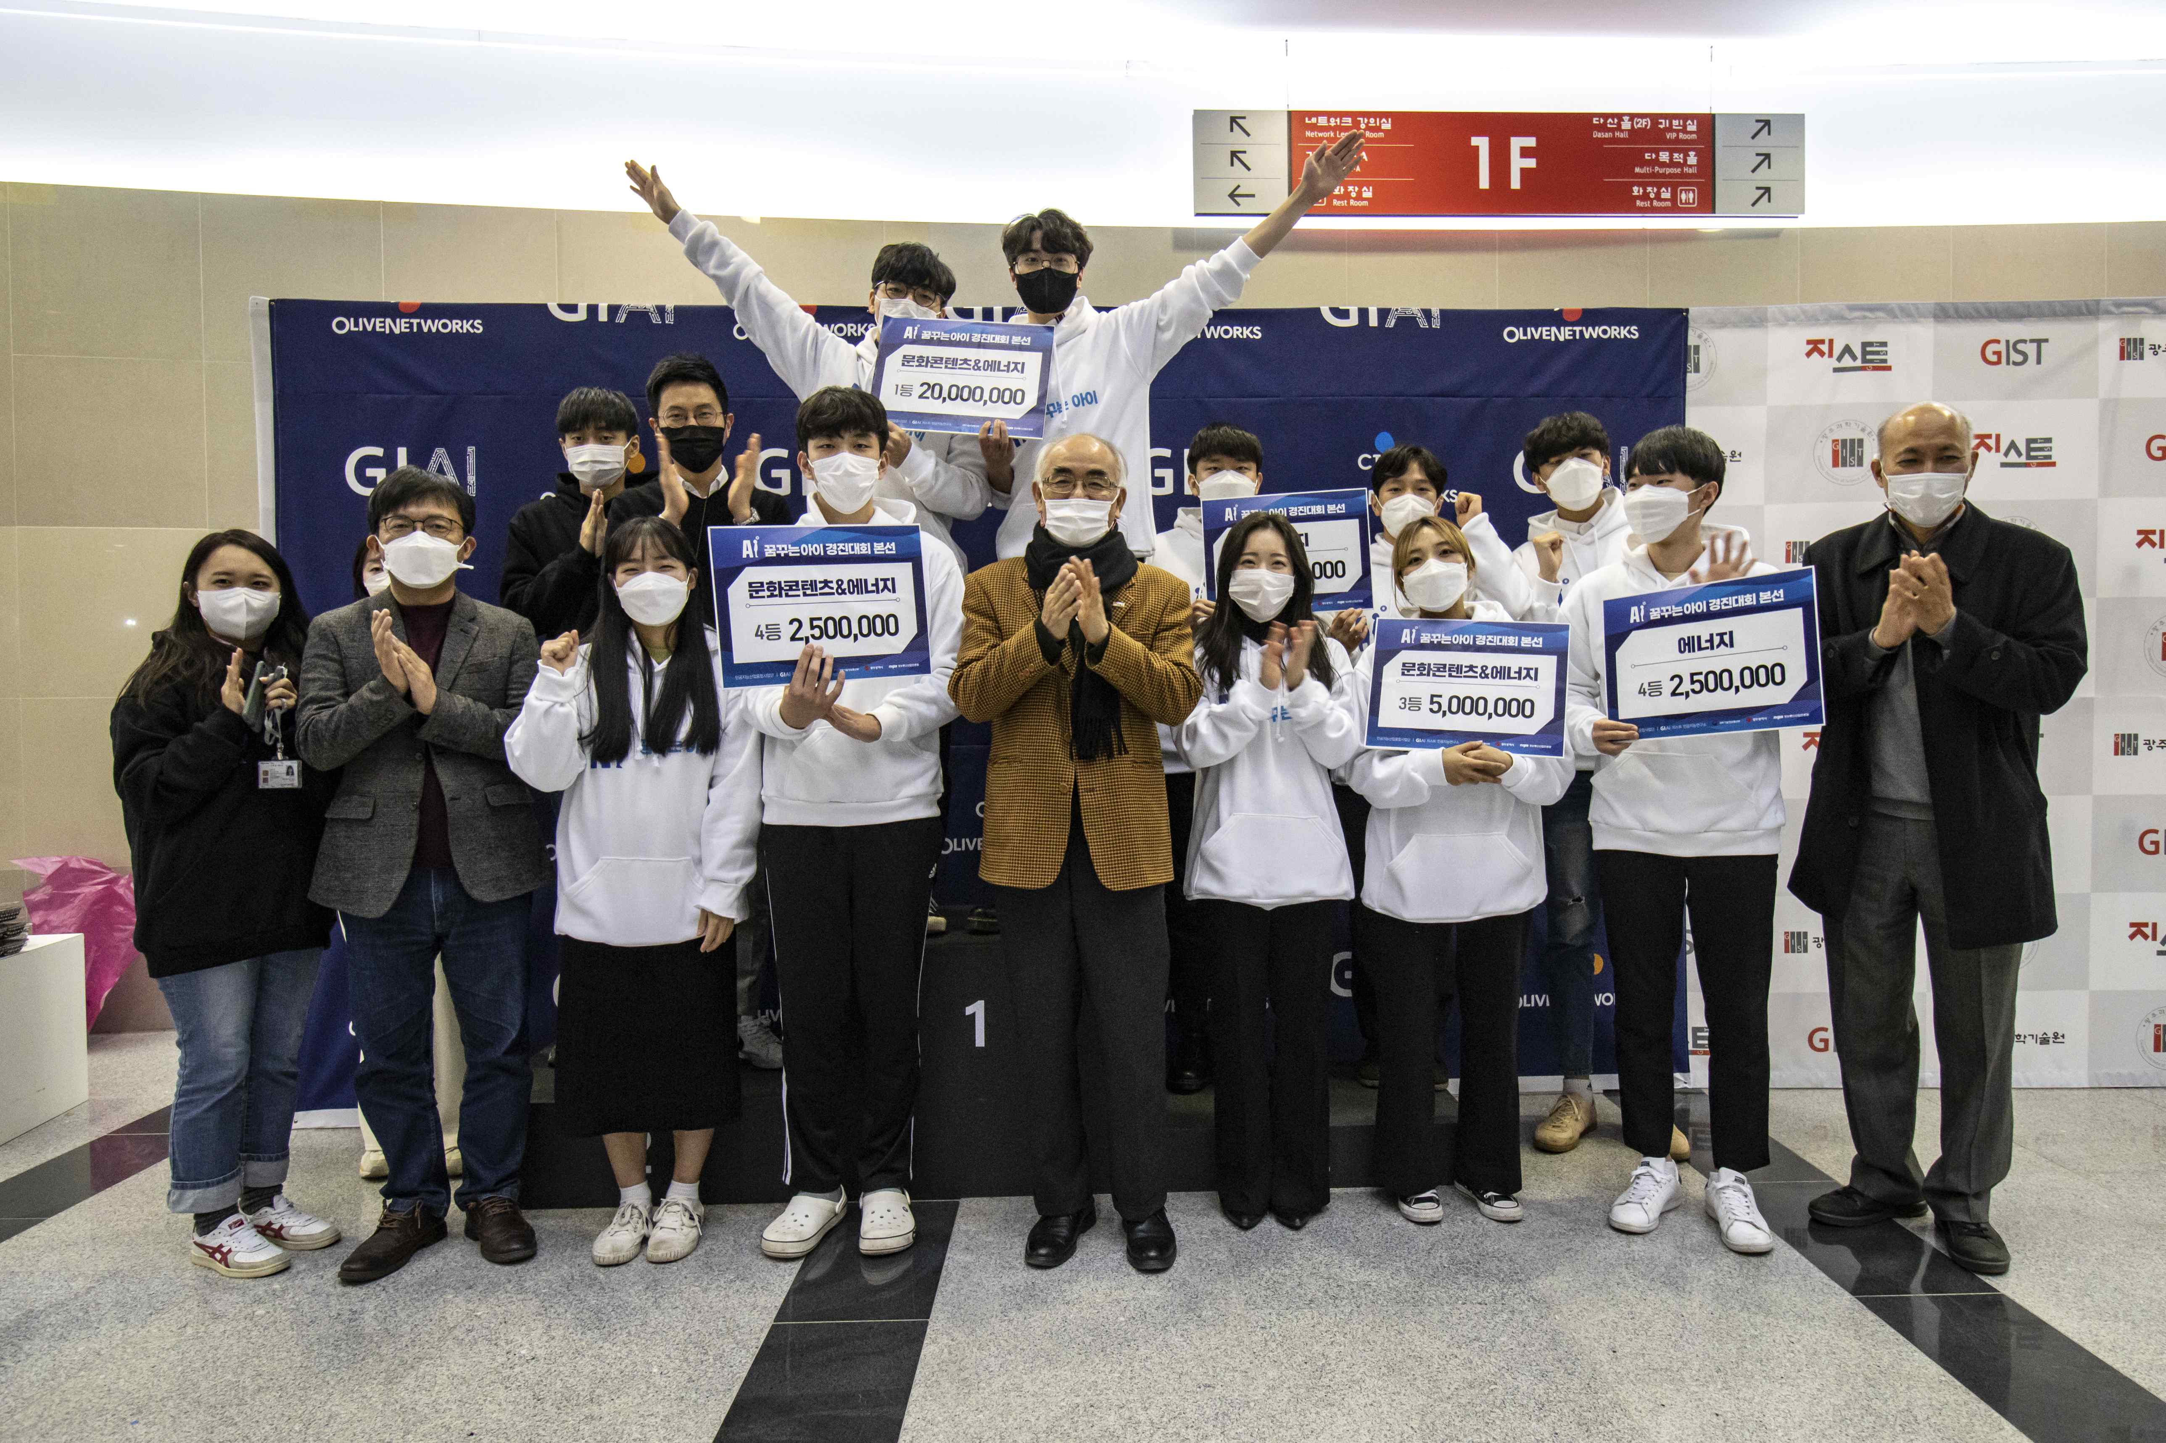
▲ The Dreaming Child AI contest was successfully held (GIST Oryong Hall)



