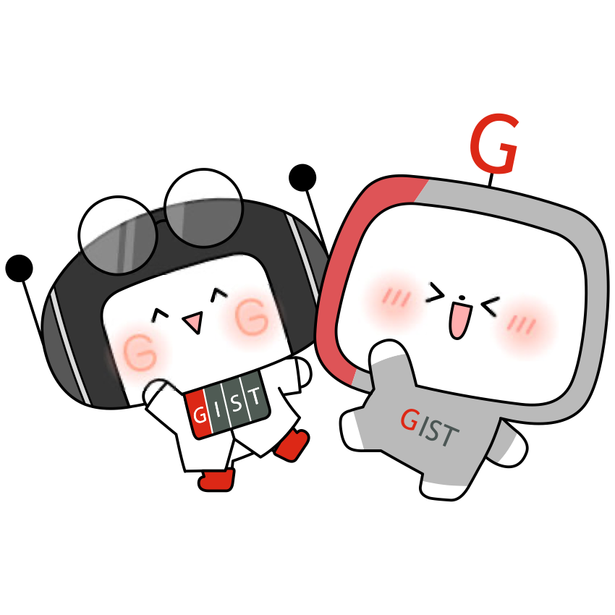
Gwangju Institute of Science and Technology
Official Press Release — https://www.gist.ac.kr

Section of Hyo Jung Kim Nayeong Lee
Public Relations Section Chief Senior Administrator
062-715-2061 062-715-2062

Contact Person You Seung Su, Administrator
for this Article Section of Public Affairs
062-715-2021

Release Date 2020.12.15

GIST's Development Fund receives 20 million
won from alumni associated companies

□ GIST (Gwangju Institute of Science and Technology, President Kiseon Kim) Development Fund recently received a total of 20 million won: 10 million from Sungil Livestock Farming Association CEO Yong-gi Lee and 10 million won from NH Networks Co., Ltd., CEO Geun-shin Lee.



∘ CEO Yong-gi Lee and CEO Geun-shin Lee both completed the 7th GIST Techno Management Business Academy (MBA) course and are regional representative professional managers who creatively cope with changing technological trends and internationalization paradigms.

□ The Sungil Livestock Farming Association was established in 2011 as a smart ICT fusion complex to modernizes livestock farming facilities and is constantly improving pig stock for breeding. In recognition of its excellence, such as acquiring eco-friendly livestock products and HACCP certification in 2012 and 2013. South Jeolla Province Governor Nak-yeon Lee visited the facility in 2017 to examine the status of the improved livestock.

∘ Established in 2001, NH Networks Co., Ltd., is a total solution company for the design, development, construction, and maintenance of CCTV video control systems necessary for integrated disaster control to help create a safer society. Through independent technology development, it has achieved remarkable achievements in various fields of ICT such as image improvement, image analysis, and energy regeneration. Through constant R&D, it has obtained 8 patents and GS certification, including for a remote location tracking system.

□ CEO Yong-gi Lee said, "After graduating from the GIST Techno Management Business Academy, I came to think that I would like to participate in cultivating talented people with affection to give back to GIST. In the midst of global change, the power of science is the power of innovation and the driving force of the world. I hope that GIST will serve as resource for the development of regional and national scientific culture."

∘ GIST Vice President for Public Affairs Young-jip Kim received the donation and said, "I would like to thank the warm, precious hearts of these two representatives for assisting in the development of GIST. GIST will actively take the lead in strengthening the future competitiveness of local industries and local economies by fostering outstanding scientific specialists."


▲ [From left] Sungil Livestock Farming Association CEO Yong-gi Lee
and NH Networks Co., Ltd., CEO Geun-shin Lee



