
Gwangju Institute of Science and Technology

Official Press Release (https://www.gist.ac.kr/)

Section of Hyo Jung Kim Nayeong Lee
Public Relations Section Chief Senior Administrator
(+82) 62-715-2061 (+82) 62-715-2062

Contact Person Chang-sung Kang
for this Article Business Support Center
062-715-6303

Release Date 2020.11.30

GIST receives excellence award for Best
College for Entrepreneurship in 2020

□ GIST (Gwangju Institute of Science and Technology, President Kiseon Kim) received the "Best College for Entrepreneurship in 2020" excellence award from the Korea Business Incubation Association and Maeil Business News.

∘ From 2017 to 2019, GIST topped the list of outstanding start-up universities for three consecutive years, and this year it won the excellence award in the category of start-up performance.

□ The award recipients were selected through a comprehensive evaluation of the Maekyung University Startup Index for three categories: start-up infrastructure, start-up support, and start-up performance for 244 four-year general universities and 167 professional universities.

□ Since opening the Business Support Center in 2000, GIST has planned and supported various start-up support programs and has received the best evaluation for its start-up operations 13 times by the Ministry of SMEs and Startups.

∘ In addition, it was selected as an excellent organization for supporting customized business start-ups in 2015 and was awarded a citation from the Ministry of Science, ICT and Future Planning (currently the Ministry of Science and ICT) in the 2016 Creative Economy Venture Startup Competition. In addition, it has been selected as the host organization of the start-up business support package for five consecutive years since 2016, and the preliminary start-up package has also been selected for two consecutive years since 2019. It has also been receiving good reviews for its start-up support and performance.

□ Business Support Center Director Byung-kwan Jo said, "GIST's excellent start-up achievements are based on the result of actively supporting specialized programs for each stage of start-up, such as supporting customized start-ups for customers, holding a start-up idea contest, and operating a program for business growth. GIST will continue to take the lead in creating jobs and contributing to the development of local industries by actively supporting start-ups in the field of artificial intelligence (AI) and to revitalize specialized local industries."

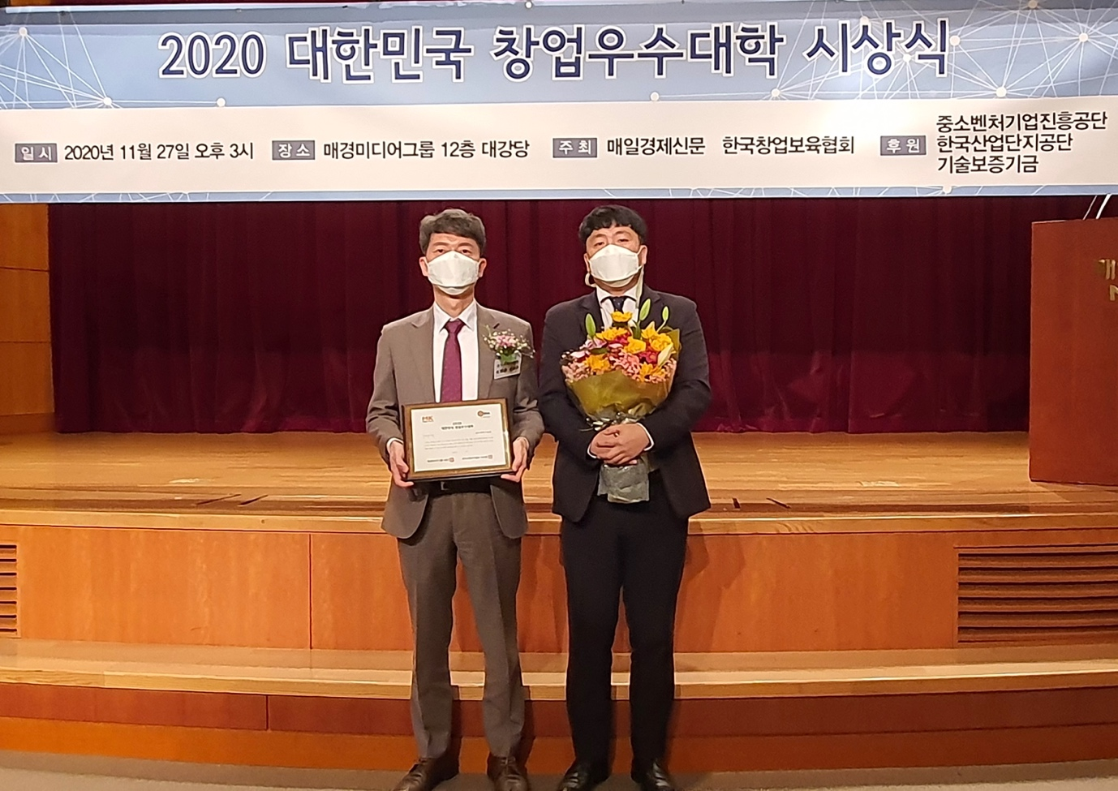▲ GIST receives excellence award for Best College for Entrepreneurship in 2020

