
Gwangju Institute of Science and Technology

Official Press Release (https://www.gist.ac.kr/)

Section of Hyo Jung Kim Nayeong Lee
Public Relations Section Chief Senior Administrator
(+82) 62-715-2061 (+82) 62-715-2062

Contact Person Moon-seop Yoon, Administrator
for this Article Section of Public Affairs
062-715-2021

Release Date 2020.11.26

GIST Development Foundation delivers smart devices and masks to 20 schools in the Gurye area

□ GIST (Gwangju Institute of Science and Technology, President Kiseon Kim) Development Foundation (Chairman Jung-joo Ko) delivered smart devices and masks to 20 schools in the Gurye area on November 24 to narrow the digital gap caused by online learning and to encourage recovery activities in flood-stricken areas.

∘ For this social contribution project, 15 smart devices and 6,000 masks were delivered by the GIST Development Foundation to 20 schools selected through the Gurye Office of Education.

□ GIST Development Foundation Chairman Jung-joo Ko said, "It is heartwarming to carry out social contribution projects to improve education in our region. Through steady social contribution projects, we will also strive for continuous regional development."

∘ Gurye-dong Middle School Principal Yang-soon Moon said, "We are deeply grateful for the social contribution projects of GIST's Development Foundation during this difficult period of Covid-19 resurgence. I will do my best for the school to improve education together with community through respect, consideration and communication."

□ Gurye-dong Middle School was established in 1969 and currently has about 30 students. Principal Yang-soon Moon was appointed as the 21st principal in September 2020 and is striving with passion and sincerity to improve the progress of education.

∘ The delivery ceremony was carried out simply by only visiting Gurye-dong Middle School to represent all of the selected schools, and the visitors followed Covid-19 safety rules.

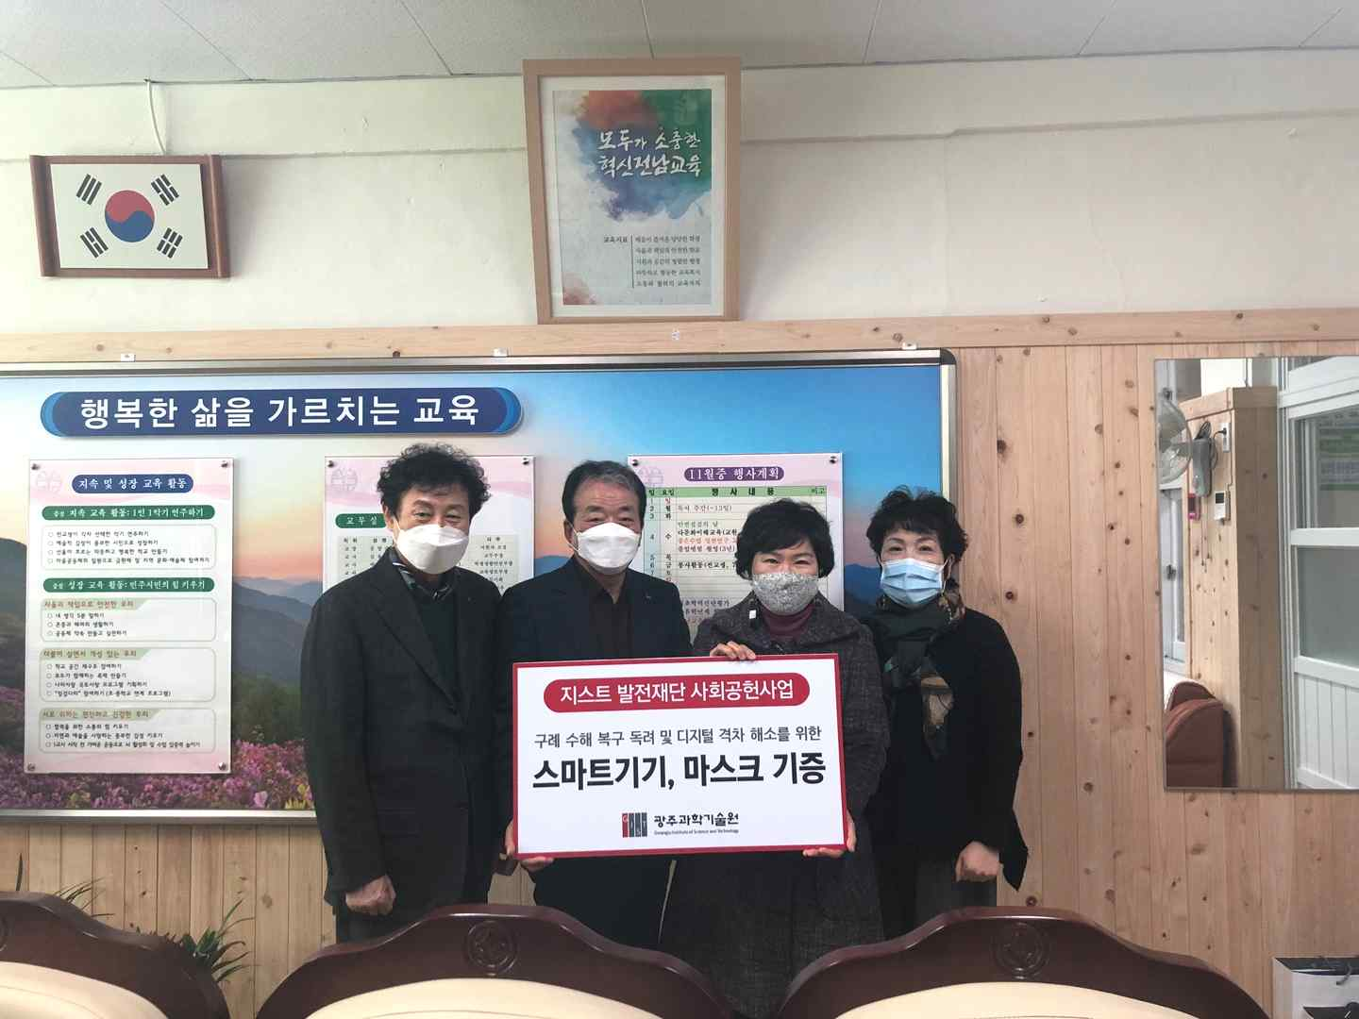
▲ [From left] GIST Development Fund Vice-Chairman Kyung-hyun Song (Chairman of Kyunghyang Industry), GIST Development Foundation Chairman Jung-joo Ko (Chairman of Nayeong Industry), and Gurye-dong Middle School Principal Yang-soon Moon

