
Gwangju Institute of Science and Technology

Official Press Release (https://www.gist.ac.kr/)

Section of Hyo Jung Kim Nayeong Lee
Public Relations Section Chief Senior Administrator
(+82) 62-715-2061 (+82) 62-715-2062

Contact Person Chang-sung Kang, Administrator
for this Article Business Support Center
062-715-6303

Release Date 2020.11.24

GIST Science and Culture Week holds
AI & IOT start-up competition

□ GIST (Gwangju Institute of Science and Technology, President Kiseon Kim) AI & IOT Makeathon*, an event for the general public to lead the 4th Industrial Revolution, was held overnight from November 13 to 14.

* Artificial Intelligence & Internet of Things Makathon: GIST's next-generation training program and idea generating contest for AI & IOT in the era of the 4th Industrial Revolution

∘ Hosted by GIST and co-hosted by the GIST Business Support Center and Open Lab Co., Ltd., this event was moved from the Creative Space G* at GIST to the Gwangju Noble Stay Hotel because of Covid-19.

* GIST Creative Space G: a complex start-up space (general workshop and education seminar space, machine workshop for prototyping, and 3D printer room) where not only GIST members but also local university students and citizens can freely communicate

□ The competition was held online to prevent the spread of Coivd-19, and the final contest, which was held offline, ended safely and successfully without any special issues by adhering to the quarantine guidelines of the government and Gwangju City.

∘ This year, a total of 12 teams, including 4 teams in the Seoul metropolitan area, 5 teams in the Jeolla region, 2 teams in the Gyeongsang region, and 1 team in the Chungcheong region, applied for the application, and 9 teams (40 members) were selected after receiving documentation of their ideas. In October, the selected teams held an online pre-review session using ZOOM to provide equipment utilization education (3D Printer), software coding mentoring to implement their ideas, material selection mentoring, and hardware mentoring.

□ Business Support Center Director Byung-kwan Jo said, "This event served as an opportunity to develop innovative start-up ideas and to test ideas through prototype production. GIST will actively take the lead in discovering and supporting excellent start-up teams through planning and operation of distinctive start-up programs to lead the field of artificial intelligence (AI)."

∘ The grand prize of this event, which was held in a Makarthon (Making Marathon) method, was awarded to Chonnam National University R&C Team, the best award was given to the MC-OB team of Seoul Digitech High School, and the excellence award was given to the 721 team of Korea Polytechnic University. The Grand Prize was awarded with the GIST Science and Technology Application Research Center's Director's Award and a prize of 1 million won, and the best award and the excellence award were given the GIST Business Support Center Award and 500,000 won and 300,000 won respectively.

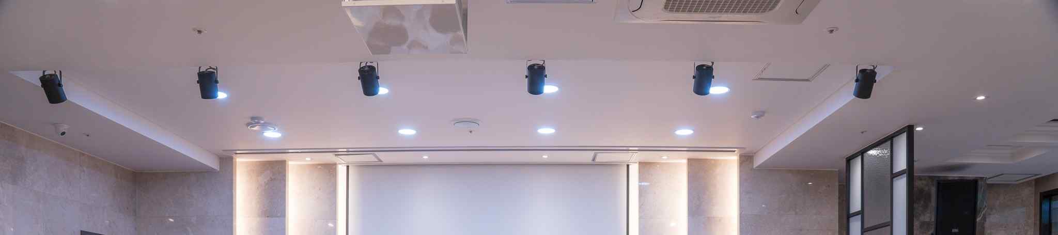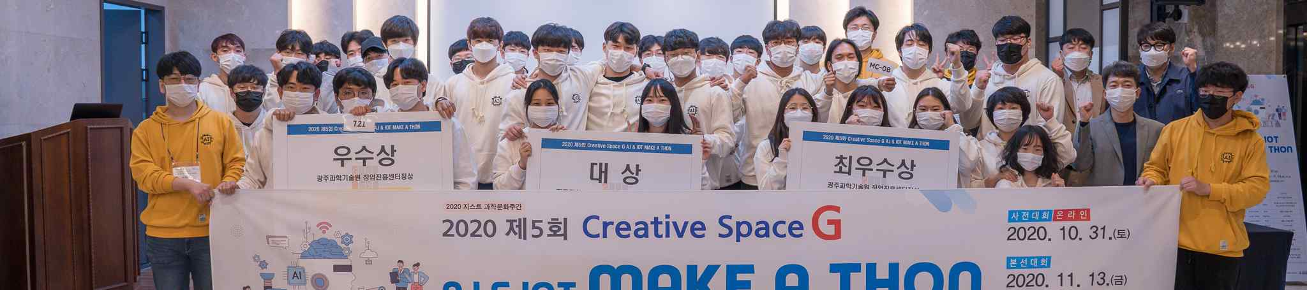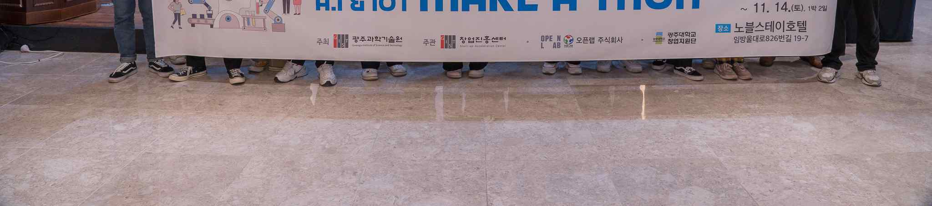
▲ 2020 AI & IOT Makathon start-up competition group photo

