
Gwangju Institute of Science and Technology

Official Press Release (https://www.gist.ac.kr/)

Section of Hyo Jung Kim Nayeong Lee
Public Relations Section Chief Senior Administrator
(+82) 62-715-2061 (+82) 62-715-2062

Release Date 2020.11.06

GIST, with three other science and technology institutes, opens 'Star Library,' an integrated
portal system

□ GIST (Gwangju Institute of Science and Technology, President Kiseon Kim) will integrate a portal system with the Korea Advanced Institute of Science and Technology (KAIST, President Seong-cheol Shin), the Daegu Gyeongbuk Institute of Science and Technology (DGIST, President Yang Kook) and the Ulsan Institute of Science and Technology (UNIST, President Yong-Hoon Lee) to comprehensively search information and research results.

∘ 'STAR Library (Science & Technology Advanced Research Library, http://starlibrary.org)' collects and analyzes science and technology information resources to support collaboration and convergence research. This is a jointly operated library portal site and has been operating since December 2015 with the support of the Ministry of Science and ICT.

□ The four institutes of science and technology have released information on 200,000 research results, including 100,000 papers, 15,000 patents, and 60,000 various academic activities, to the public from the second half of 2019 through the'Star Library' portal site. From this fall, the information of 752 laboratories, along with the information of 1,170 researchers (full-time faculty members) at the four science and technology institutes, can be searched and utilized in an integrated manner.

∘ In addition, the'Star Library' provides access to the latest research trends, including domestic and international research projects, and an integrated search of data held by the four science and technology institutes is also possible.

∘ Verified integrated research information is expected to be of great help to students wishing to go to graduate school, to domestic and foreign researchers wishing to perform collaborative research, and for companies and local communities that need information from experts in various fields of the science and technology institutes.

□ Until today's development, starting with the conclusion of a business agreement in 2014 between the libraries of the science and technology institutes, KAIST's Researcher Information Management System (RIMS) was established in 2017 to share information on research results and was then standardized and expanded to the other science and technology institutes. At the beginning of this year, the presidents of the four science and technology institutes signed a "business agreement for joint use of academic and research information," laying the foundation for providing a wide range of services.

□ GIST Office of Library and Information Resources Dean Min-Gon Kim said, "Through the 'Star Library,' which is an integrated portal system that allows sharing of core information and experiences such as academic and excellent research achievements of specialized universities in science and technology, it has laid the foundation for comprehensive information sharing and is expected to create synergy for mutual cooperation."

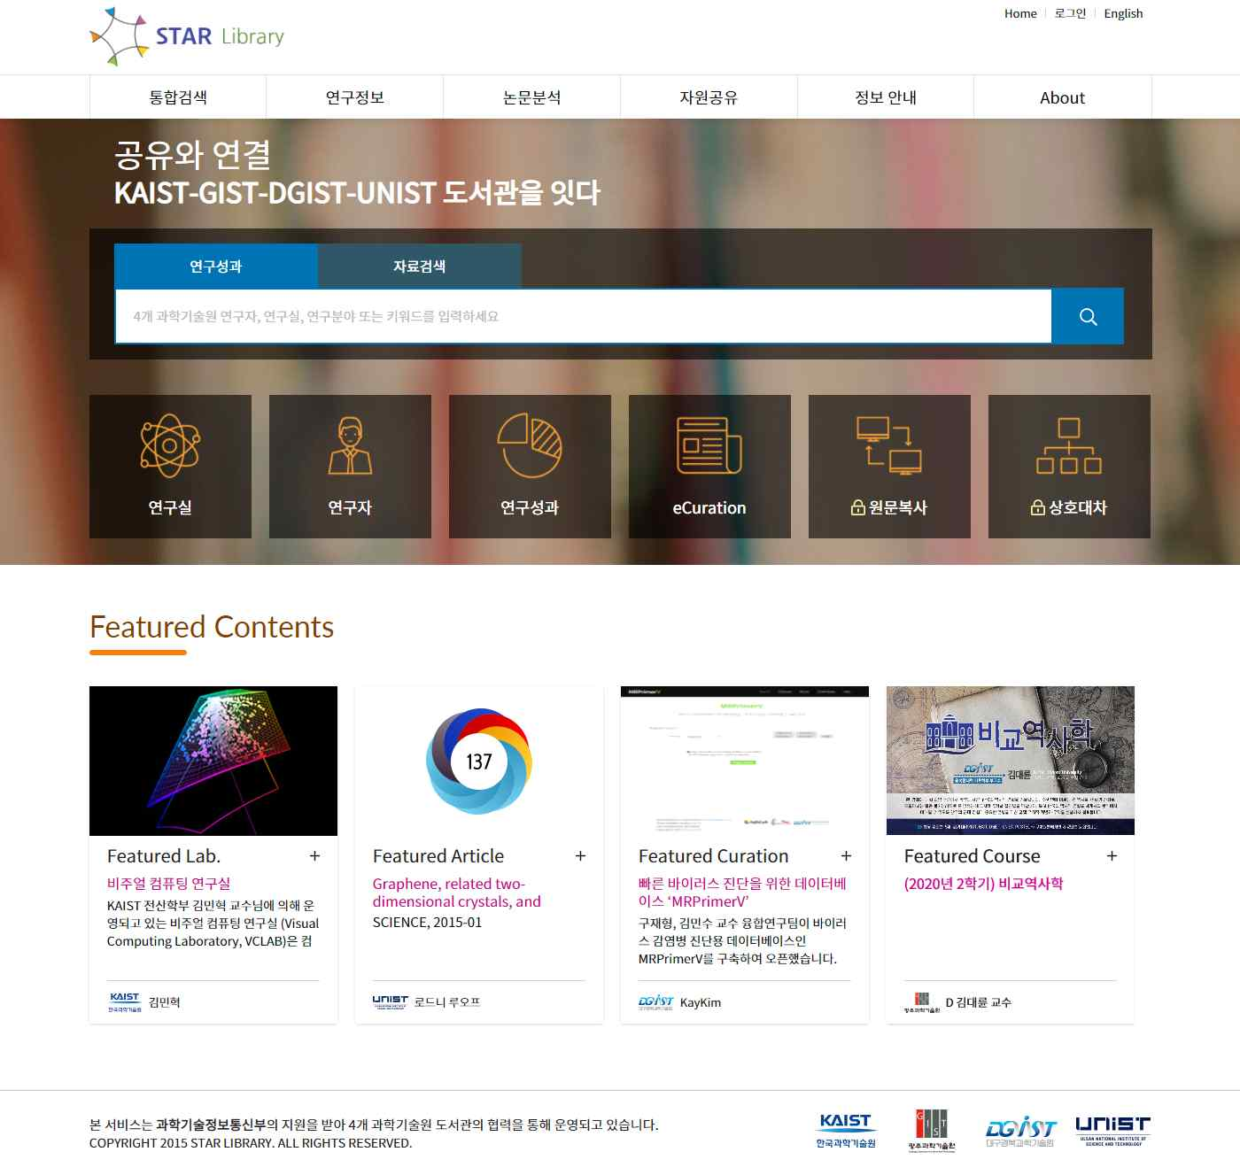
▲ Star Library main photo

