
Gwangju Institute of Science and Technology

Official Press Release (https://www.gist.ac.kr/)

Section of Hyo Jung Kim Nayeong Lee
Public Relations Section Chief Senior Administrator
(+82) 62-715-2061 (+82) 62-715-2062

Contact Person Joo-bong Park, Section Chief
for this Article Section of Research Strategy
062-715-5210

Release Date 2020.10.29

GIST-Gwangju City to launch the "Civil Safety Industry Council" for customized disaster
safety response

□ GIST (Gwangju Institute of Science and Technology, President Kiseon Kim) and the Gwangju Metropolitan City Hall (Mayor Yong-seop Lee) held the inauguration ceremony of the "Civil Safety Industry Council" (Chairman In S. Kim, GIST Vice-President for R&D) at the Kim Dae-jung Convention Center on October 28, 2020, which was attended by experts from the disaster safety industry, academia, research, and government.

∘ This council was promoted to resolve immediate social problems such as disasters, safety, accidents, prevention, etc. and to build a safe society through the development of local community cooperative disaster safety technologies based on national responsibilities, such as post-corona response.

□ The council consists of a total of 35 people, including 9 policy experts, 10 safety/industrial R&D experts, 10 cooperation experts, and 6 from related industries. For efficient discussions, the council is operated in 3 committees for each function.

∘ ▲ The policy subcommittee discusses the direction of fostering safety industry and establishing macro-policies by discovering safety issues and agendas. ▲ The research and industry subcommittee developing ways to 'create local food through national medium and large R&D plans related to disaster safety.' ▲ The exchange subcommittee plans to discuss 'activating the establishment of a practical safety industry network and ecosystem.'

□ GIST Vice President of R&D In S. Kim will chair meetings on a quarterly basis and will work with industry, academia, research, and government to find solutions to citizens' experiences in the field of disaster and safety tailored to the region. The conference focused on the disaster safety control tower, artificial intelligence + disaster safety research and development projects.

∘ Chairman In S. Kim said, "We will periodically investigates various disaster safety-related issues proposed through the council to derive scientific and technological solutions and industrial-academic-related cooperation measures. We will do our best to improve the quality of life not only for Gwangju citizens but also for all the people of Korea."

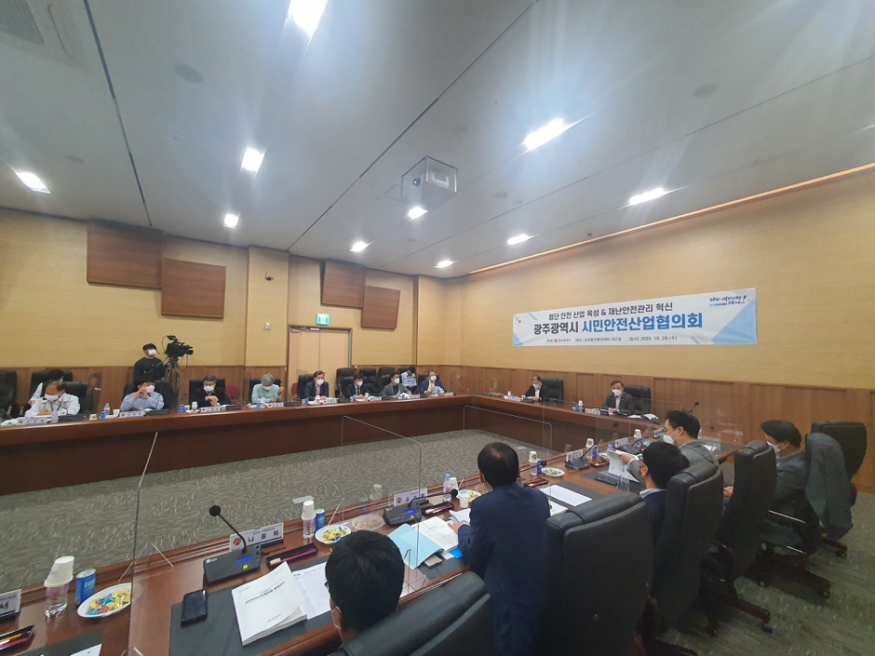
▲ GIST and the Gwangju Metropolitan City Hall host the "Civil Safety Industry Council"

