
Gwangju Institute of Science and Technology

Official Press Release (https://www.gist.ac.kr/)

Section of Hyo Jung Kim Nayeong Lee
Public Relations Section Chief Senior Administrator
(+82) 62-715-2061 (+82) 62-715-2062

Contact Person Joon-ho Park, Administrator
for this Article Auditor Office
062-715-2009

Release Date 2020.10.15

GIST joins hands with local CEOs
to spread a culture of integrity

□ GIST (Gwangju Institute of Science and Technology, President Kiseon Kim) Auditor Office (Auditor Kwang-sik Shin) signed a business agreement (MoU) with the Gwangju High-tech National Industrial Complex Management Council (Chairman Yong-beom Lee) to spread and promote the culture of community integrity.

∘ Through this agreement, the GIST Auditor Office and the High-tech National Industrial Complex Management Council jointly promote anti-corruption, promote integrity education, and anti-corruption. Various cooperative activities were decided to be carried out to establish and spread a culture of integrity in the region, such as exchange of information and sharing cases of institutional improvement to strengthen integrity.

□ The GIST Auditor Office earned '2nd grade (excellent)' in the '2019 Corruption Prevention Directive Assessment' evaluated by the Ministry of Science and ICT, recognizing the achievements of the office's active anti-corruption and integrity policy promotion efforts and activities to spread the culture of integrity.

□ Auditor Kwang-sik Shin said, "GIST, as a public institution, continues to expand cooperation with private organizations in line with the government's anti-corruption and integrity policy. We intend to play an active role as an agency in improving the integrity of the private sector."

∘ Chairman Yong-beom Lee said, "It is no exaggeration to say that corporate sustainability depends not only on the improvement of business performance but also on the establishment of a clean organizational culture. Through this agreement, it is expected that the council will contribute to the creation of a clean corporate culture and the spread of a culture of integrity in the local community."

□ Chairman Yong-beom Lee is currently the CEO of Optonix Co., Ltd., a company specializing in laser and ultra-precision optical parts located in the Gwangju High-tech National Industrial Complex. Optonix Co., Ltd. was the only one selected in Gwangju Metropolitan City for '2019 Best Job Companies in Korea' by the Ministry of Employment and Labor and the Jobs Committee, and was awarded the Presidential Citation on the '2019 Korea Industrial Park Day.'

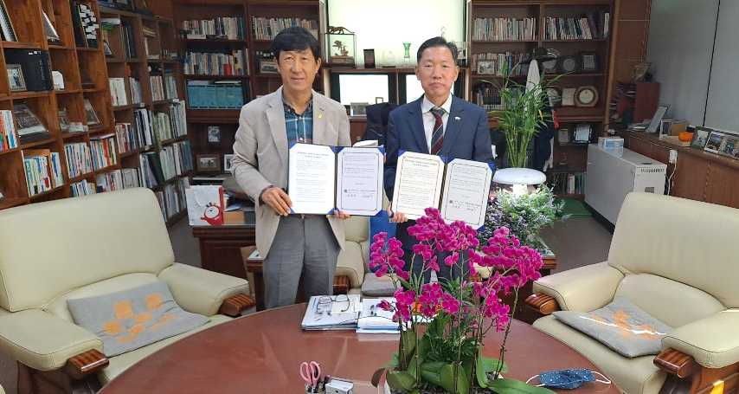
▲ GIST-Gwangju High-tech National Industrial Complex Management Council sign MoU
(From the left: Chairman Yong-beom Lee of the Gwangju High-tech National Industrial
Complex Management Council and GIST Auditor Kwang-sik Shin

