
Gwangju Institute of Science and Technology

Official Press Release (https://www.gist.ac.kr/)

Section of Hyo Jung Kim Nayeong Lee
Public Relations Section Chief Senior Administrator
(+82) 62-715-2061 (+82) 62-715-2062

Contact Person Seung Su You, Administrator
for this Article Section of Public Affairs
062-715-2025

Release Date 2020.09.03

National Assemblyman Beom-kye Park visits GIST to discuss future innovative growth measures for the region and ways to overcome COVID-19

□ National Assemblyman Park Beom-gye (Democratic Party of Korea) visited GIST (Gwangju Institute of Science and Technology, President Kiseon Kim) on September 2, 2020, to discuss future innovative growth measures for the region and ways to overcome COVID-19 wit GIST President Kiseon Kim, Vice President Jong-In Song, Vice President for Public Affairs Young-jip Kim, GIST Development Foundation Chair Jung-joo Ko, and Office of International and Public Affairs Dean Sung-Gyoo Park.

∘ This meeting was organized to seek ways to develop future innovations in the region based on AI, to share regional difficulties arising from the COVID-19 crisis, and to seek solutions together.

□ In particular, to overcome the crisis in the region caused by COVID-19 and turn the crisis into an opportunity for new growth, the meeting reinforced the need to actively respond with strength in solving regional problems, improving capabilities for innovation, and expanding future growth engines.

□ National Assemblyman Park Beom-gye said, "I would like to express my gratitude to the members of GIST who are doing their best to create AI specialists and develop the region even with the hardships caused by COVID-19. I will always listen to the opinions of the local community and provide active policy support so that GIST's efforts for innovative growth in local communities can bear fruit."

□ President Kiseon Kim said, "To overcome Corona 19, we are preparing to actively respond using science and technology, such as establishing an antivirus center. GIST will actively contribute to securing new growth engines for the local community by fostering AI convergence specialists needed for local industries and by securing world-class AI core technologies."

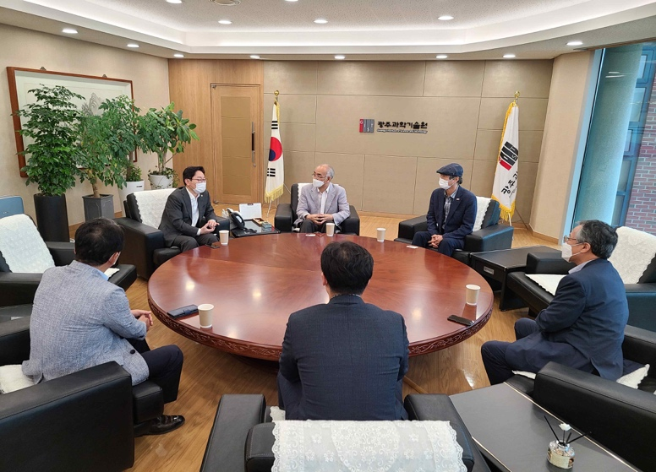
[Photo 1] National Assemblyman Park Beom-gye, GIST President Kiseon Kim, Vice President Jong-In Song, Vice President for Public Affairs Young-jip Kim, GIST Development Foundation Chair Jung-joo Ko, and Office of International and Public Affairs Dean Sung-Gyoo Park

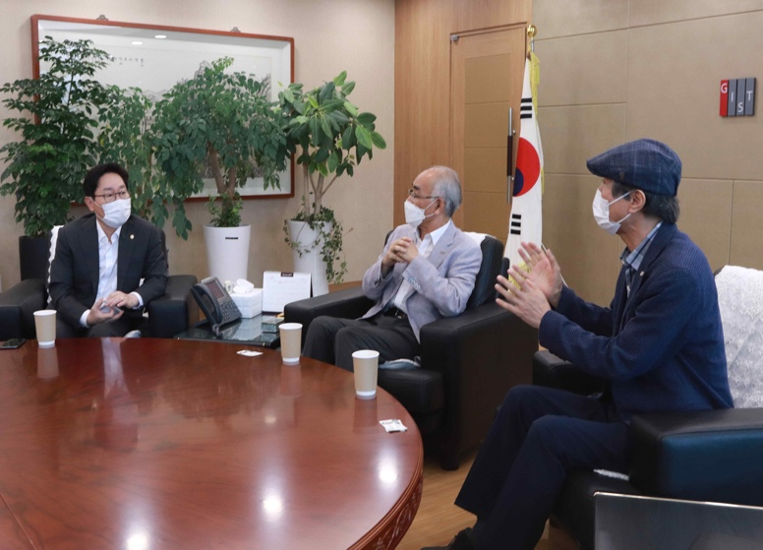
[Photo 2] From left: National Assemblyman Park Beom-gye, GIST President Kiseon Kim, and Vice President Jong-In Song

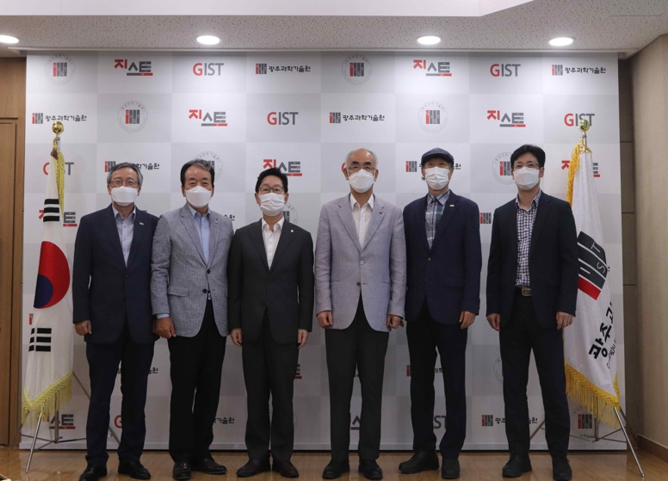
[Photo 3] From left: Vice President for Public Affairs Young-jip Kim, GIST Development Foundation Chair Jung-joo Ko, National Assemblyman Park Beom-gye, GIST President Kiseon Kim, and Vice President Jong-In Song, and Office of International and Public Affairs Dean Sung-Gyoo Park

