
Gwangju Institute of Science and Technology

Official Press Release (https://www.gist.ac.kr/)

Section of Hyo Jung Kim Nayeong Lee
Public Relations Section Chief Senior Administrator
(+82) 62-715-2061 (+82) 62-715-2062

Contact Person Moon-sub Yoon, Administrator
for this Article Section of Public Affairs
(+82) 62-715-2021

Release Date 2020.06.15

GIST donates masks to local child centers
to prevent the spread of COVID-19

□ GIST (Gwangju Institute of Science and Technology, President Kiseon Kim) donated masks to 27 children's centers on June 12 to prevent the spread of COVID-19.

∘ GIST's Section of Public Affair conducted a Good Mask Sharing Campaign for GIST members for two weeks from May 15 to May 29. Faculty, students, and staff, as well as a donation of 200 masks from Purify Techno, a research institute company, joined resources to deliver masks to students at children's centers in Gwangju.

□ The mask delivery ceremony for preventing the spread of COVID-19 was simplified selecting one local children's center near GIST with masks being delivered to the other children's center by couriers.

∘ The head of a local children's center that received masks said, "During this difficult period of another wave of COVID-19, we are grateful that GIST is taking the lead in helping local students."

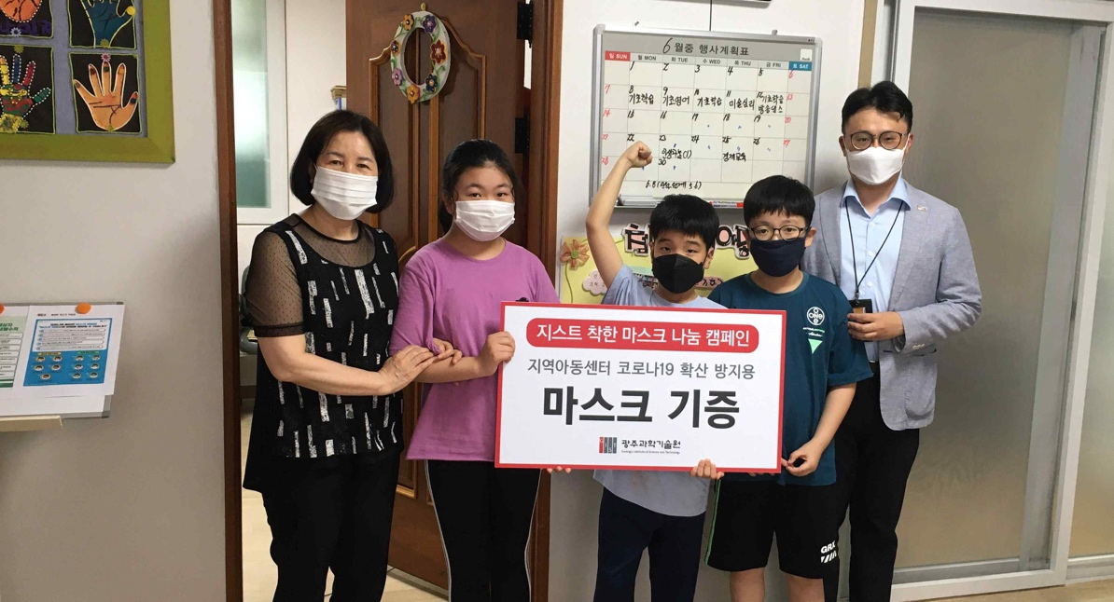
[Photo] GIST delivers masks to preven COVID-19 to a local children's center

