
Gwangju Institute of Science and Technology

Official Press Release (https://www.gist.ac.kr/)

Section of Hyo Jung Kim Nayeong Lee
Public Relations Section Chief Senior Administrator
(+82) 62-715-2061 (+82) 62-715-2062

Contact Person Sung-Gyoo Park, Director
for this Article Anti-Virus Research Center
(+82) 62-715-2511

Release Date 2020.06.09

"GIST Anti-Virus Research Center" established to actively respond to new viruses such as COVID-19

□ GIST (Gwangju Institute of Science and Technology, President Kiseon Kim) Anti-Virus Research Center (Director Sung-Gyoo Park, life sciences professor) was established to actively respond to new viruses that can cause infectious diseases, and the opening ceremony was held at GIST Oryong Hall on June 9, 2020.

∘ This research center was established to quickly respond to new viruses that cause infectious diseases such as COVID-19 and MERS (Middle East Respiratory Syndrome) and to establish core groups of experts from various fields to provide the highest level of protection, diagnosis, and treatment.

□ The center's main research scope is to research viruses and develop protection, diagnostics, vaccines, and therapeutic agents for infectious diseases. Furthermore, it will systematically study the life-cycle of infectious disease-causing viruses. It intends to build anti-virus research models and develop technological countermeasures through fusion and strategic research for various issues caused by new viruses.

∘ In particular, the goal is to proactively respond to new virus problems that emerge after the end of COVID-19, as well as to develop technologies for responding to COVID-19, and to derive the best anti-virus research results so that GIST's research capabilities can contribute to the international community.

□ The research center has established an expert group from various fields for multidisciplinary antiviral research. Participating researchers at the center are divided into protection, diagnosis, treatment, vaccine, and mechanism research.

∘ Professor Sung-Gyoo Park is the director of the research center ▲ Professors Heechul Choi, Inchan Kwon, and Chang-Duk Jun for protection technology ▲ Professors Gwang-Rog Lee, Young Min Song, and Jihwan Park for diagnostics ▲ Professor Yong-Chul Kim, Jiwon Seo, and Mi-Sun Jin for treatment ▲ Professors Sung-Gyoo Park, Hyunju Lee, and Chin-Ju Park for vaccine development ▲ Professors Young-Soo Jun, Chang-Myung Oh , and Soo-Hyun Eom for mutual cooperation and joint convergence research.

∘ In addition, the center will conduct state-of-the-art research based on close cooperation with GIST's AI Research Center, Laboratory Animal Resource Center, and Aging Research Institute.

□ Director Sung-Gyoo Park said, "The GIST Anti-Virus Research Center will actively research various problems caused by new viruses as well as conduct traditional research through convergence and strategic research. It is expected to play a preemptive role in anti-virus research by quickly diagnosing infectious diseases through the establishment of virus research models and the development of response technologies and even propose treatment methods."

□ Meanwhile, in April of this year, GIST was selected for the final six projects by participating in the 'COVID-19' Response Research Task to support the development and commercialization of COVID-19 response technology.

∘ The selected projects: ▲ Development of bio-disinfectant to prevent coronavirus infection (Professor Inchan Kwon) ▲ COVID-19 main protease (3CLpro) virus infection prevention and treatment technology development through discovery of target inhibitors and food supplements (Professor Yong-Chul Kim) ▲ High reliability patch type oxygen saturation/temperature sensor for immigration monitoring (Professor Young Min Song) ▲ Development of COVID-19 and similar CoV infection early diagnosis technology with accuracy within 15 minutes (Professor Gwang-Rog Lee) ▲ Development of a nasopharyngeal/throat spray to block ACE2-derived peptide-based corona19 infection (Professor Young-Soo Jun) ▲ Development and commercialization of nanofiber filter for safe mask using green solvent (Professor Heechul Choi).

∘ Up to 50 million won of research funds will be provided for each project, and government research will be conducted from May to the end of this year. The results are being promoted so that they can be applied directly to the current chapter in connection with local governments and businesses.

▲ GIST Anti-Virus Research Center opening group photo

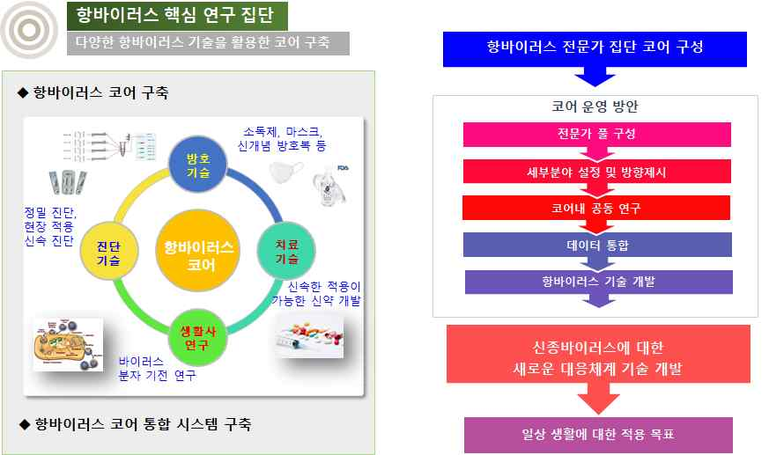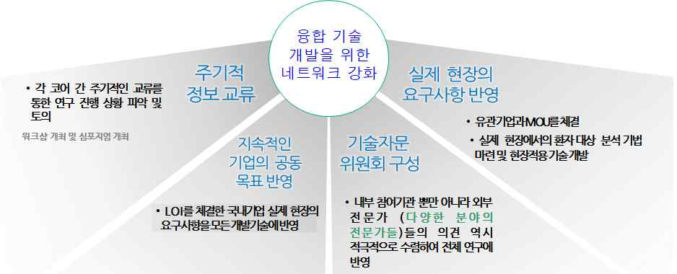
▲ GIST Anti-Virus Research Center organization and key features

