
Gwangju Institute of Science and Technology

Official Press Release (https://www.gist.ac.kr/)

Section of Hyo Jung Kim Nayeong Lee
Public Relations Section Chief Senior Administrator
(+82) 62-715-2061 (+82) 62-715-2062

Contact Person Tae-wan Kim, Administrator
for this Article Business Support Center
(+82) 62-715-6302

Release Date 2020.06.04

GIST holds 2020 Start-up Idea Competition

□ GIST (Gwangju Institute of Science and Technology, President Kiseon Kim) held the '2020 Start-up Idea Competition' to lead the 4th Industrial Revolution in discovering outstanding start-up ideas and in spreading a start-up culture.

∘ Beginning in 2013, this competition is an entrepreneurship program that recruits student entrepreneurship teams through announcements at the beginning of each year. This year's GIST Start-up Idea Competition was held as an online to prevent COVID-19.

□ In early March of this year, GIST undergraduate and graduate students were invited to submit their entrepreneurship ideas in all fields for commercialization. By May 15, a total of 35 teams entered, and 17 business ideas were subsequently selected through a document review, and the final 4 teams were selected on June 3 for a presentation review.

∘ ▲ The grand prize was given to Hyung-joon Jang and Ho-yeon Lee, a team of students in the Department of Chemistry, for 'Urinary and Uric Acid Detection Sensors that do not require measurement equipment' ▲ Jae-joon Lee of the Department of Mechanical Engineering won the excellence prize for 'Electric Motor Comprehensive Solution' ▲ the first honorary prize was awarded to Min-jae Cho, a student of the School of Mechanical Engineering, who developed 'FMCW 4D LiDAR development with high transmittance in harsh environments' ▲ the second honorary prize was awarded to Hyun-seung Jeong, a student at the Institute of Integrated Technology, for 'High-performance electrode for high temperature polymer electrolyte membrane fuel cell.'

□ The GIST Start-up Idea Contest was designed to help freshmen who entered GIST with festivals and programs to promote a university's start-up culture without any unnecessary burdens.

∘ Starting with this competition, GIST will produce start-up ideas such as GIST Sprint for Startup and Innopolis Campus projects in the form of early prototypes by linking various programs that can advance start-up ideas, and it plans to provide an opportunity to verify ideas.

∘ Among other start-up ideas proposed at the competition, fields related to artificial intelligence (AI) will be linked to start-up programs implemented by Gwangju Metropolitan City and the GIST AI Research Institute. A separate start-up camp will be run for students who want additional counseling and mentoring.

□ GIST Business Support Center Director Cho Byung-kwan Cho said, "The event will create a healthy student start-up culture and will actively recruit innovative start-up ideas to help create strong products through additional business links. In the future, GIST will actively take the lead in discovering challenging start-up teams through the operation of distinctive start-up programs to lead the 4th Industrial Revolution.

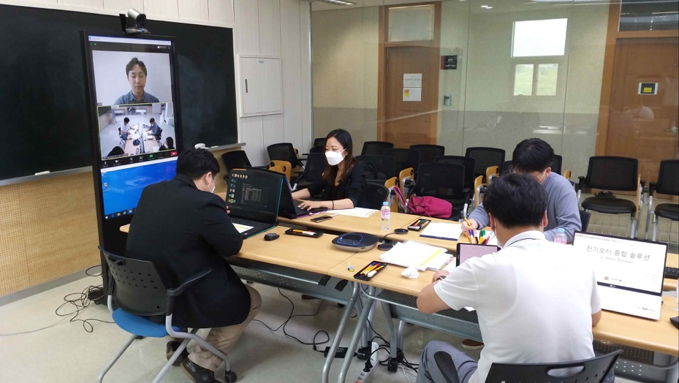
▲ Online presentation review for the 2020 GIST Start-up Idea Contest: Four judges will conduct the presentation review using Zoom (on-site judges will participate in the event wearing a mask).

