
Gwangju Institute of Science and Technology

Official Press Release (https://www.gist.ac.kr/)

Section of Hyo Jung Kim Nayeong Lee
Public Relations Section Chief Senior Administrator
(+82) 62-715-2061 (+82) 62-715-2062

Contact Person Kyung-jin Cho, Administrator
for this Article Business Support Center
062-715-2596

Release Date 2020.03.30

GIST hosts a donation ceremony to receive disinfectants from JD Company, which is a graduated company from the Business Support Center

□ Gwangju Institute of Science and Technology (GIST, President Kiseon Kim) recently received disinfectants to prevent the spread of COVID-19 from JD Company, which is a graduated company * from the Business Support Center.

* graduated company: companies that are designated by the Ministry of SMEs and Startups to receive support for three years from the Business Support Center and have become self-sufficient and relocated to an off-site premise

∘ The donation ceremony was conducted with officials from both organizations on March 27 at the GIST Business Support Center and was attended by GIST Vice President for R&DB In S. Kim, GIST Technology Institute Director Woo-jin Park, GIST Business Support Center Director Sung-keun Ki, and JD CEO Jae-yeol Yang.

∘ JD Company was developing a brine solution for water supply and sewage systems when it moved to the GIST Business Support Center in 2014 and received mentoring, domestic and foreign market research, and 1: 1 technical guidance between professors and the company. The business model was changed to the production of sterilized water for home use. Afterwards, after completing product development and market entry through various additional support from corporate support centers such as R&D, overseas market entry, intellectual property rights acquisition, and marketing, and after graduating in 2018, it has grown into a company that exports overseas and to various government offices, including Gwangju City Hall.

∘ JD's VIRURcatcher sterilizing disinfectant, which was deposited this time, was certified by a nationally recognized testing and certification agency and can sterilize all germs and viruses (99.9%) within 30 seconds and is an effective product to prevent the spread of COVID-19.

□ GIST Vice President for R&DB In S. Kim said, "With many small and medium-sized enterprises suffering from difficulties due to the recent COVID-19 crisis, GIST will provide various support for the survival and growth of our partner companies. The donated sterilizers will be used in preventing the spread of COVID-19 among GIST members so that they can concentrate on research activities even with this difficult situation."

∘ JD CEO Jae-yeol Yang said, "We were able to overcome the death valley of SMEs with the support of the Business Support Center, and I wanted to convey my gratitude with this donation. We sincerely hope that small businesses in Gwangju, as well as GIST, will be able to overcome difficult times."

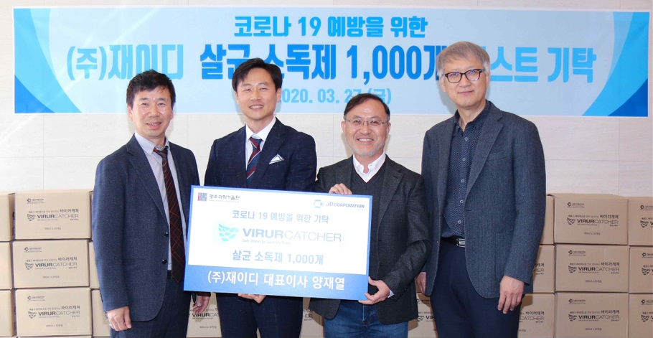
▲ Photo of JD's disinfectant donation to GIST: (from left) GIST Business Support Center Director Sung-keun Ki, JD CEO Jae-yeol Yang, GIST Vice President for R&DB In S. Kim,
and GIST Technology Institute Director Woo-jin Park

