
Gwangju Institute of Science and Technology

Official Press Release (https://www.gist.ac.kr/)

Section of Hyo Jung Kim Nayeong Lee
Public Relations Section Chief Senior Administrator
(+82) 62-715-2061 (+82) 62-715-2062

Release Date 2020.03.13

GIST hosts retirement ceremonies

□ Gwangju Institute of Science and Technology (GIST, President Kiseon Kim) held retirement ceremonies for Department of Biomedical Science and Engineering Professor Hyoung-Ihl Kim and School of Electrical Engineering and Computer Science Professor Chang-Soo Park on February 21, 2020, and March 10, 2020.

∘ The retirement ceremonies were held in the first half of this year by the respective departments to prevent the spread of CORVID-19.

□ Prior to being appointed to his position at GIST in 2010, Professor Hyoung-Ihl Kim received his Ph.D. in immunology from Chonbuk National University and was an associate professor at Chonbuk National University School of Medicine as well as a vsiting professor at Oregon Health & Science University (OHSU) and served as chief of neurosurgery at Jeonju Jesus Hospital.

∘ Professor Kim was the founding chairman of the Honam Epilepsy Society and the founding director of the Korean Society for Spinal Rehabilitation and Surgery and received the Korean Neurosurgery Academic Award (1989), Korean Rehabilitation Medicine Academic Award (1997), and the Korean Academy of Neurosurgery Lee Joo-Gul Academic Award (2009, 2016).

□ Prior to being appointed to his position at GIST in 2000, Professor Chang-Soo Park received a doctorate in engineering from Texas A&M University and then headed ETRI Optical Communications Research Office and worked as a researcher at the ERC Center at Texas A&M University.

∘ As major positions, Professor Park served as the head of the Department of Information and Communication Engineering, the Director of Research, the Director of the Entrepreneurship Technology Support Center, the Director of the BK Information & Communication Sector, the Director of the Culture Contents Technology Research Center, the Director of the Optical Technology Specialization Research Center, and he received the Prime Minister's Award (2011), the Researcher Award (2011), the National Research and Development Project Excellence Award (100), and the ICIEE 2017 Best Presentation Winner (2017).

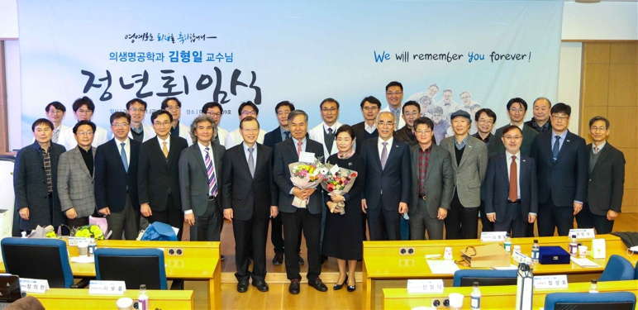
▲ [Photo 1] Professor Hyoung-Ihl Kim's retirement ceremony

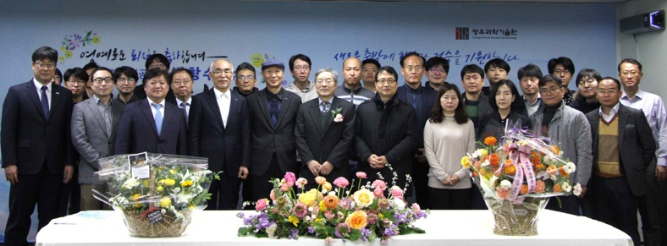
▲ [Photo 2] Professor Chang-Soo Park's retirement ceremony

