
Gwangju Institute of Science and Technology

Official Press Release (https://www.gist.ac.kr/)

Section of Mi-Yeon Kim Nayeong Lee
Public Affairs Section Chief Senior Administrator
(+82) 62-715-2020 (+82) 62-715-2024

Contact Person Mi-na Choi, Administrator
for this Article Section of Public Affairs
(+82) 62-715-2622

Release Date 2019.03.13

GIST hosts ceremony for the 9th GIST Techno Management Business Academy and GIST Development Fund

□ GIST (President Kiseon Kim) – The GIST Techno Management Business Academy (GTMBA) held its 9th opening ceremony on March 12, 2019, at Oryong Hall. Along with GIST President Kiseon Kim, about 70 people attended the ceremony, including the 8th GTMBA Alumni Association President Kyung-hyun Song.

∘ GTMBA created a special technical management course in 2011 to provide CEOs with a systematic training program, and a total of 310 people have graduated from the course as of last year with the 8th training program.

□ For this year's 9th GTMBA training program, 43 participants from various backgrounds throughout Gwangju and South Jeolla province will be taught in science, economics, management, and social sciences during the 24 week program, which will also include attending an overseas training session at the National University of Singapore.

□ GIST President Kiseon Kim said, "GIST will continue to successfully manage this important program so that knowledge about emerging technologies, human-oriented artificial intelligence expertise, and trends in advanced technologies can be combined with improved corporate and social management. Through the GTMBA program, I am hopeful that the participants will be able to steadily transform themselves so that they can make a larger beneficial impact on Korean society."

∘ President of the GTMBA Alumni Association Kyung-hyun Song said, "GTMBA will not spare any effort to provide the best education for the 9th training program so that the students can improve their businesses though courses in science, technology, business, economics, and humanities."

□ During the opening ceremony, HanYoung P&S, Ltd., CEO Yoon-seob Kim donated 10 million won to the GIST Development Fund.

∘ Yoon-seob Kim serves as the CEO of HanYoung P&S, Ltd., which specializes in molds, household appliances, and lighting products. The company has received numerous awards and recognitions, including from Gwangju Metropolitan City and the Ministry of Commerce. He is currently serving as the 8th GTMBA Alumni Association president.

∘ The donation will be used to support GTMBA.

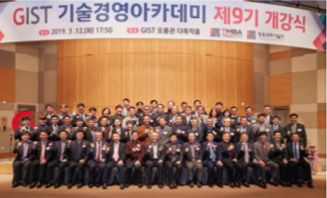
▲ A commemorative photograph of the opening ceremony of the
9th GIST Techno Management Business Academy

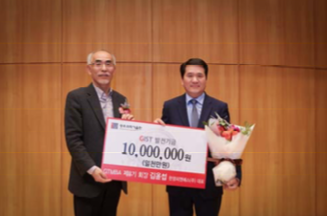
▲ Photograph of GIST President Kiseon Kim (left) and the 8th GTMBA Alumni
Association President Kyung-hyun Song (CEO of HanYoung P&S, Ltd.)

